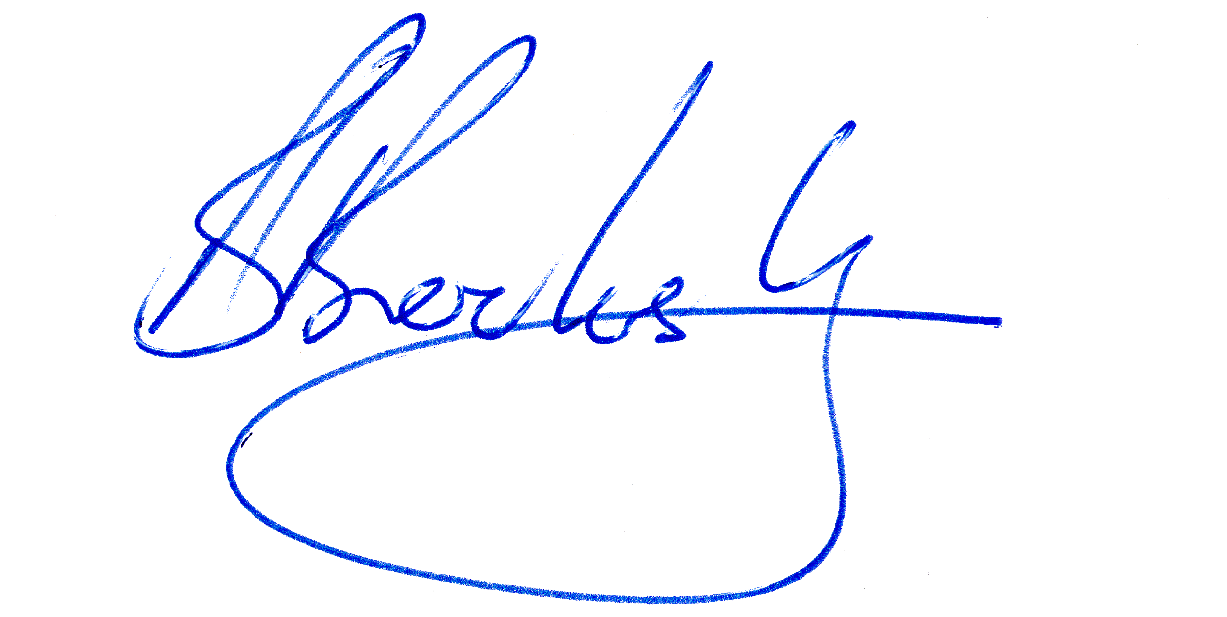 



**A COPY OF THIS TMP SHALL BE AVAILABLE ON SITE AT ALL TIMES**

SJTM 2179

Rev 1

1 | P a g e

WORKS ON ROADS TRAFFIC MANAGEMENT PLAN

Prepared by: 

### BURN PROGRAM

**GENERIC TRAFFIC MANAGEMENT PLAN**

**All public roads affected by the**

**Department of Biodiversity, Conservation and Attractions and the Department of Fire and Emergency Services WA**

**Burn Operations**

### SJ TRAFFIC MANAGEMENT

**July 2022 – June 2023**

I, Angela Anders (KTS-AWTM-20-38305-05), declare that I have designed this Traffic Management Plan, no site visit was conducted due to the generic nature of the TMP. The Traffic Management Plan prepared, subject to the variations approved, is in accordance with the MRWA Code of Practice, AGTTM and AS 1742.3

Signature: …… …………… Date: 24 June 2022

…………………………

|  |  |  |  |  |
| --- | --- | --- | --- | --- |
|  | **Name / Company** | **Accreditation Details** | **Date** | **Signed** |
| TMP Designed by | **Angela Anders**  SJ Traffic Management | KTS-AWTM-20-38305-05 | 24/06/22 |  |
| TMP Reviewed by | **Cheryl Johnson**  SJ Traffic Management | KTS-AWTM-19-47786-01 | 28/06/22 | P24C4T1#y1 |
| RTM Endorsed by  / TMP Reviewed by | **Brad Brooksby** Brad Brooksby Consulting | RTM 032 | 06/09/22 |  |
|  | Road authority authorisation of the implementation of traffic signs and | | | |
|  | devices is given for Traffic Management Plan No. SJTM 2179 | | | |
|  | (Note: this can be provided by the road authority via email referencing | | | |
| Road Authority Authorisation | the TMP and Rev No.)  Signed: Authorised Officer:  Date: | | | |
|  | (Print Name) Position: | | | |
|  | **Approval may be found in Appendix H**. | | | |

|  |  |  |
| --- | --- | --- |
| TMP No: SJTM- 2179 | Rev No: 1 | Date: 24/06/22 |

**Revision Register**



SJTM 2179

Rev 1

2 | P a g e

|  |  |  |  |  |
| --- | --- | --- | --- | --- |
| **Revision Number** | **Revision Date** | **Comments** | **Section / Page No.** | **Revised By** |
| 0 | Date | Original TMP | ALL | Angela Anders |
| 1 | 29 June 2022 | Numerous minor grammar changes | All | Brad Brooksby |

**Contents**



Definitions 8

* 1. Introduction 8
  2. Purpose and Scope 8
  3. Objective and Strategies 9
  4. Project overview 10
  5. Generic / Site Specific Traffic Management Plan Aide Memoire 10
  6. Existing Traffic and Road Environment 10
  7. Project Details, Site Assessment and Site Constraint /Impacts 11
  8. Overview of Proposed TTM 12
  9. Project Representatives 12
  10. Risk management 13
  11. Risk Management 13
  12. Hierarchy of Controls 13
  13. Risk identification and Assessment 14
  14. Volume and Composition 14
  15. Road Type Risk Weighting 15
  16. Risk Classification Tables 16
  17. Risk Register 18
  18. Traffic Management Planning and Assessment 28
  19. Traffic Assessment and Analysis 28
      1. Traffic and Speed Data 28
      2. Traffic Flow Analysis 28
      3. Temporary Speed Zones 28
      4. Existing Traffic signals 28
      5. Impact to adjoining network. 28
      6. End of Queue Treatment 28
      7. Temporary Traffic Signals 29
  20. Road Users 29
      1. Pedestrians 29
      2. Cyclists 29
      3. Public Transport 29
      4. Heavy and Oversized Vehicles 29
      5. Existing Parking Facilities 29
      6. Access to Adjoining Properties / Business 30
      7. Rail Crossings 30
      8. School Crossings 30

SJTM 2179 Rev 1 3 | P a g e

* + 1. Special Events and Other Works 30



* + 1. Emergency Vehicle Access 30
  1. Works at Night or in Dark Conditions 30
  2. Road Safety Barriers 31
  3. Consultation and Communication / Notification 31
     1. Other Agencies 31
     2. Public 31
  4. Site Assessment 32
  5. Provision to Address Environmental Conditions 32
     1. Adverse Weather 32
     2. Rain 32
     3. Other adverse weather (strong winds, thunderstorms, etc.) 32
     4. Sun Glare 32
     5. Fog, Dust and Smoke 33
     6. Visibility Restrictions 33

5.1.5 Road Geometry, Terrain, Vegetation and Structures 33

* 1. Existing Traffic and Adverting Signs 33
  2. Safety Plan 34
  3. Occupational Safety and Health 34
     1. Fatigue Management 34
     2. Escape Routes 35
  4. Roles and Responsibilities 35
     1. Responsibilities 35
     2. Roles 37
     3. Pre-Planning Roles 38
     4. Responsibilities & Accreditation 38
     5. Burn Controller (Duty Officer) 38
     6. Traffic Management Specialist 39
     7. Lookout Person 40
     8. Escort Vehicle Driver 40
  5. PPE 41
  6. Plant and Equipment 41
  7. Trip Hazards 42
  8. Implementation 43
  9. Traffic Guidance Schemes 43
  10. Pre-Burn Process 43

SJTM 2179 Rev 1 4 | P a g e

* 1. Changes to Traffic Guidance Schemes 44



* 1. Sequence and Staging 45
  2. Traffic Control Devices 47
     1. Sign Requirements 47
     2. Tolerances on positioning of signs and devices 48
     3. Flashing Arrow Signs 48
     4. Variable Message Signs 48
     5. Delineation 49
  3. Site Access for Work Vehicles 49
  4. Communicating TMP Requirements 50
  5. Emergency Arrangements and Contingencies 51
  6. Traffic Incident Procedures 51
     1. Serious Injury or Fatality 52
     2. Minor Incident or Vehicle Break Down within Site 52
     3. Reporting Traffic Incidents 52
  7. Emergency Services 53
  8. Dangerous Goods 53
  9. Damage to Services 53
  10. Failure of Services 53
      1. Failure of Traffic Signals 53
      2. Failure of Street Lighting 53
      3. Failure of Power 53
  11. Emergency Contacts 54

8.6 Emergency Services Contacts General 54

* 1. Monitoring and measurement 55
  2. Daily Inspections 55
     1. Before works start 55
     2. During work hours 56
     3. Closing down each day 56
     4. After hours or unattended worksite 56
  3. TMP Audits and Inspections 57
  4. Records 57
  5. Public Feedback 57
  6. Management Review and Approvals 58
  7. TMP Review and Improvement 58
  8. Variations 58

SJTM 2179 Rev 1 5 | P a g e

* 1. Approvals 58



SJTM 2179

Rev 1

6 | P a g e

Appendix A 59

Notification of Roadworks 59

Appendix B 60

Variation to Standards 60

Appendix C 66

Record Forms 66

Appendix D 76

Traffic Analysis and Volume Counts 76

Appendix E 77

Examples of traffic management devices 77

Appendix F 81

Traffic Guidance Schemes 81

End of Document 85

|  |  |
| --- | --- |
| **Acronym** | **Definition** |
| AADT | Annual Average Daily Traffic |
| AGTTM | Austroads Guide to Temporary Traffic Management |
| AS | Australian Standard |
| AS/NZ | Australian and New Zealand Standard |
| AWTM | Advanced Worksite Traffic Manager |
| BWTM | Basic Worksite Traffic Manager |
| CoP | Main Roads WA Code of Practice – Traffic Management for Works on Roads |
| DFES | Department of Fire and Emergency Services |
| DBCA | Department of Biodiversity, Conservation and Attractions |
| HVS | Heavy Vehicle Services |
| ISO | International Standards Organisation |
| LGA | Local Government Area |
| MMS | Multi Message Sign |
| MRWA | Main Roads Western Australia |
| OSH | Occupational Safety and Health |
| PPE | Personal Protective Equipment |
| PTCD | Portable Traffic Control Device |
| PTSS | Portable Traffic Signal System |
| RAV | Restricted Access Vehicle |
| RNOC | Road Network Operations Centre |
| RTM | Roadwork Traffic Manager (accredited by MRWA) |
| TC | Traffic Controller |
| TTM | Temporary Traffic Management |
| TMI | Traffic Management Implementer (Traffic Management Team Leader) |
| TGS | Traffic Guidance Scheme |
| TMA | Truck Mounted Attenuator |
| TMP | Traffic Management Plan |
| VMS | Variable Message Sign |
| Vpd | Vehicles per day |
| Vph | Vehicles per hour |
| WTM | Worksite Traffic Manager |



SJTM 2179

Rev 1

7 | P a g e

##### DEFINITIONS

|  |  |
| --- | --- |
| **Term** | **Definition** |
| Aftercare | A traffic guidance scheme for a non-attended worksite |
| Operational Area | The area that includes the worksite and area directly influenced or affected by  the operation. |
| Network Operator | Road owner or authorised management agency |
| Public Road | Any road that can be trafficked by a member of the public, not including roads  that are physically blocked for management purposes or roads within private properties that have been unlawfully accessed. |
| Risk | The effect of uncertainty on objectives. |
| Shadow Vehicle | A vehicle positioned in such a way as to provide physical protection from  oncoming vehicles to personnel involved in mobile operation within the worksite where an appropriate traffic management scheme is not in place. |
| Taper | Progressive restriction of lane width or closure. |
| Vehicle-Mounted  Warning Device | A device as defined in AS 1742.3 |
| Worksite | An area that includes the work area(s) and any additional length of road required for advanced signing, tapers, side-tracks or other areas needed for associated purposes. |



* 1. **INTRODUCTION**

##### Purpose and Scope

This Traffic Management Plan (TMP) outlines the traffic control and traffic management procedures to be implemented by the Department of Biodiversity, Conservation and Attractions (DBCA) and Department of Fire and Emergency Services (DFES) to manage potential hazards associated with the traffic environment during the project.

Burning operations are a primary land management tool utilised by the DBCA and DFES employees and sub-contractors to achieve a range of outcomes relating to bushfire mitigation, biodiversity and silviculture. Burn Plans are developed in consultation with the road authority to create a comprehensive document for each planned burn detailing the purpose of the burn, how the burn will be implemented and managed and considers impacts and risks within the burn area and to other stakeholders. All decisions and actions that occur before, during and after the burn are recorded in the burn plan.

This TMP informs part of the Burn Plan and identifies and manages hazards in or adjacent to road networks.

The interaction between burn activities and road traffic is considered to be a significant risk. It is essential that appropriate pre-planning is undertaken and operational procedures and processes consider the risks to both the on-site worker and road user and fulfil the duty of care requirements.

This TMP applies to planned fire operations undertaken on or near public roads by DBCA and DFES. The plan provides traffic management guidance for fire practitioners when developing Burn Plans and implementing Burn Plan operations. This plan has been developed with consideration to the operational and planning complexities associated with planned burn operations and acknowledges the fact that traffic management is only one aspect of risk in the burn operation.

The TMP applies a flexible approach requiring a dynamic assessment of hazards and their influence on the risk profile of the operation. Competent practitioners are required to implement this plan to achieve a safe outcome. This is reflected in Section 1 (p 10) of the Main Roads WA Traffic Management for Works on Roads - Code of Practice (Code) which states:

“Main Roads WA recognises that situations sometimes arise where application of these requirements is not appropriate and that variation to these requirements will be necessary. When it becomes apparent that deviation is necessary from the requirements of this Code, persons arranging the works should carefully consider all possible options, using common sense and judgment based on ‘risk management’ carried out in accordance with sections

4.3 and 4.5. Further, they shall ensure that their actions are consistent with related legislation.”

DBCA and DFES will not implement a Burn Plan where the outcome of the risk assessment of the traffic management components as a result of the risk assessment undertaken during the planning stage has identified a residual risk rating of High or greater.

Planned burning is a dynamic operation that requires workers to undertake a variety of operations in proximity to, though not generally on, or near, the traffic lane of a road. When possible, the preference is to close roads on a burn perimeter and close all internal tracks and roads prior to ignition.

Traffic guidance may need to be modified as the various phases of the work are undertaken, and environmental conditions change to ensure guidance remains fit for purpose.

This TMP focuses on DBCA and DFES operations which are mostly off the traffic lane, with plant and personnel following the progress of the fire along the verge. Occasionally when a vegetation is close to the road pavement or a culvert or other obstruction prevents access along the verge, plant and personnel may use the road for a short period of time.

SJTM 2179 Rev 1 8 | P a g e

##### Objective and Strategies



SJTM 2179

Rev 1

9 | P a g e

This TMP relates to the management of road users and personnel affected by the planned burn. Traffic management is among a suite of factors and issues associated with DBCA and DFES operations. Thus, it forms part of the overall fire doctrine. Traffic management is specifically addressed in the Burn Plan.

The objectives of the Traffic Management Plan are to:

* + - Provide for a safe environment with an adequate warning for all road users travelling roads
    - Protect workers and contractors on the worksite
    - Ensure road network performance is maintained at an acceptable level throughout the duration of the work by minimising disruption, congestion and delays to all road users.
    - Maintain operational efficiency of burn program operations and
    - Ensure access to adjacent properties is maintained except under agreement.

To meet the above objectives the Traffic Management Plan will will provide strategies to:

* + - Provide wherever practicable, a sufficient number of traffic lanes to accommodate vehicle traffic volumes.
    - Minimise delays and traffic congestion
    - Provide appropriate and sufficient signage to warn, instruct, and guide road users and traffic passing through the worksite and
    - Ensure that the work area hazards are kept to tolerable levels and that all road users are adequately protected from operational hazards arising from the burn.

The specific methods used to address the strategies outlined above are:

* + - Procedures and responsibilities.
    - Traffic Guidance Schemes (TGS) and
    - This Traffic Management Plan.



SJTM 2179

Rev 1

10 | P a g e

* 1. **PROJECT OVERVIEW**

##### Generic / Site Specific Traffic Management Plan Aide Memoire

This TMP is designed for generic use on various roads throughout Western Australia, each site should have a site assessment done prior to commencing work to ensure that this TMP and included TGSs are suitable for the location of the works.

The Aide Memoire Form 1 at Appendix C has been developed to assist in determining the need for the traffic management setup to be generic or site specific. However, those implementing the plan need to be very aware of the scope of situations covered by the plan.

Where a TMP is to be used on more than one occasion or at a number of generic locations, continuous improvement must be considered.

This will ensure the quality of traffic management is maintained or improved when required. The process should include debriefing meetings to discuss any issues or risks associated with the plan. TMPs must be kept up to date considering changes in traffic volumes, vehicle types, the road environment, work practices, legislation, and standards.

##### Existing Traffic and Road Environment

As this TMP is designed for generic use on various roads, information such as the existing traffic and road environment shall be considered for each location prior to implementation of the TMP.

A suitably accredited person must select the Traffic Guidance Scheme(s) for implementation at the worksite, following consideration of the Site Specific Traffic Management Plan Aide memoire Form 1 (Section 2.1 above) and the suite of generic TGSs. A site visit or investigation of the site must be conducted and confirmation that the selected TGS (s) are “Site Suitable”. The specific TGS to be implemented shall be recorded in the burn plan if determined during the pre-planning phase, or on the Road Specific Risk Assessment – (Day of Burn) Form 2 at Appendix C if decided or changed on day of burn.

##### Project Details, Site Assessment and Site Constraint /Impacts



SJTM 2179

Rev 1

11 | P a g e

|  |  |
| --- | --- |
| **ITEM** | **DESCRIPTION** |
| Project | The Department of Biodiversity, Conservation and Attractions & Department of Fire and Emergency Services burn programming operations on or near all public roads which do not involve  complex traffic arrangements as defined by the Main Roads Code of Practice. |
| Location | Burn program operations that affect public roads. |
| Road Classification, Existing Speed Limit | All public roads range from 40 – 110 km/h. |
| Road Authority | Various. |
| Local Government | Various. |
| Principal | No 0097 Department of Biodiversity, Conservation and Attractions. |
| Prime Contractor | Department of Biodiversity, Conservation and Attractions & Department of Fire and Emergency Services and their Subcontractors. |
| Sub-Contractor | Various. (Registered with Main Roads WA to work on Main Roads roads). |
| Scope of Works | Burn program operations which affect public roads. |
| Staging of Work / Temporary Traffic Management | Various.  Advance notification – Variable Message Signs.  Works including verge works, lane closures, road closures. Unattended works. |
| Project Date | July 2022 – June 2023. |
| Hours / Days of Work | Monday – Sunday generally during daylight hours but can include dark conditions. |
| Duration of Work | Generally, 1 Shift with aftercare as required but can be over several days. |
| Other Constraints | Weather conditions. |
| Concurrent/adjacent Works or Projects | Burns programmed not to clash with other events or projects as advised by road authority. |

##### Overview of Proposed TTM



SJTM 2179

Rev 1

12 | P a g e

|  |  |
| --- | --- |
| **ITEM** | **DESCRIPTION** |
| Temporary Traffic Management Descriptions | This Generic TMP contains only non-complex Traffic Guidance Schemes. Any works conducted outside of the scope of these  TGSs shall have a Site Specific TMP designed. |
| Speed zone dates and times | All speed zones Monday – Sunday. |
| Lane Closures dates and times | Monday-Sunday |
| Road Closures dates and times | Monday-Sunday |
| Signal modifications description | Signal modification is not applicable to this TMP. |
| Proposed lane widths | As per TGS |
| Road Safety Barrier | Road Safety Barriers not required for this project. When existing temporary road safety road barriers are present traffic management signs and devices will be minimised adjacent to barriers due to the lack of escape route to traffic management  personnel and a Lookout Person will be utilised. |

##### Project Representatives

|  |  |
| --- | --- |
| **Traffic Management Plan Preparation** | **Generic Document** |
| Project Manager / Prime Contractor | Brad Brooksby  Brad Brooksby Consulting [Brad.Brooksby@bigpond.com](mailto:Brad.Brooksby@bigpond.com) Mob 0435 164 175 |
| Planning – Short / Medium Term Works | Managers or delegates have a duty of care  under this plan to ensure that traffic management needs are fully considered. |
| TMP Design | Angela Anders  SJ Traffic Management. |
| TMP Implementation | Operations Officer or delegate, who shall, as a minimum requirement, hold Basic Worksite Traffic Management accreditation and shall conduct a site inspection prior to implementing the TMP. |



* 1. **RISK MANAGEMENT**

##### Risk Management

The International Standard for Risk Management (AS ISO 31000) highlights the need to identify, analyse, evaluate and treat risks. The risk management processes and standards contained in this TMP align with AS ISO 31000 risk principles, management processes and standards used in DBCA Burn Plan planning and operations. The TMP acknowledges that risk is inevitable and ultimately a decision is made regarding the tolerability of retained risk. “Risk management entails the identification and analysis of all hazards arising during works on roads including the setting up, operating, changing and ultimately dismantling of the traffic guidance scheme, following the determination of appropriate measures to mitigate those risks. The process is appropriate at all levels of planning and operation.

In each case the process should be carried out by first identifying all the hazards likely to arise, evaluating them in terms of likelihood of occurrence and adverse consequences using historical data, experience or other means. The proposed procedural statement or traffic guidance scheme should be then checked in detail to ensure that adequate means of controlling or reducing those risks found to be significant are in place.” (AGTTM 10, Section 2 Risk Management for TTM).

In alignment with AS ISO 31000 this TMP manages risk using the following steps:

* Establishing context – at a corporate level through identification of the road network. At an individual burn level by identifying the roads within and in proximity to the individual burn area and their relative level of importance in terms of network performance.
* Identification of risk – the TMP identifies hazards likely to influence or impact on traffic or the workers within the worksite where public roads are involved.
* Analysis of risk – the TMP quantifies the risk through an analysis of consequences and likelihood of those consequences occurring.
* Evaluation of Risk – confirming if a risk is tolerable and if not, what can be done to reduce the risk level and
* Treatment of risk – Undertaking actions that effectively reduce risk by changing the likelihood or magnitude of the consequences. This also enacts the principle of treating risk to ‘As Low as Reasonably Practicable”.

The level of risk post-treatment is the ‘Residual Risk’ which undergoes an additional evaluation to determine tolerability. The TMP considers this to be the final risk level of the operation.

##### Hierarchy of Controls

This plan raises management of traffic at Burn Plan from an administrative function to an engineering function. This approach facilitates the adaptation of a generic plan and schemes to suit a specific situation. When combined with the use of risk assessment tools, a robust traffic management scheme can be produced that achieves the required traffic management objectives.

Where hazards have been identified the following hierarchy of controls should be implemented:

* Elimination
* Isolation
* Substitution;
* Engineering;
* Administration; and
* Personal Protection Equipment.

In alignment with AS ISO 31000, DBCA and DFES will commit to a process of continual improvement through regular review and amendment of this plan. This will ensure that the plan remains contemporary and fit for purpose.

SJTM 2179 Rev 1 13 | P a g e

##### Risk identification and Assessment



Risk management is an iterative process because it is not possible to identify all hazards associated with an operation at the pre-operation planning stage.

A quote from “Section 1 (p 11) of Traffic Management for Works on Roads Code of Practice” is reiterated below:

“MRWA recognises that situations sometimes arise where the application of these requirements is not appropriate and that variation to these requirements will be necessary. When it becomes apparent that deviation is necessary from the requirements of this Code, persons arranging the works should carefully consider all possible options, using common sense and judgment based on ‘risk management’ carried out in accordance with sections

4.3 and 4.5. Further, they shall ensure that their actions are consistent with related legislation.”

DBCA and DFES concurs with this clause and requires staff to apply risk management using the attached Risk Assessment Matrices (Forms 2 & 3) when assessing changes to a traffic management scheme outlined in this TMP. Monitoring, risk identification and analysis, including changes to the traffic management scheme are to be recorded in the fire diary.

Traffic management schemes have been developed considering a variety of variable operational considerations.

The preferred management option for treatment of traffic related risk is Road Closure. Where this is not practicable, the scheme applied will involve the erection of traffic control devices in accordance with this plan.

Risk assessment for road and traffic management occurs at three phases in burn planning:

* Pre-planning – Includes planning associated with Burn Plan development and development of the individual Burn Plans.
* Day of burn planning – Includes factors identified in pre-planning and the range of operational variables that could not be adequately identified in pre-planning and
* Unforeseen risks – un-forecast factors which may arise during the active burn operation.

Where residual risk identified in the day of burn planning is High or Very High, the Burn Controller shall not proceed without reviewing the current operations plan.

Where unforeseen risk arises resulting in a situation where the risk is High or Very High and the risk cannot be mitigated, the Burn Controller must consider the declaration of an incident.

In this case, the Burn Controller/Incident Controller should request Police assistance, notify the Network Operator, and apply traffic management in accordance with the Traffic Management during Emergencies (2015) - updated 2018.

[https://semc.wa.gov.au/Documents/Resources/LegislationPolicyPlansProcedureandGuidelines/Guidel](https://semc.wa.gov.au/Documents/Resources/LegislationPolicyPlansProcedureandGuidelines/Guidelines/TrafficManagementduringEmergenciesGuideline.pdf#search%3Dtraffic%20management) [ines/TrafficManagementduringEmergenciesGuideline.pdf#search=traffic%20management.](https://semc.wa.gov.au/Documents/Resources/LegislationPolicyPlansProcedureandGuidelines/Guidelines/TrafficManagementduringEmergenciesGuideline.pdf#search%3Dtraffic%20management)

##### Volume and Composition

The volume, speed and composition of traffic significantly influence the risk level for personnel in the worksite and road users. Vehicle volumes, composition, and speed will influence the level of planning required to achieve safe, effective traffic management.

Estimates of traffic composition and volume are to be considered as part of the pre-planning process and risk evaluation, see section 7.2. An indication of these can be obtained from the road authority. In the case of unmonitored roads, estimates may be available from the local MRWA Regional, District Office or MRWA traffic map website.

SJTM 2179 Rev 1 14 | P a g e

Traffic volume and composition will influence the level of consideration and amount of pre-planning required prior to implementation of a Burn Plan.



SJTM 2179

Rev 1

15 | P a g e

<https://trafficmap.mainroads.wa.gov.au/map>.

##### Road Type Risk Weighting

The weighting that should be given to various road types at the planning stage of a Burn Plan to inform risk assessment processes in Table 3 below.

For roads with a weighting of High and Very High, it is appropriate to consult with the road authority to confirm their requirements. The process is outlined in more detail in Section 7.2 Pre-Burn Process.

**Table 1 - Road type Risk Weighting**

|  |  |  |
| --- | --- | --- |
| **Function** | **Functional Description** | **Traffic Management Risk**  **Weighting** |
| Primary Distributor | All main roads are providing major Regional and Inter-Regional movement of large volumes of fast moving traffic. These roads have few if any alternative routes and often carry more than 5,000 VPD.  Normally a Category 2 or 3 road in the AGTTM. | Very High |
| District Distributor | Roads that typically carry traffic, including trucks, between industrial or residential areas. They are managed by LGA’s and often connect to Primary Distributors and carry at least 100 VPD. This includes key access roads for which no alternative access or egress exists.  Normally a Category 1 or 2 road in the AGTTM. | High |
| Collector | Roads typically carrying traffic within a cell and connect to District Distributors. These roads also include moderate level Shire roads providing key linkages to District Distributors and high level Departmental roads providing access to key sites. These roads typically carry at least 50 VPD.  Normally a Category 1 road in the AGTTM. | Medium |
| Access Road Level 1 | Minor Roads carrying between 10 - 50 VPD. These roads typically provide access to properties and provide management access. This group includes roads within rangelands that are sealed or unsealed, a majority of Departmental strategic roads that have **Minor** consequence in the event of closure.  Normally a Category 1 road in the AGTTM. | Low |
| Access Road Level 2 | Minor road carrying <10 VPD or with multiple alternative routes. This includes roads within rangelands and forested areas that are unsealed and have **Insignificant** consequence in the event of closure.  Normally a Category 1 road in the AGTTM. | Very Low |

##### Risk Classification Tables



**IMPORTANT NOTE:** The likelihood of an event or hazard occurring shall first be assessed over

the duration of the activity (i.e., “period of exposure”). For risk assessment purposes the assessed likelihood shall then be proportioned for a “period of exposure” of one year.

SJTM 2179

Rev 1

16 | P a g e

**QUALITATIVE MEASURES OF CONSEQUENCE OR IMPACT**

|  |  |  |  |
| --- | --- | --- | --- |
| **Consequence** | **OH/S** | **Road User**  **Impact** | **Road Network**  **Impact** |
| **Insignificant** | No Injury or first aid  treatment. | No impact on environmental speed. | No impact on the level of  service. |
| **Minor** | On-site first aid only. Safety Incident Report  required. | Information signs only required. Operations are evident to the road user. | Minor impact on the level of service. |
| **Low** | Minor off-site medical treatment.  No Lost Time Injury. | Some minor traffic control required. E.g. Speed drop not exceeding 20 km/h from  normal posted speed. | Some delays and congestion to traffic  diversions available. |
| **Moderate** | Medical Treatment or Lost Time Injury.  No Worksafe Report required. | Sight distance reduced to less than 120 m for a distance longer than 2 km. | Delays and congestion for a longer period.  Diversion is available up to  30 min round trip. |
| **Major** | Significant injuries or hospitalisation.  Worksafe Report required. | Sight distance reduced to less than 80 m for longer than 1 km. | Unacceptable network delays.  No diversions are less than 30 km at 80 km/h  available. |
| **Catastrophic** | Death / Debilitating injury | Sight distance reduced to less than 40 m for longer than 500 m. | Unacceptable network delays.  Dead End Road |

**QUALITATIVE MEASURES OF LIKELIHOOD**

|  |  |
| --- | --- |
| **Likelihood** | **The Event or Hazard(s):** |
| **Almost Certain** | * Is expected to occur in most circumstances; or * A common or repeating occurrence; or * Will occur within one season. |
| **Likely** | * Will probably occur in most circumstances; or * Will occur within two seasons. |
| **Possible** | * Might occur sometime; or * Has happened elsewhere; or * Likely to occur within three seasons. |
| **Unlikely** | * Could occur at some time; or * Will probably occur within four seasons. |
| **Rare** | * May occur in exceptional circumstances; or * Is not likely to occur within the next five seasons. |

**QUALITATIVE RISK ANALYSIS MATRIX – RISK RATING**



SJTM 2179

Rev 1

17 | P a g e

|  |  |  |  |  |  |  |
| --- | --- | --- | --- | --- | --- | --- |
| **LIKELIHOOD** | ***CONSEQUENCE*** | | | | | |
| ***Insignificant***  ***2*** | ***Minor***  ***4*** | ***Low***  ***8*** | ***Moderate***  ***16*** | ***Major***  ***32*** | ***Catastrophic***  ***64*** |
| **Almost Certain**  **9** | **Medium**  **18** | **Medium**  **36** | **High**  **72** | **High**  **144** | **Very High**  **288** | **Very High**  **576** |
| **Likely**  **7** | **Low**  **14** | **Medium**  **28** | **Medium**  **56** | **High**  **112** | **High**  **224** | **Very High**  **448** |
| **Possibly**  **5** | **Low**  **10** | **Low**  **20** | **Medium**  **40** | **Medium**  **80** | **High**  **160** | **High**  **320** |
| **Unlikely**  **3** | **Very Low**  **6** | **Low**  **12** | **Low**  **24** | **Medium**  **48** | **Medium**  **96** | **High**  **192** |
| **Rare**  **1** | **Very Low**  **2** | **Very Low**  **4** | **Low**  **8** | **Low**  **16** | **Medium**  **32** | **Medium**  **64** |

**MANAGEMENT APPROACH FOR RESIDUAL RISK RATING**

|  |  |
| --- | --- |
| **Residual Risk Rating** | **Required Treatment** |
| Very High | Unacceptable risk. **HOLD POINT**. Work cannot proceed until risk has been reduced. |
| High | High priority, OSH MR, and Roadworks Traffic Manager (RTM) must review the risk assessment and approve the treatment and endorse the TGS prior to its implementation. |
| Medium | Medium Risk, standard traffic control and work practices subject to review by accredited AWTM personnel prior to implementation. |
| Low | Managed in accordance with the approved management procedures and traffic control practices. |

##### Risk Register



The risk table given below is specific to Burn Plan operations. During Burn Plan implementation, personnel spend little time working on the road. The road is used as a corridor for access, during pre-burn preparation, ignition and patrolling.

Hazards arising from smoke (and other issues that may impact road users) must be considered in addition to the risks in Table 2 below identified below.

For planned burns adjacent a Main Roads WA road reserve; closure of the Main Road will not be considered for mitigation in terms of significant risk or as a mitigation of risk when planning for burning operations. This rule may also apply to strategic local government and strategic egress roads.

All Burn Plans without exception will be discussed with and accepted by the relevant road authority before implementation.

**Table 2 - Risk Register**

|  |  |  |  |  |  |  |  |  |  |
| --- | --- | --- | --- | --- | --- | --- | --- | --- | --- |
| **Item** | **Risk Event** | **Consequence** | **Pre–treatment Risk** | | | **Treatment** | **Residual Risk** | | |
| **L** | **C** | **RR** | **L** | **C** | **RR** |
| 1 | **Planning**: Lack of planning – crews onsite with insufficient tools, signs and devices. | Results in delays to traffic and / workers. | L 7 | M 16 | High 112 | Use robust documented planning process with use of appropriate TGSs. | U 3 | M 16 | Medium 48 |
| 2 | **Planning**: Site inspection not undertaken by TMP designer. | Results in unknown risks. | P 5 | M 32 | High 160 | Use robust documented planning process including site inspected by Prescribing Officer, Operations Officer or delegate, discussed with Road Authority and Site-Specific Traffic Management Plan Aide Memoire. | U 3 | M 32 | Medium 96 |
| 3 | **Planning**: TGS selected as “Site Suitable”, Guidance Schemes – may require specific Traffic Guidance Scheme, Review by Manager, timing of works, advance signage, public notification, arrangement of crews and materials. | Delays to traffic. | L 7 | M 16 | High 112 | Pre-planning, Selection of appropriate Traffic Guidance Schemes using site specific vs generic Aide Memoire (Form 1) – may require specific Traffic Guidance Scheme, Review by Manager, timing of works, advance signage, public notification, arrangement of crews and materials. | U 3 | M 16 | Medium 48 |

SJTM 2179 Rev 1 18 | P a g e



|  |  |  |  |  |  |  |  |  |  |
| --- | --- | --- | --- | --- | --- | --- | --- | --- | --- |
| **Item** | **Risk Event** | **Consequence** | **Pre–treatment Risk** | | | **Treatment** | **Residual Risk** | | |
| **L** | **C** | **RR** | **L** | **C** | **RR** |
| 4 | **Planning:** Pros and Cons of the traffic management – Consider options for the works. The different traffic management treatment types, the resulting effects on the road network.  Use a Safe Job Planning approach. | Delays to traffic. | L 7 | M 16 | High 112 | Pre Planning and reviewing options.  Consider ‘After Care’ requirements if works cannot be completed in one shift or require additional works not planned. | U 3 | M 16 | Medium 48 |
| 5 | **Planning**: Inadequately assessed works on roads leading to inappropriate risk treatment and management. | Delays to traffic. | P 5 | M 32 | High 160 | Ensure TMP, including associated risk management processes, are undertaken and documented. | U 3 | M 32 | Medium 96 |
| 6 | **Planning:** Works within or close to communities. | Insufficient notification and consideration of effects. | L 7 | M 16 | High 112 | Ensure adequate consultation with the network operator and advance warning when required. | U 3 | L 8 | Low 24 |
| 7 | **Planning:** Risk Assessment is not aligned with Main Roads template. | Confusion by non DBCA or DFES users. | L 7 | M 16 | High 112 | Meets AS ISO 31000 Standard. Extensively used by DBCA. | U 3 | L 8 | Low 24 |
| 8 | **Planning:** Use of non-approved signs, distances, tape. | Confusion by non DBCA or DFES users. | L 7 | M 16 | High 112 | Common-sense signage better informs road user. | U 3 | L 8 | Low 24 |
| 9 | **Planning:** Longer distances for 40 km/h sites. | Road users may speed up. | L 7 | M 16 | High 112 | When speed compliance is achieved can be used.  Use Fire vehicles to travel at temporary speed to achieve compliance if required.  Agreed at planning stage with Road Authority. | U 3 | L 8 | Low 24 |
| 10 | **Planning:** Longer distances for 60 km/h sites. | Road users may speed up. | L 7 | M 16 | High 112 | When speed compliance is achieved can be used.  Use Fire vehicles to travel at temporary speed to achieve compliance if required.  Agreed at planning stage with Road Authority. | U 3 | L 8 | Low 24 |

SJTM 2179 Rev 1 19 | P a g e



|  |  |  |  |  |  |  |  |  |  |
| --- | --- | --- | --- | --- | --- | --- | --- | --- | --- |
| **Item** | **Risk Event** | **Consequence** | **Pre–treatment Risk** | | | **Treatment** | **Residual Risk** | | |
| **L** | **C** | **RR** | **L** | **C** | **RR** |
| 11 | **Planning:** Buffer Zone distances used when technically not required. | Extends length of signage, small delay for road users. | L 7 | M 16 | High 112 | Ease of application and consistency of distances between signs. | U 3 | L 8 | Low 24 |
| 12 | **Planning:** Prescribing Officers, Burn Controllers and Operations Officers to undertake risk assessment, select appropriate TGSs and make minor amendments to the TGSs. | Standard practice in DBCA and DFES. | L 7 | M 16 | High 112 | The TMP is not complex in nature. Both Burn Controllers and Operations Officers have received significant training in risk assessment and have been working with prescribed burn TMP’s for significant periods of time. AWTM to be available by phone or email at short notice.  MRWA has previously approved this variation to standard. | U 3 | M 32 | Medium 96 |
| 13 | **Planning:** Direction of who is in charge, specific risks. | Lack of leadership, confusion. | L 7 | M 16 | High 112 | A senior traffic management person shall be nominated for each site, with a deputy to ensure clear lines of communication. | U 3 | L 8 | Low 24 |

SJTM 2179 Rev 1 20 | P a g e



|  |  |  |  |  |  |  |  |  |  |
| --- | --- | --- | --- | --- | --- | --- | --- | --- | --- |
| **Item** | **Risk Event** | **Consequence** | **Pre–treatment Risk** | | | **Treatment** | **Residual Risk** | | |
| **L** | **C** | **RR** | **L** | **C** | **RR** |
| 14 | **Planning:** Common worksite risks. | Injury to workers. | L 7 | M 16 | High 112 | Items specifically addressed in SWMS: Slips Trips and Falls;  Direct contact to be made between  workers on foot and operators on plant in line with DBCA procedures to travel through a worksite;  Reverse parking, designated turn around points for traffic control, safe turn locations shall be discussed and agreed upon in a pre-start meeting;  U-Turns or three-point turns not permitted on highways;  A senior traffic management person shall be nominated for each site, with a deputy to ensure clear lines of communication; and  Changes to schemes by adding or changing signs and or devices to be documented and approved. | U 3 | L 8 | Low 24 |
| 15 | **Traffic Management Workers**: Installation or removal of traffic management devices. | Major injuries to traffic management worker. | P 9 | C 32 | Very High  288 | Use flashing lights or flashing bar, high visibility vests, use lookout person, install signs in the correct sequence.  Where works and vehicles will be further than 6 m from traffic lane – don’t install traffic management devices or signs. | R 1 | C 64 | Medium 64 |
| 16 | **Traffic Management Workers:** Installation and retrieval of traffic management devices. | Major injuries to traffic management worker. | P 9 | C 32 | Very High  288 | Traffic management workers are to receive a pre-work briefing and comply with the guideline provided in this document.  Lookout Persons to be used when sight distances are restricted. | R 1 | C 64 | Medium 64 |

SJTM 2179 Rev 1 21 | P a g e



|  |  |  |  |  |  |  |  |  |  |
| --- | --- | --- | --- | --- | --- | --- | --- | --- | --- |
| **Item** | **Risk Event** | **Consequence** | **Pre–treatment Risk** | | | **Treatment** | **Residual Risk** | | |
| **L** | **C** | **RR** | **L** | **C** | **RR** |
| 17 | **Traffic Management Workers:** Incorrectly installed traffic control devices. | Crash and legal action. | P 9 | C 32 | Very High  288 | Training (BWTM) and inspection prior to starting work, if unsure check with line manager. | R 1 | C 64 | Medium 64 |
| 18 | ***Workers:*** Working closer than 1.2 m to passing traffic. | Major injuries to worker. | L 7 | C 64 | Very High 448 | Reduce speed to 40 km/h. Increase width of the safety zone, on-site communications between all workers and TC, daily briefing. | U 3 | M 32 | Medium 96 |
| 19 | ***Workers:*** Working closer than 3 m but more than 1.2 m to passing traffic. | Major injuries to worker. | L 7 | C 64 | Very High 448 | Reduce speed to 60 km/h; or use gaps in traffic with Lookout Person. | U 3 | M 32 | Medium 96 |
| 20 | ***Workers:*** Working with lack of escape route - barrier, median, culverts. | Injuries to Worker. | P 5 | M 32 | High 160 | Use Lookout Person. Close adjacent traffic lane. | U 3 | M 32 | Medium 96 |
| 21 | ***Workers:*** Working in dark conditions. | Injuries to Worker. | P 5 | M 32 | High 160 | Use PPE Night, Lookout Person, Risk assessment for use of lights by Burn Controller will determine if lighting is required for the situation considering speed of works, distance workers are away from the road, practicality of placing lights and the volume speed and composition of traffic.  Traffic controllers (Stop Slow bat) **MUST** be lit with the tower placed approx. 20 m in front of the TC so approaching traffic have a clear view of the TC. | U 3 | M 32 | Medium 96 |
| 22 | **Workers:** Working beyond 14 hours in a single shift. | Poor decisions fatigue. Injuries to Worker. | P 5 | M 32 | High 160 | Works within DBCA fatigue guidelines. | U 3 | M 32 | Medium 96 |
| 23 | **Workers:** Workers without Basic Worksite Traffic Management accreditation or 12 months experience implementing signs and devices. | Crash and possible legal action. | P 5 | M 32 | High 160 | Mentor with experienced and trained (BWTM) personnel and inspection of devices prior to starting work.  Can **ONLY** implement signs or devices on Category 1 roads. | U 3 | M 32 | Medium 96 |

SJTM 2179 Rev 1 22 | P a g e



|  |  |  |  |  |  |  |  |  |  |
| --- | --- | --- | --- | --- | --- | --- | --- | --- | --- |
| **Item** | **Risk Event** | **Consequence** | **Pre–treatment Risk** | | | **Treatment** | **Residual Risk** | | |
| **L** | **C** | **RR** | **L** | **C** | **RR** |
| 24 | **Devices*:*** Incorrect choice and poor implementation of traffic devices: Incorrectly installed traffic control devices. | Crash and possible legal action. | P 5 | M 32 | High 160 | Implement TMP.  Utilise trained (BWTM) personnel and inspection prior to starting work, if unsure check with line manager. | U 3 | M 32 | Medium 96 |
| 25 | **Devices***:* MMS panels blowing out of the frame. | Lack of direction to road users - damage to vehicles and possible injuries to persons involved. | P 5 | M 15 | Medium 80 | When using MMS panels ensure two 5 mm thick core flute signs are back to back when possible in the multi- message frame to help prevent the sign from blowing out. | U 3 | M 16 | Medium 48 |
| 26 | **Devices*:*** Non-reflective signs and temporary roll up signs. | Not approved. - Legal action. | P 5 | M 32 | High 160 | Non-reflective signs - Use only in daylight conditions on Category 1A roads – see section (4.5 Road Type Risk Weighting) or internal tracks.  Roll up signs as temporary measure for advance fire units without space to accommodate Multi Message Signage and legs. | U 3 | M 16 | Medium 48 |
| 27 | **Devices:** Signage on one side of road. | Road user may not see the sign and be unaware of works. | P 5 | M 32 | High 160 | Use only in daylight conditions on Category 1A roads – see section (4.5 Road Type Risk Weighting) or internal tracks.  Particularly when signs can be an obstruction to vehicles on narrow tracks. | U 3 | M 16 | Medium 48 |

SJTM 2179 Rev 1 23 | P a g e



|  |  |  |  |  |  |  |  |  |  |
| --- | --- | --- | --- | --- | --- | --- | --- | --- | --- |
| **Item** | **Risk Event** | **Consequence** | **Pre–treatment Risk** | | | **Treatment** | **Residual Risk** | | |
| **L** | **C** | **RR** | **L** | **C** | **RR** |
| 28 | **Devices:** Repeater signage using temporary speed zone only.  Single speed sign may be installed in a MMS rather than have custom made signs for 600 x 600 mm panels on low traffic volume roads (less than 50 vpd). | Road user may be unaware of workers.  Reduction of signage requirements for long worksites allows more efficient workforce and reduces delays to the road user. | P 5 | M 32 | High 160 | Use only for simple speed reduction TGSs.  In addition, vehicles displaying red and blue lights and smoke and fire make the other messages redundant.  Smaller and easier to handle single frame repeaters on these roads reduces risk to installers as the greatest traffic risk on these simple set-ups is the sign installation and removal process where workers are closest to traffic. | U 3 | M 16 | Medium 48 |
| 29 | **Devices:** Most worksites delineation is not used due to the fast-moving worksite as setting up, moving and packing away an extensive number of cones results in delay in productivity. | Worker hit by errant vehicle. | P 5 | M 32 | High 160 | A Lookout Person is to be used where visibility for oncoming traffic is restricted (blind corners, crests, intersections, etc.). | U 3 | M 16 | Medium 48 |
| 30 | **Use of Traffic Controllers rather than PTCD’s** for short term events such as felling trees, branches, or plant moving from the road or verge in a moving worksite. | Traffic Controller in traffic lane may be hit by approaching vehicle. | P 5 | M 32 | High 160 | Where it can be shown that the set-up, testing and dismantling of a PTCD is significantly longer than the use of traffic controllers and the road has good sight distance to the traffic controllers position, there is an escape route and traffic is compliant, traffic controllers can be use rather than PTCD’s.  Benefit to road users with less delays through the worksite and allows efficient operations. | U 3 | M 32 | Medium 96 |
| 31 | **Emergency vehicles:** access past worksite. | Unacceptable delays. | P 5 | M 15 | Medium 80 | Advise site personnel to allow their passage. | U 3 | M 16 | Medium 48 |
| 32 | **Road User:** Vehicle crash, breakdown blocking lane. | Delays and congestion to traffic. | P 5 | M 15 | Medium 80 | Remove vehicle from the road to a safe location and make the site safe. | U 3 | M 16 | Medium 48 |

SJTM 2179 Rev 1 24 | P a g e



|  |  |  |  |  |  |  |  |  |  |
| --- | --- | --- | --- | --- | --- | --- | --- | --- | --- |
| **Item** | **Risk Event** | **Consequence** | **Pre–treatment Risk** | | | **Treatment** | **Residual Risk** | | |
| **L** | **C** | **RR** | **L** | **C** | **RR** |
| 33 | **Road User:** Oversized loads. | Delays and congestion to traffic. | P 5 | M 15 | Medium 80 | Advise site personnel to allow their passage ASAP. The workers close to the traffic lane will stand down till the vehicle has past and move any signs or delineation to allow the oversized vehicle to pass safely. | U 3 | M 16 | Medium 48 |
| 34 | **Road User:** Drivers disregarding signage when site attended. | Motorists not aware of works casing a crash. | P 5 | M 15 | Medium 80 | A consistent approach to sign setup “Warn, Inform, Control, Direct and Restore. | U 3 | M 16 | Medium 48 |
| 35 | **Traffic:** Private vehicle entering worksite crashing. | Damage to vehicles and moderate injuries to persons involved. | P 5 | M 15 | Medium 80 | Advanced warning signs, flashing lights on vehicles. Apply TMP. | U 3 | M 16 | Medium 48 |
| 36 | **Traffic:** Rear end crash between road users - Rear end crash in queue before Traffic Controller. | Moderate damage to vehicles = most common crash at work traffic management. | P 5 | M 32 | High 160 | Reduce speed to ensure 2.0 “D” sight- distance, repeat Prepare to Stop signage when required.  Reinforces to road user “Stop”. Provide for long queuing.  Place cone on road edge to mark the expected queue length, if queue exceeds add additional Prepare to Stop signage. | U 3 | M 32 | Medium 96 |
| 37 | **Traffic:** Speeding Traffic within the work zone. | Places workers at risk of injury. | L 7 | M 32 | High 224 | Conduct onsite inspection and adjust signage as required.  Consider the use of an escort vehicle.  Remove personnel from the worksite. Consider Police assistance. | U 3 | M 32 | Medium 96 |
| 38 | **Worksite:** Reduced work zone width. | Vehicle hitting the worker. | P 5 | C 64 | High 320 | Apply TMP Reduce speed – 40, 60, 80 km/h. | R 1 | C 64 | Medium 64 |
| 39 | **Escort Vehicle:** Change of name from Pilot Vehicle to Escort Vehicle. | Confusion between Road Traffic Regulations requirements for Pilot vehicle and an escort vehicle for traffic management works. | P 5 | C 64 | High 320 | Pilot vehicle changed to Escort Vehicle in TMP signage removed from TGS to avoid confusion and replaced with a simple “Follow Me” signage. | R 1 | C 64 | Medium 64 |

SJTM 2179 Rev 1 25 | P a g e



|  |  |  |  |  |  |  |  |  |  |
| --- | --- | --- | --- | --- | --- | --- | --- | --- | --- |
| **Item** | **Risk Event** | **Consequence** | **Pre–treatment Risk** | | | **Treatment** | **Residual Risk** | | |
| **L** | **C** | **RR** | **L** | **C** | **RR** |
| 40 | **Escort Vehicle:** Used to maintain speed of traffic when required. | Speeding road users. | P 5 | C 64 | High 320 | Reduces speeding road users. | R 1 | C 64 | Medium 64 |
| 41 | **Work Vehicles:** Have red and blue lamps. | AS 1742.3 requires a pair of rotating flashing yellow lamps. | P 5 | C 64 | High 320 | Can be substituted for yellow lamps where they are approved for use on permitted vehicles. | R 1 | C 64 | Medium 64 |
| 42 | **Worksite Length:** - to provide efficiencies in work lots.   * 60 km/k sites can be up to 20 km max traffic 500 vpd or road authority approval. * 40 km/h sites can be up to 5 km max traffic 150 vpd or road authority approval.   Preplanning and endorsement from Road Authority when worksite lengths or traffic volumes are greater. | Potential non-compliance of traffic | P 5 | C 64 | High 320 | Simple TGSs and other visual cues for motorists (Red & Blue lights, smoke and fire).  Preplanning and endorsement from Road Authority where worksite lengths or traffic volumes are greater.  Where the speed of road users is compliant.  Onsite (not pre-planned) changes can be approved with a risk assessment and sign off by an AWTM when the risk assessment addresses speed compliance and awareness of works by the road user. | R 1 | C 64 | Medium 64 |
| 43 | **Environment:** Poor visibility fog smoke. | Major injuries to persons involved and damage to vehicles. | P 5 | M 32 | High 160 | Apply TMP Use VMS. | U 3 | M 32 | Medium 96 |
| 44 | **Environment:** Topography or sight- distance. | Major injuries to persons involved and damage to vehicles. | P 5 | M 32 | High 160 | Apply TMP. Use VMS | U 3 | M 32 | Medium 96 |

SJTM 2179 Rev 1 26 | P a g e



|  |  |  |  |  |  |  |  |  |  |
| --- | --- | --- | --- | --- | --- | --- | --- | --- | --- |
| **Item** | **Risk Event** | **Consequence** | **Pre–treatment Risk** | | | **Treatment** | **Residual Risk** | | |
| **L** | **C** | **RR** | **L** | **C** | **RR** |
| 45 | **Aftercare:** Signs knocked down when site unattended. | Road user not aware of works, crash. | P 5 | M 32 | High 160 | Extra ballast on devices, inspection regime for the unattended site. | U 3 | M 32 | Medium 96 |
| 47 | **Aftercare:** Trees or branches weakened by the fire fall onto the road when site unattended. | Road user not aware of obstruction, crash. | P 5 | M 32 | High 160 | Conduct a site inspection of potential trees or branches which could fall onto the road and make safe before the site is unattended. | U 3 | M 32 | Medium 96 |
| 48 | **Aftercare:** Smoke and or fog reduce visibility for the road user when the site unattended. | Road user not aware of reduced vision, crash. | P 5 | M 32 | High 160 | Determine smoke/fog likelihood using BOM and Department resources.  Use appropriate aftercare TGS with additional signage in low lying areas etc. | U 3 | M 32 | Medium 96 |

SJTM 2179 Rev 1 27 | P a g e



* + 1. **Impact to adjoining network.**

There is not expected to be any impact to the adjoining road network by the Traffic Guidance Schemes that are contained within this plan. If impact occurs a site specific TMP shall be designed.

* + 1. **End of Queue Treatment**

End of queue protection shall be assessed onsite by a BWTM accredited person. End of queue crashes are the most common crash in rural temporary traffic management sites.

A cone is to be placed on the verge at the expected end of queue, if the queue extends past the cone additional Prepare to Stop signage as detailed in the TGSs is to be installed.

SJTM 2179

Rev 1

28 | P a g e

* 1. **TRAFFIC MANAGEMENT PLANNING AND ASSESSMENT**

##### Traffic Assessment and Analysis

##### Traffic and Speed Data

To determine the 85th Percentile Speed, travel in the traffic stream where there is a sufficient volume of traffic to match and observe the speed of the majority of vehicles and record the speed.

If traffic volumes are not available, they can be estimated by counting the number of cars and trucks over a 10-minute period and multiplying by 6. This will provide the approximate vehicles per hour (vph). By multiplying the vehicles per hour figure by 10 this will provide an approximate vehicles per day (vpd).

Use Main Roads WA traffic map website when possible. <https://trafficmap.mainroads.wa.gov.au/map>

##### Traffic Flow Analysis

Traffic flow analysis shall be gathered during the site inspection process prior to implementation. It is important to differentiate between the posted speed limit and speed environment, especially when unsealed roads are concerned. For example, a gravel road will not be signposted and may be assumed to be 110 km/h although the reasonable and safe travel speed may be 80 km/h given limitations of the road and the environment. This is the “likely operational speed” and should be used when analysing risk. Data may be available for roads where geometric design has been determined and the appropriate speed posted. Where data is not available local knowledge should be applied to ensure a fit for purpose outcome is achieved.

##### Temporary Speed Zones

Posted speeds within this Generic TMP cover 40 kph to 110 kph. The suitable TGS shall be chosen once a site inspection has been completed depending on the speed of the road and the distance that workers on foot are working from the trafficable lane.

##### Existing Traffic signals

Existing Traffic Signals are not affected by this Generic TMP. If lane closures are required that will affect existing traffic signals, a site specific TMP shall be designed.

##### Temporary Traffic Signals



Austroads Guide Temporary Traffic Management states that Portable Traffic Control Devices (PTCD) are the preferred method to control traffic. However, it is accepted that it is not practical to use PTCDs for all work types and locations and higher risk locations need to be prioritised.

The Code states PTCDs must be used as the method of traffic control, for roads with:

* + - * a permanent speed limit of 90 km/h or more and over 2,000 vpd; OR
      * a permanent speed limit of 70 km/h or more and over 10,000 vpd

Although this is planned works, occasions can occur when traffic may need to be held for short periods of time to allow machinery to access the verge, or a branch or tree to be felled.

In these cases, the works can be done more efficiently for the workers and the road user by use of traffic controllers rather than the setup, testing and dismantling PTCD’s.

In general, where activities would result in road users being held for 5 minutes or less and the shuttle flow is less than 500 m, traffic controllers can be used.

##### Road Users

##### Pedestrians

Where works are required and pedestrians cannot be safely guided to a suitable path, a generic traffic management plan cannot be used. A site-specific traffic management plan shall be sought from appropriately accredited traffic management personnel.

##### Cyclists

Where works are required and cyclists cannot be safely guided to or along a suitable path, a generic traffic management plan cannot be used. A site-specific traffic management plan shall be sought from appropriately accredited traffic management personnel.

##### Public Transport

The proposed works may impact public transport or school bus routes or stops. The implication of disrupting school bus access has significant social ramifications. The Prescribing Officer will need to identify the occurrence of school bus routes and management requirements.

Should public transport facilities or school buses be adversely affected by this plan (e.g. diversion from normal route or long delays) an AWTM accredited person shall assess the site for suitability. A site specific TMP may be required. Public Transport and School Bus operators shall be notified of any works affecting their assets or routes.

##### Heavy and Oversized Vehicles

Details of heavy and oversized vehicle routes shall be considered as part of the pre-planning process.

Where works are affected by oversized loads, site personnel shall assist their passage as soon as possible. Workers close to the traffic lane will stand down till the vehicle has passed and moved any signs or delineation to allow the oversized vehicle to pass.

Traffic Controllers have been positioned in such a location that Heavy Vehicle Services have adequate stopping distance.

##### Existing Parking Facilities

Where impact to existing facilities occurs, permission shall be sought from the Road Authority or parking asset owner to close the bays. The Road Authority or parking asset owner may request a site specific TMP is to be designed.

SJTM 2179 Rev 1 29 | P a g e

##### Access to Adjoining Properties / Business



If disruption may occur the staff members on site shall specifically advise and consult with property owners to minimise disruption before commencing works.

##### Rail Crossings

Should rail crossings be affected by this plan an AWTM Accredited Person shall assess the site for suitability. A site specific TMP may be required.

##### School Crossings

DBCA or DFES personnel and their subcontractors shall provide traffic control for school aged children having to cross the road at school pickup and set down times.

##### Special Events and Other Works

Contact shall be made with Main Roads and the Local Government prior to schemes from this generic TMP being implemented to ensure no other works or events are scheduled during the proposed work hours/days.

##### Emergency Vehicle Access

Emergency vehicles shall be given priority through the worksite if possible, with workers close to the traffic lane standing down till the emergency vehicle has passed, moving any signs or delineation to allow the emergency vehicle to pass safely. The following procedure shall be followed when emergency vehicles approach the work area with Traffic Controllers operating.

* + - * The Traffic Crew Leader takes control of the site and requests Traffic Controllers hold traffic in all directions.
      * Confirm direction that emergency vehicle is coming from.
      * Traffic Crew Leaders requests that traffic traveling in the same direction as the emergency vehicle is released to provide a clear path.
      * Traffic flow is maintained from this direction until the emergency vehicle passes through the site.
      * Traffic Crew Leader request all traffic is held again.
      * Single Lane Operation is recommenced starting with the end of site that has the longest queue.

##### Works at Night or in Dark Conditions

The safety of road users and departmental personnel is paramount where necessary burning operations need to be undertaken at night. The traffic volumes are usually very low at night. This TMP provides for the recommendations outlined in clause 6.7 Night Works of AGTTM 03.

It is not practical to provide supplementary artificial lighting in every situation. The Burn Controller or Site Supervisor will undertake a r risk assessment to determine if additional lighting is required for the situation and consider the duration of works, progress and speed of works along the road, the distance workers are away from the road, the practicality of placing lighting and the volume, speed and composition of traffic.

Any workers alighting from vehicles need to take care, use a lookout person when they can, and alight from the verge side when possible. When working in dark conditions, one person must be nominated as the Lookout Person until all personnel are clear of the vehicle and road. All personnel must wear clothing that conforms to AS 4602 night standard. All plant must have activated flashing lamps.

When traffic controllers (Stop Slow) are to be used in dark conditions, they shall be lit with the lighting preferably placed approximately 20 m in front of the traffic controller from the road user approach, so the light fully illuminates their position and the traffic controller.

SJTM 2179 Rev 1 30 | P a g e

##### Road Safety Barriers



SJTM 2179

Rev 1

31 | P a g e

Temporary Road Safety Barriers are not catered for within the scope of this TMP. When there are existing road barriers, traffic management signs and devices will be minimised adjacent to barriers due to the lack of escape route to traffic management personnel and a Lookout Person will be utilised.

##### Consultation and Communication / Notification

The need will differ for each site and is covered through the relevant Burn Plan and consultation with road authorities.

##### Other Agencies

DBCA and DFES identifies relevant stakeholders during the burn planning phase. Stakeholders, including LGA’s and MRWA, are consulted during the pre-planning phase (refer section 7.2 Pre-Burn Planning Process) and notified on each day of ignition through pre-identified contacts contained within the prescribed fire plan.

##### Public

The need will differ for each site and is covered through the relevant Burn Plan and consultation with road authorities.



* 1. **SITE ASSESSMENT**

##### Provision to Address Environmental Conditions

Burn Plan operations are subject to changing weather conditions. Some aspects of the environment can be assessed and managed through planning processes, while others are highly variable and subject to rapid and continual change.

Some aspects for the environment can be assessed and managed through the planning process utilising the Prescribed Burning Manual when creating the Prescribed Fire Plan for the relevant burn. Monitoring is then required to ensure that variations are identified and managed as they occur.

Smoke and ambient light are the primary environmental factors influencing visibility and traffic management.

##### Adverse Weather

When adverse weather conditions are encountered during works, the following contingency plans should be applied.

Note: any adjustments to the plan must be risk assessed and approved by someone holding a WTM or a 'Competent Person’ with BWTM accreditation. Major changes will require AWTM assessment and/or road authority approval.

##### Rain

In the event of rain, an on-site assessment must be made. Sign spacing, and tapers may be extended by 25% to account for increased stopping distances. Slippery (T3-3) signs may be placed as required and all changes shall be recorded in the daily diary.

If rain occurs, Traffic Management Personnel shall inspect the site and where signage and / or devices are not clearly visible, signage may need to be adjusted to improve visibility or if necessary, provide additional signage and delineation. Where stopping distances are adversely affected by wet surfaces, spacing between signs may need to be adjusted to provide increased reaction time for drivers.

In cases where it is determined that the rain is so heavy that the risk is considered unacceptable, all work shall cease until rain has cleared. All changes shall be noted in the daily diary.

##### Other adverse weather (strong winds, thunderstorms, etc.)

In the event of expected adverse weather additional sandbags shall be utilised to lessen the chance of signs blowing over. Delineation may be double-based (bollards) or cones double-stacked to add additional stability. Should weather conditions deteriorate or be expected to deteriorate such that the risk is considered unacceptable, all work shall cease until weather conditions are safe to procced. All changes shall be noted in the daily diary.

Should adverse weather be forecast which will significantly affect the works or traffic management then the works shall be cancelled and rescheduled.

##### Sun Glare

Where sun glare is identified as adversely affecting a driver’s ability to sight signage and / or traffic control devices, consideration must be given to adjusting sign locations and additional delineation and/or traffic control devices to address the risk.

Traffic controllers may also need to assist in maintaining low traffic speeds in the event that traffic control is adversely affected by glare at sunset and sunrise. All changes are to be noted in the daily diary.

SJTM 2179 Rev 1 32 | P a g e

##### Fog, Dust and Smoke



accredited person shall be consulted.

**5.2**

**Existing Traffic and Adverting Signs**

(*Obstruction, Visibility of temporary signage, covering of existing signs.*)

Any permanent signs that conflict with the temporary signs must be covered or removed from the road user’s line of sight.

SJTM 2179

Rev 1

33 | P a g e

Where fog, dust or smoke is identified as adversely affecting a driver’s ability to sight signage and / or traffic control devices, sign locations may need to be adjusted and additional delineation and/or traffic control devices provided to address the risk.

All changes are to be noted in the daily diary.

Should works be affected by fog, dust, or smoke to the extent that risk is considered unacceptable, all work shall cease immediately, and Traffic Controllers (and other personnel if necessary) shall be deployed immediately to close the site.

##### Visibility Restrictions

Smoke reduces visibility within the work site and over the travelled path of the road. This TMP outlines measures to deal with reduced sight distances.

If smoke or haze restricts visibility, all signs are to be located further away, where they can be clearly seen. Table 3 below provides guidance on minimum distances.

**Table 3 - Minimum Sight Distances**

|  |  |
| --- | --- |
| **Posted Speed km/h** | **Minimum Sight Distance (metres)** |
| 60 | 120 |
| 70 | 140 |
| 80 | 160 |
| 90 | 180 |
| 100 | 200 |
| 110 | 220 |

Further information can be found on Main Roads Smoke Hazards on Roads below.

[https://www.mainroads.wa.gov.au/technical-commercial/technical-library/road-traffic-engineering/traffic-](https://www.mainroads.wa.gov.au/technical-commercial/technical-library/road-traffic-engineering/traffic-management/policy-for-special-signs/smoke-hazards-on-roads/) [management/policy-for-special-signs/smoke-hazards-on-roads/](https://www.mainroads.wa.gov.au/technical-commercial/technical-library/road-traffic-engineering/traffic-management/policy-for-special-signs/smoke-hazards-on-roads/)

##### 5.1.5 Road Geometry, Terrain, Vegetation and Structures

Road geometry, terrain, vegetation and structures shall be inspected during the site inspection process. If any of these items impact the works and can’t be addressed by one of the generic TGSs, an AWTM



* + 1. **Fatigue Management**

All personnel are to ensure that fatigue is managed in accordance with the DBCA or DFES Fatigue Management Guidelines.

When Traffic Controllers are engaged in active traffic management, for example, Stop - Slow traffic control, it is important that fatigue is managed to reduce the risk of fatigue related incidents.

The AGTTM 07 states that Traffic Controller’s Period of Duty does not exceed two hours without a 15- minute break or change of duties. If Stop - Slow operations are expected to be required for more than two hours, a third Traffic Controller will be required to provide traffic controller services during the required breaks.

SJTM 2179

Rev 1

34 | P a g e

* 1. **SAFETY PLAN**

##### Occupational Safety and Health

All persons and organisations undertaking these works or using the roadwork site have a duty of care under statute and common law to provide a safe workplace for all personnel working at the site, accessing the site or who may be impacted by the construction activity including employees, contractors, subcontractors, visitors to the site and the general public.

This TMP forms part of the overall project Burn Plan and provides details on how all road users considered likely to pass through, past, or around the worksite will be safely and efficiently managed for the full duration of the site occupancy and works.

All traffic management works, and control devices shall be in accordance with:

* Guide to Temporary Traffic Management-Austroads 2019
* Australian Standard AS 1742.3; Traffic Control Devices for Works on Roads
* AS/NZS ISO 31000– Risk Management – Principles and Guidelines
* AS/NZS 4602– High visibility safety garments
* Disability Services Act
* Guide to Preparation of Traffic Management Plans
* Local Government Act 1995
* Main Roads Act 1930
* MRWA Specification 202
* Occupational Safety & Health Act 1984
* Occupational Safety & Health Regulations 1996
* Road Traffic Act 1974
* Road Traffic Code 2000
* Traffic Management for Works on Roads Code of Practice
* Traffic Management Plan Preparation Guidelines

##### Escape Routes



All personnel and Traffic Controllers **MUST** ensure that a positive escape route has been identified and is available to enable quick lateral movement away from an errant vehicle or another object. A positive escape route will generally include:

* + - * Relatively flat/level terrain that the worker or traffic controller can easily navigate at speed to avoid errant vehicle.
      * Not impeded by vehicles, barrier systems and other roadside furniture and
      * Not in a median of a dual carriageway unless an adjacent traffic lane has also been closed or the width of the median is greater than 8 m.
      * Where an escape route is not achievable for a worker (i.e. road safety barrier) a Lookout Person with direct contact (two way or other means of communication) can be used.
      * Traffic Controllers are to reposition themselves where an escape route is possible or use PCTD’s.

##### Roles and Responsibilities

DBCA (Registration 0097 Department of Parks and Wildlife Western Australia) is a registered body and can implement traffic management devices on Main Roads network.

DFES is not a registered body and is **NOT** to implement traffic management devices on Main Roads network.

If signage for planned works is required by DFES on the Main Roads network, a registered traffic management company must be used to implement signage and devices. Confirm Local Authority road signage requirements during the planning stage.

##### Responsibilities

All personnel engaged in the field activities will follow the correct work practices as required by the CoP, AGTTM and AS 1742.3.

All personnel responsible for temporary traffic management shall ensure that the number, type and location of signs, devices and barricades are to a standard not less than Appendix F of this plan, CoP, AGTTM and AS 1742.3 (except where specifically detailed in this TMP with reasons for the variations). Should a situation arise that is not covered by this TMP, CoP, AGTTM or AS 1742.3, the Road Authority Representative shall be notified.

DBCA and DFES acknowledges that when conducting burn program operations, they have a its Duty of Care to road users and personnel, (inclusive of employees, contractors, sub-contractors) within the worksite.

The Duty of Care is a legislative obligation and is reflected in the risk management and work processes outlined in this plan. All practicable steps shall be taken to prevent the occurrence of injury and/or property damage to employees, subcontractors, road users and all other members of the public.

All personnel will not commence or continue work until all signs, devices and barricades are in place and operational in accordance with the requirements of the TMP.

DBCA and DFES will ensure that all personnel responsible for the erection, maintenance, relocation and removal of signs, delineation and markings are accredited in accordance with Table 4 on the following page.

SJTM 2179 Rev 1 35 | P a g e

**Table 4 Accreditation Requirements**



(Copy of Table 14 from the Code of Practice).

SJTM 2179

Rev 1

36 | P a g e

|  |  |  |
| --- | --- | --- |
| **Task** | **Required Main Roads Accreditation** | **Austroads Role Title** |
| On site manual traffic control using a Stop-Slow bat. Operate portable traffic signals systems.  Operate portable boom barrier. | *Traffic Controller* | *Traffic Controller* |
| Selection of appropriate generic TGS, within an approved TMP, assess as site suitable and implement.  Selection and Implementation of correct approved site specific TGS, required for the stage of works (or event). Monitor and maintain the performance of the implemented TGS.  Adjustment of signs and devices within tolerances. | *Basic Worksite Traffic Management* | *Traffic Management Implementer (TMI)* |
| Implement traffic signs and devices from an approved TMP in accordance with AGTTM Part 5 – Short Term Low Impact Works e.g. Worker (symbolic), GRADER AHEAD, ROAD PLANT AHEAD or ROADWORK AHEAD. | *Basic Worksite Traffic Management – Non - Practitioner* | *Traffic Management Implementer –Non- Practitioner (TMI-NP)* |
| Review TMPs prepared by a person holding an AWTM accreditation.  Monitoring the effectiveness of, and on-site adjustments to the Traffic Management Plan in accordance with its scope and objectives.  This includes adjusting, adding and/or removing signs and devices where the intent/objectives of the TMP and operation of the road network are not adversely impacted. Changes to the TMP/TGS shall not involve adding lane or road closures, speed limit changes, or adding any additional regulatory signs that have not been approved (note: WTMs may add repeater signs). | *Worksite Traffic Management* | *Not currently in the Austroads Training Framework, however the WTM accreditation will be retained in WA* |
| Prepare, review, monitor and adjust Traffic Management Plans and Traffic Guidance Scheme. | *Advanced Worksite Traffic Management* | *Traffic Management Designer (TMD)* |
| Review and endorsement of Traffic Management Plans involving ‘complex traffic arrangements.  Suitability and compliance audits of Traffic Management Plans involving ‘complex traffic arrangements’, as may be specified for works undertaken for or on behalf of Main Roads.  Undertaking ‘risk management’, and preparation or endorsement of, any Traffic Management Plan proposing to implement a lesser treatment than required by this Code for all works undertaken for or on behalf of Main Roads. | *Roadworks Traffic Manager* | *There is no equivalent in the Austroads framework.*  *RTMs to be retained in WA* |
| The operation of a truck mounted attenuator (TMA) when carrying out traffic management activities. | *Operate Truck Mounted Attenuator* | *TMA operator training is not included.* |

##### Roles



SJTM 2179

Rev 1

37 | P a g e

The layout on the below outlines a typical DBCA and DFES management structure for a Burn Plan. This management structure aligns with Australasian Inter-service Incident Management System (AIIMS) and DBCA and DFES Standard Operating Procedures and processes.

**Burn Controller**

[Duty Officer]

Logistics Officer

[OPTIONAL]

Operations Officer (Traffic Manager unless delegated)

Must hold minimum of a current Basic Worksite Traffic Management

qualification

Planning Officer

[OPTIONAL]

**Traffic Manager** [Optional]

Sector Commander

May be experienced Contractor, Crew Leader, Sector

Commander etc.]

Crews

Traffic Management Specialist – High Risk Complex Operations Only

##### Pre-Planning Roles



**DBCA Executive Director Regional & Fire Management Services, and DFES Rural Fire Division, and Operations Command** – has an overarching responsibility to ensure DBCA and DFES fulfils its Duty of Care requirements through implementation of effective management systems and processes and shall:

***Minimum Accreditation:*** *No Traffic Management Accreditation required.*

**DBCA District Manager, and DFES Operations Management** – responsible for ensuring traffic management pre-planning processes are undertaken to ensure as far as is reasonably practicable all hazards are identified and managed. The District Manager, Operations Management is responsible for ensuring adequate consultation and liaison occurs with stakeholders likely to be affected by the burn operations. For DBCA in regions without Districts, this responsibility rests with the Regional Manager.

***Minimum Accreditation:*** *No Traffic Management Accreditation required.*

**DBCA District Fire Coordinator, and DFES/LGA Burn Controller** – Responsible for undertaking the pre-planning components to ensure as far as is reasonably practicable all hazards are identified and managed. The District Fire Coordinator, Burn Controller ensures adequate consultation and liaison occurs with stakeholders likely to be affected by the burn operations and ensures the required information is contained in the Burn Plan. In regions without Districts, this responsibility rests with the DBCA Regional Leader Fire Management.

***Minimum Accreditation:*** *No Traffic Management Accreditation required though BWTM recommended.*

**Prescribing Officer** *–* Responsible for developing the Burn Plan in accordance with the documented processes and standards. This process involves assessing the physical attributes and the types of operations to be undertaken in the planned worksite and determining the likely traffic management requirements. The prescribing officer develops an indicative Traffic Management Scheme and enters the required information into the Burn Plan.

***Minimum Accreditation:*** *No Traffic Management Accreditation required though BWTM recommended.*

##### Responsibilities & Accreditation

DBCA and DFES have the responsibility to ensure that an appropriate Traffic Management Plan and Traffic Guidance Schemes are implemented for the prevention of injury to employees, contractors, subcontractors, road users and all members of the public, as well as for the prevention of property damage.

##### Burn Controller (Duty Officer)

***Minimum Accreditation:*** *No Traffic Management Accreditation required though BWTM*

*recommended.*

The Burn Controller is responsible for the overall coordination and management of the Burn Plan operation. This is the equivalent of the Incident Controller role in AIIMS. The Burn Controller shall:

* + - * Ensure pre-operational traffic management planning and risk assessment has been completed and the proposed operations comply with pre-operational requirements.
      * Be selected for the role based on their experience and knowledge.
      * To have experience and understanding of the risk management process.
      * Confirm if a site-specific plan is required.
      * Select the correct generic TGSs and record the TGS used.
      * Ensure a traffic management scheme (comprising a list of relevant TGSs and a plan showing the spatial layout of traffic control devices tailored to the operation) is developed and receive advice that it is implemented for the operational area in accordance with this TMP.

SJTM 2179 Rev 1 38 | P a g e

* + - * + Ensure suitable communication and consultation with the affected stakeholders is undertaken in accordance with the Burn Plan.



* + - * + Monitor the fitness for purpose of traffic management controls through monitoring and forecasting changes in conditions. Collate and archive traffic management documentation.
        + Collate and ensure that changes to TGS have been risk assessed and documented in the Form 2 and/or daily diary.
        + Facilitate Suitability Review and Compliance Inspections of traffic management and incident investigations through the Designer when required.
        + Collate post-operational feedback from field inspections, worksite personnel and members of the public, and record in the ‘Lessons Learnt’ section of the Burn Plan with reference to the Designer, if required, and
        + Ensure that fatigue is managed in accordance with the DBCA Fatigue Management Guidelines.

##### Traffic Management Specialist

***Minimum Accreditation:*** *Advanced Worksite Traffic Management Accreditation.*

The Traffic Management Specialist is to be available on short notice (phone/email) to assist with traffic management operations. A Traffic Management Specialist may develop plans beyond the scope of this plan to apply required changes in traffic management resulting from unplanned changes in operation, traffic or environmental conditions.

##### Traffic Manager (Operations Officers or Delegate)

***Minimum Accreditation:*** *Basic Worksite Traffic Management.*

The Traffic Manager (Competent Person) oversees and directs all operational activities on site. This officer is responsible for the development, implementation and maintenance of a traffic management scheme for the duration of the operation. The Operations Officer will fill this role unless it is delegated to a role-specific individual.

The Traffic Manager shall:

* + - * Instruct workers on the relevant safety standards; including equipment to be used, operational processes and standards and use of PPE as outlined in Section 6.3 Personal Protective Equipment.
      * Confirm and implement a traffic management scheme for the area of operations linked with the operational requirements.
      * Ensure that a copy of the current and approved TMP and selected TGS are on site while workers are present.
      * Consider the requirement for contingency plans based on traffic management.
      * Ensure traffic control measures are implemented and maintained in accordance with this TMP, (inform Burn Controller that it has been implemented).
      * Render assistance to road users and stakeholders when incidents arising out of the works affect the network performance or the safety of road users and workers.
      * Monitor the area of operations and take appropriate action to correct unsafe conditions, including any necessary modifications to the scheme.
      * Manage safety and welfare of personnel involved in traffic management; and
      * Collate traffic management documentation in accordance with Section 9.3 Records from the operational period and include in post-burn records. Undertake post-burn evaluation of traffic management and report findings and recommendations to the Burn Controller.

Part or all of these duties may be delegated to an individual by the Operations Officer when traffic management increases in duration or complexity, or the workload of the Operations Officer limits direct traffic management capacity. A person singularly tasked with this role will assist in maintaining a fit for purpose traffic management scheme by coordinating traffic management with work operations and the working environment.

SJTM 2179 Rev 1 39 | P a g e

Where appointed, the Traffic Manager will undertake operational aspects of traffic management as directed by the Operations Officer and shall report directly to the Operations Officer. They will complete the required documentation including the Sign Management Planning and Monitoring form contained in the Burn Plan and ensure all records relating to traffic management are provided to the Burn Controller for filing at the end of each shift.



##### Traffic Controller

***Minimum Accreditation:*** Hold a current Traffic Controller’s accreditation.

Traffic Controllers include all personnel directing or controlling traffic using a stop/slow bat. They shall work in compliance with AGTTM 07 Guide to Temporary Traffic Management Part 7 Traffic Controllers and have traffic control accreditation in accordance with the national competency.

Traffic Controllers shall:

* + - * Wear PPE as specified in section 6.3 Personal Protective Equipment and or by the Operations Officer at all times while on the worksite.
      * Apply the TMP and comply with instructions of the Operations Officer or delegated representative.
      * Monitor and report adequacy of traffic control and factors influencing the safety of public or workers.
      * Ensure that a positive escape route is available to enable quick lateral movement away from an errant vehicle or other object; and
      * Monitor queues and ensuring adequate sight distance to advance warning signs and the end of the queue.

##### Lookout Person

***Minimum Accreditation****: Hold a current drivers license.* The Lookout Person/Spotter is responsible for assisting workers and the public, and shall:

* + - * Ensure that they are positioned clear of the roadway (not standing on the road) with positive communications (two-way or direct contact) to workers to see approaching traffic in time to warn workers to vacate the roadway before its arrival, this can be as a driver in a vehicle with two-way communications or standing on site.
      * Warn, assist and guide public safely past or through the worksite
      * Warn personnel of approaching traffic when working near road barriers or verges with limited escape routes, sections of road with limited sight distance due to crests or curves, limited sight distance due to smoke or plant and for working in gaps in traffic.
      * Correctly wear high visibility vests, in addition to other protective equipment required (e.g. footwear, eye protection, helmet, sun protection etc.), at all times while on the worksite.
      * Comply with the requirements of the TMP and ensure no activity is undertaken that will endanger the safety of other workers or the general public and
      * Enter and leave the site by approved routes and in accordance with safe work practices.

A Lookout Person is required to be deemed competent, demonstrating the ability to comprehend traffic management and safety.

##### Escort Vehicle Driver

*Minimum Accreditation:* Hold a current Basic Worksite Traffic Management accreditation. The Escort Vehicle Driver is responsible for assisting road users along the road at the correct speed, and shall:

* + - * Ensure the escort vehicle travels sufficiently slowly to ensure the following vehicles can form a closely bunched cluster; and
      * An Escort Vehicle with “FOLLOW ME & DO NOT OVERTAKE” signage a a vehicle mounted warning device shall be mounted on the rear or roof of the escort vehicle, clearly visible to all following road users.

SJTM 2179 Rev 1 40 | P a g e

* + - * When using an escort vehicle, PCTD’s or traffic controllers shall be located at each end of the worksite closure to stop traffic until the escort vehicle is available to provide guidance.



##### PPE

DBCA and DFES requires all personnel entering the work site to have and use appropriate Personal Protective Equipment. This includes correctly wearing high visibility garments to AS/NZS 4602 High- Visibility Safety Garments for Day/Night use, i n addition to other protective equipment required on a site- by-site basis (e.g. helmet, protective footwear, eye protection, sun protection etc.) at all times whilst on the worksite.

All PPE will comply an individual’s respective department’s Standard Operating Procedure (SOP).

* DBCA - Fire Standard Operating Procedure 73.
* DFES - Standard Operating Procedure 3.2.1 – Personal Protective Equipment for Fire Operations.

The minimum standards set out in Table 5 below may be added to within the special conditions of the particular engagement. PPE also covers clothing that is worn on site.

**Table 5 - Personal Protective Equipmenet**

|  |  |  |
| --- | --- | --- |
| **LOCATION** | **CLOTHING** | **FOOTWEAR / EYEWEAR** |
| Traffic Management Staff involved in active fire  management duties | Clothing that conforms with DBCA Fire SOP 73 and DFES SOP 3.2.1 – Personal Protective Equipment (PPE). | As per Fire SOP 73  /SOP 3.2.1. |
| Traffic Management Staff **NOT** involved in active fire management duties (e.g. – contractors) | Minimum Fire Standard  Long Sleeves cotton drill (buttoned down); Long cotton drill pants;  High-Visibility shirt, vest or jacket to AS/NZS 1906 and AS/NZS 4602;  Gloves (to be carried at all times and used for manual handling tasks); and  Hard hats in a forest environment. | Well maintained and supportive ankle-high safety boots (preference is lace up). |

In addition to the above clothing standards every person shall have the following PPE available to them when in the field or at depots and yards for use as required:

* Protective footwear
* Gloves (to be carried at all times and used for manual handling tasks)
* Hard hats with wide brim attachment
* Sun Protection
* Hearing protection
* Eye protection which conforms to AS/NZ 1067.

If the Safe Work Method Statement (SWMS) or Risk Assessment specifies additional PPE for a project, task, or location then this shall become part of the minimum requirements for that situation.

Any project, task or location may have Special Conditions relating to PPE and other safety requirements. These will be specified ahead of time in relevant documentation and are mandatory requirements.

##### Plant and Equipment

All plant and equipment at the workplace shall meet statutory requirements and have the required registration, licences or certification where required. All mobile earthmoving equipment and heavy fleet shall be fitted with:

* A suitable, and functioning, reversing alarm.
* A pair of rotating flashing yellow lamps in accordance with AS 1742.3 clause 4.14.1. or
* Red and blue lamps can be substituted for yellow lamps where they are approved for use on permitted vehicles.

SJTM 2179 Rev 1 41 | P a g e

All workers will be made aware of the safe work practice at the time of the site induction. All workers will be made aware of the safe work practice at the time of the site induction.



SJTM 2179

Rev 1

42 | P a g e

##### Trip Hazards

The worksite and its immediate surroundings shall be suitably protected and free of hazards, which could result in tripping by cyclists or pedestrians.

Hazards, which cannot be removed, shall be suitably protected to prevent injury to road users, including those with sight impairment. Where level differences are significant, suitable barriers, which preclude pedestrian access shall be used.

Where works extend beyond daylight hours and adjacent lighting is insufficient to illuminate hazards to cyclists or pedestrians, the Burn Controller or site supervisor will determine by risk assessment if lighting is required for the situation considering duration of works, speed of works along the road, the distance workers are away from the road, the practicality of placing lights and the volume, speed and composition of traffic.

The worksite shall be kept tidy to reduce the risk to workers.



* 1. **IMPLEMENTATION**

##### Traffic Guidance Schemes

The Traffic Guidance Schemes are outlined in Appendix F and have been provided to demonstrate the type of controls that will be implemented for this Traffic Management Plan.

All sign and device requirements are shown on each TGS. Should the use of additional (not shown on the TGS or listing of devices) or reduced number of devices be required due to unforeseen needs, they shall be recorded within the Daily Diary as a variation to the TMP, following prior approval.

A traffic Guidance Scheme Selection Matrix is detailed in Appendix F.

##### Pre-Burn Process

The Prescribing Officer should undertake the following process for each Burn Plan:

* + - Confirm boundary roads, including internal roads that may be used as cell boundaries.
    - Identify all internal roads and tracks requiring closure during the burn operation.
    - Identify roads in the vicinity of the burn likely to be **directly** affected by smoke and significantly reduce sight distance. Include only roads where it is reasonably foreseeable that smoke from the nominated Burn Plan will negatively impact on the sight distance of travelling road users taking into account predicted smoke volume and dispersal. Remote accumulations of ‘drift smoke’ are not reasonably foreseeable and cannot be considered.

Note: Usually about a 1 km buffer around the burn should be carefully considered.

* + - Categorise roads not planned for closure adjacent to or in the vicinity using the Road Type Risk Weighting shown in Table 3. Road function can be determined at <https://mrwebapps.mainroads.wa.gov.au/PublicMaps/RoadInformationMapping>
    - List in the Burn Plan roads not planned for closure adjacent to or in the vicinity of the Burn Plan. Determine the traffic volumes (refer 3.4) and likely operational speed (refer 4.1.2) and **worker clearance** from traffic.
    - For roads categorised as Medium or above in Table 3, complete the P**re-Operational Risk Assessment and Treatment Schedule** – Form 3.
    - Have the network operator endorse the **Pre Operational Risk Assessment** and **Treatment Schedule.**
    - Incorporate risk rating and the required risk treatments into the risk register and associated actions in the Burn Plan.
    - Develop an indicative Traffic Management Scheme by assigning appropriate TGSs to the area of operations using information from points iv and v (above). Also refer to Aide Memoire in Form 1 to determine whether a Site Specific TGS may be required.
    - Consult with the road authorities and other appropriate stakeholders identified in the Burn Plan.

Note: It is accepted that in instances when the road network density is high, undertaking individual assessments of all roads is not practicable. In this instance, where the risk profile and required treatments are uniform, the roads can be spatially grouped and treated as one. For example, ‘roads within XXX subdivision bounded by XXX…’.

SJTM 2179 Rev 1 43 | P a g e

##### Day of Burn Process



The following process should be undertaken by the Burn Controller prior to the commencement of each work shift to tailor the indicative traffic management scheme to suit current operational and environmental settings:

* + - Identify all the roads likely to be affected by the proposed burn operation from the Burn Plan.
* Obtain a copy of the Traffic Risk Assessment and Treatment Schedule and identify listed roads likely to be affected.
* Verify the Risk Assessment and Treatment Schedule information is consistent for the proposed operation and current environmental factors. Adjust the treatments as needed and document with rationale.
* Conduct and document an informal assessment of risk for the roads not included in the Risk Assessment and Treatment Schedule with treatments weighted with a preference for Road Closure where appropriate (Using Form 2).
* Assign appropriate TGSs for each road/work components affected by the operation and anticipated timeframe for implementation. Table 6 Traffic Guidance Scheme Selection Guide will provide guidance on TGS selection. Show the location of TGSs on a suitable operations map. This list of affected roads associated TGSs and a map showing locations constitutes the ‘Traffic Management Scheme’.
* Ensure sufficient signs and resources are available to implement the selected traffic management scheme.
* Ensure the Traffic Management Scheme is implemented, and on-site inspections are conducted prior to burn ignition, and
* Determine monitoring requirements for Traffic Management Scheme that includes regular inspections. Note that road closures require a specific inspection schedule while the burn is active. The monitoring schedule is to be considered daily by the Burn Controller.

##### Changes to Traffic Guidance Schemes

On-site changes to TGSs, when the change is to enhance, and not increase the risk of the guidance scheme, may be made by persons holding Basic Worksite Traffic Management or higher qualification. Such changes are to be approved by the Operations Officer and recorded in the Daily Diary.

Where signs are inadequate, a substitute can be used where it can be shown that it is fit for purpose and provides adequate traffic management commensurate with the risk profile of the road. These variations must be recorded within the Daily Diary as a variation to the Scheme, following approval by the Responsible (Operations) Officer.

If the change results in less signage, then the change must be specifically approved by the Burn Controller after a fully documented risk assessment showing that the reduction in signage will produce a risk score of Medium or less – Refer ‘Road Specific (day of burn) Risk Assessment’ Form 2.

Pre burn changes are to be discussed with the road authority in the pre-planning stage, but unexpected day of burn on-site changes that are beyond the authority of the Burn Controller should be endorsed by an AWTM person as per Form 1.

SJTM 2179 Rev 1 44 | P a g e

##### Sequence and Staging



Refer to Traffic Guidance Scheme in specific Traffic Management Plans for individual worksite details. General sequence for implementing, maintaining, and dismantling traffic control shall be as below. The sequence of temporary traffic management installation, work activities and temporary traffic management removal are shown in the Figures on the following page. The dismantling of traffic management shall be

carried out in the reverse order.

SJTM 2179

Rev 1

45 | P a g e

It is imperative that an initial field inspection is undertaken by the Traffic Manager (Operations Officer or delegated representative) prior to installation of traffic control devices to confirm:

* Ensure that the TGS selected is “site suitable”.
* The type of operation being undertaken and progressive timeframes.
* The area of operations.
* Environmental conditions (work area, sight distances, traffic flow etc.) and
* Safety factors that may influence workers and the road user.

This inspection will allow an informed judgement to be made regarding the adequacy of the Traffic Management Scheme and safety hazards that apply for the area.

Before work commences, signs and devices at approaches to the work area shall be erected in accordance with the adopted TGS, in the following order:

* Advance warning signs.
* All intermediate advance warning and regulatory signs and devices required in advance of the taper or start of the work area.
* All delineating devices required to form a taper including flashing arrow signs or temporary hazard markers where required.
* Delineation past the work area or into a side-track.
* Other warning signs or regulatory signs.

Delineation devices such as cones and bollards should be placed in the same sequence, i.e., those furthest in advance of the work placed first.

Where a work area is moving progressively along the road, relocation of the signs ahead should take place in the above sequence. Those behind should be relocated in the reverse sequence.

Signs and devices that are erected before they are required shall be covered by a suitable material. The cover shall be removed immediately prior to the commencement of work.

Removal of traffic control signs and devices should be undertaken in the reverse order of erection, progressing from the work area out toward the approaches.



Figure 3 - Typical Signage installation with side streets

SJTM 2179

Rev 1

46 | P a g e

**Figure 1 - Typical Signage installation**

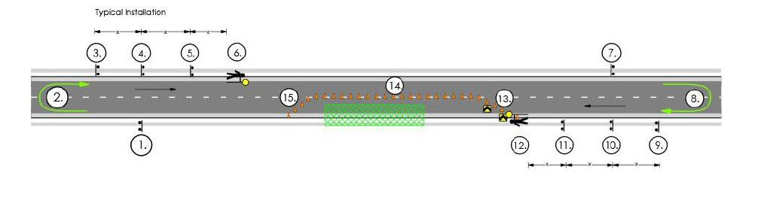Figure 2 - Typical Signage installation

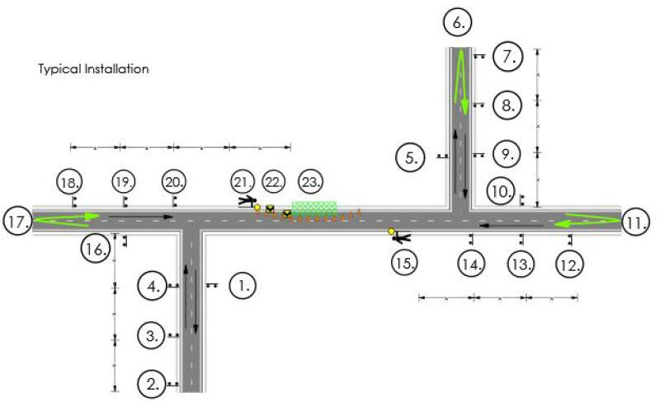

##### Traffic Control Devices

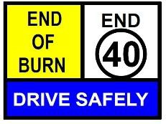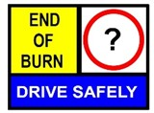

When using MMS, two 5 mm thick core flute panels are to be used back to back when possible in the multi-message frame to help prevent the sign from blowing out. Use reverse side messaging as described in the TGS or be blank.

The TGSs use a “?” speed sign as shown below. This sign represents the resetting of the original speed zone and is used to reduce the quantity of TGSs.

If the road is not speed zoned, then the End 40,

End 60 or End 80 signs shall be used.

SJTM 2179

Rev 1

47 | P a g e

##### Sign Requirements

All signs used shall conform to the designs and dimensions as shown in AS/NZS 1742.3, AGTTM and the CoP.

For low and very low classification roads (refer Table 3) (Section 3.5 Road Type Risk Weighting - Tracks and very low traffic volume rural roads) the use of single panel, multi-panel signs or reflective roll up signs can be used when a risk assessment is undertaken by the senior traffic management worker onsite. The use of multi-panel signage is preferred on higher order, high traffic volume roads.

Non-reflective roll up signs (canvass or plastic) can only be used as a temporary measure in daytime operations for advance fire units without space to accommodate Multi Message Signage and legs. Non- compliant signs are to be replaced with compliant signage as soon as practical.

Signage can be reduced to one side only in daylight conditions on Low or Very Low category roads (Section 3.5 Road Type Risk Weighting) or internal tracks, particularly when signs can be an obstruction to vehicles on narrow tracks.

Prior to installation, all signs and devices shall be checked by the Site Supervisor or a suitably qualified person to ensure that they are in good condition and meet the following requirements:

* + - * Mechanical condition - Items that are bent, broken or have surface damage shall not be used.
      * Cleanliness - Items should be free from accumulated dirt, road grime or other contamination.
      * Colour of fluorescent signs - Fluorescent signs whose colour has faded to a point where they have lost their daylight impact shall be replaced.
      * Retro reflectivity - Signs used for night-time or in low light conditions whose retro reflectivity is degraded either from long use or surface damage and does not meet the requirements of AS 1906 shall be replaced.
      * Battery operated devices - shall be checked for lamp operation and battery condition.

Where signs do not conform either to the requirements of AGTTM 03 2.5.3 Signs or would fail to pass any of the above checks, they shall be replaced on notice.

Signs and devices shall be positioned and erected in accordance with the locations and spacing’s shown on the drawings. All signs shall be positioned and erected such that:



* + - * They are properly displayed and securely mounted.
      * They are within the driver’s line of sight.
      * They cannot be obscured from view.
      * They do not obscure other devices from the driver’s line of sight.
      * They do not become a possible hazard to workers or vehicles; and
      * They do not deflect traffic into an undesirable path.

Signs and devices that are erected before they are required shall be covered by a suitable opaque material. The cover shall be removed immediately prior to the commencement of work.

Where there is a potential for conflict of information between existing signage and temporary signage erected for the purpose of traffic control, the existing signs shall be covered. The material covering the sign shall ensure that the sign cannot be seen under all conditions i.e., day, night, and wet weather.

Care will be taken to ensure existing signs are not damaged by the covering material or by adhesive tape.

##### Tolerances on positioning of signs and devices

Where a specific distance for the longitudinal positioning of signs or devices with respect to other items or features is stated, for the spacing of delineating devices or for the length of tapers or markings, the following tolerances may be applied:

1. Positioning of signs, length of tapers or markings:
   1. Minimum, 10% less than the distances or lengths given.
   2. Maximum, 25% more than the distances or lengths given.
2. Spacing of delineating devices:
   1. Maximum, 10% more than the spacing shown.
   2. No minimum.

These tolerances shall not apply where a distance, length or spacing is already stated as a maximum, a minimum or a range.

##### Flashing Arrow Signs

There are no schemes contained within this Generic TMP requiring the use of Flashing Arrow Signs.

##### Variable Message Signs

The use of Variable Message Signs (VMS) as part of this plan is encouraged due to the effectiveness as an information source for road users. Users of the plan are advised that VMS may only be used to provide extra information to the road user. Messages shown on VMS shall be additional to, and not substituted for, any sign, warning or delineating device. The nature and positioning of VMS should complement the signs and devices as outlined in AS 1742.3.

VMS should, as far as is practicable, reflect the existing environmental or operational conditions. Monitoring regimes and regular amendment may be required to achieve this outcome. The following link is from Main Roads WA information on VMS.

[guidelines-for-variable-message-signs.pdf (mainroads.wa.gov.au)](https://www.mainroads.wa.gov.au/globalassets/technical-commercial/technical-library/road-and-traffic-engineering/smart-freeways/guidelines-for-variable-message-signs.pdf?_t_id=c2_k1wTfZoVZGGXSnQI4Sw%3d%3d&_t_uuid=YiZbQ5tqQjmH7n%2f2f0k95Q&_t_q=Variable%2Bmessage%2Bsign&_t_tags=language%3aen%2candquerymatch&_t_hit.id=MainRoads_CMS_Core_Media_PDFDocument/_0bc61e79-1d2b-4747-8e05-bc6913f4d05f&_t_hit.pos=1)

SJTM 2179 Rev 1 48 | P a g e

Messages can be altered on the VMS to suit the conditions and road environment and recorded in the daily diary. Words on the screen shall not comprise more than four words or numbers on any one screen and two screens should be the maximum used.



Traffic Controllers may assist work vehicles enter and exit the work area.

All entry and exit movements will be in accordance with the Road Traffic Code and shall be undertaken in the following manner:

Vehicles shall:

* Decelerate slowly and signal their intention by indicator to leave the traffic stream.
* Activate the vehicle’s rotating yellow lamp, where fitted, once a speed of 20 km/h. has been reached and at least 50 m prior to the exit location.
* Switch on the vehicle hazard lights once the vehicle is stationary.
* Where risks associated with unassisted exit or entry to or from the traffic stream are high, Traffic Controllers should be used to assist entry and exit movements.

SJTM 2179

Rev 1

49 | P a g e

Typical messages include:

* Burning Off Ahead / Next ? kms,
* Smoke Hazard / Turn Headlights On,
* Drive Carefully / Reduce Speed,
* Burning Off Planned / X Date,
* Burning Off / Road Closed Ahead,
* Burning Off Ahead / Mobile Plant Ahead,
* Burning Off / Prepare to Stop etc.

##### Delineation

For most worksites delineation is not used due to the fast-moving worksite as setting up, moving and packing away an extensive number of cones results in delay in productivity and increased risk to workers who are otherwise generally working away from the road edge.

Traffic cones will be erected in accordance with the TGSs in Appendix F. Generally, traffic cones will be the device that is used for delineation.

Traffic cones shall be at least 700 mm high and shall be fitted with suitable white retro-reflective tape placed in accordance with AS 1742.3. The traffic cones shall be constructed from fluorescent orange or red material that is resilient to impact and will not damage vehicles when hit at low speed.

The base of the cones shall be designed to be stable under reasonably expected wind conditions and air turbulence from passing traffic

Traffic cones will be inspected at intervals necessary to ensure any miss-alignment or displacement is identified and corrected prior to this causing disruption to traffic.

##### Site Access for Work Vehicles

Traffic management and work vehicles entering and exiting the traffic stream shall be mindful of the conditions that may affect the safety of these movements.

Vehicles fitted with rotating amber lamps shall have the vehicle’s rotating lamp activated prior to entering the traffic stream and shall undertake the following.



SJTM 2179

Rev 1

50 | P a g e

* Switch off the vehicle hazard lights.
* Indicate intention to enter the traffic stream using direction indicators.
* Ensure there is a suitable gap from oncoming traffic to allow for a safe entry manoeuvre; and,
* Turn off the rotating yellow lamp(s) once a speed of 40 km/h is reached.

Entry and exit manoeuvres shall be avoided in close proximity to intersections. Work personnel shall not cross traffic streams on foot unless absolutely necessary.

Vehicles shall not obstruct paths and be parked an adequate distance from intersections or driveways to ensure clear sight lines remain for all road users.

##### Communicating TMP Requirements

The BWTM accredited person in charge of implementing the TMP shall communicate its requirements to the personnel on ground. An approved copy of this TMP shall be provided to the Operations Officer or delegate prior to implementation. A copy of the approved traffic management plan shall be on site.Onsite Two-Way Communications

There are many channels that have been established by law for two-way communication purposes including the Emergency channel 5 and the data transmission channels 22 and 23.

Certain channels are used as repeater stations and **shall not** be used for general conversation these are 1-8 and 31-38.

The supervisor / project manager can select an appropriate channel for communication purposes from channel 12 – 17, 39 & 40 inclusive.



* 1. **EMERGENCY ARRANGEMENTS AND CONTINGENCIES**

##### Traffic Incident Procedures

In the event of an incident or accident, whether or not involving workers, traffic or road users, all work shall cease, and traffic shall be stopped as necessary to avoid further deterioration of the situation.

First Aid shall be administered as necessary, and medical assistance shall be called for if required. For life threatening injuries an ambulance shall be called on telephone number 000. The Police shall also be called on 000 for traffic crashes where life threatening injuries are apparent.

Any traffic crash resulting in non-life-threatening injury shall immediately be reported to the WA Police Service on 131 444.

Broken down vehicles and vehicles involved in minor non-injury crashes shall be temporarily moved to the verge as soon as possible after details of the crash locations have been gathered and noted.

Where necessary to maintain traffic flow, vehicles shall be temporarily moved into the closed section of the work area behind the cones, providing there is no risk to vehicles and their occupants or workers.

Suitable recovery systems shall be used to facilitate prompt removal of broken down or crashed vehicles. Assistance shall be rendered to ensure the impact of the incident on the network is minimised.

Details of all incidents and accidents shall be reported to the Traffic Supervisor/Crew Leader and Project Manager immediately and subsequently using the incident report form at Appendix C (or similar).

Ensure that the following information is recorded:

* Location, Time, and Date of accident.
* Weather conditions.
* Condition of the travelled path (e.g., lane width and surface condition).
* Details of the accident, including any injuries and vehicle (s) involved.
* Details of emergency services called to the accident.
* Details of type, size and location of signs and devices in use at the time of the accident.
* Details of any traffic management devices damaged as a result of the accident; and
* Details of any witnesses to the accident.

Road plant within the work area that may impact on any services requiring access to a crash site will be cleared from the area quickly as necessary.

SJTM 2179 Rev 1 51 | P a g e

##### Serious Injury or Fatality



All site personnel shall be briefed on control procedures covering incidents and crashes that result in serious injury or fatalities.

**Where a fatal or serious injury occurs at a work site** all work shall cease immediately, machinery and vehicles turned off and the area cleared of personnel as soon as possible. Traffic Controllers (and other personnel if necessary) shall be deployed immediately to ensure no traffic or other road users approach the area.

An Ambulance and Police shall be called on telephone number 000 where life threatening injuries are apparent.

All workers and traffic management personnel shall preserve the scene leaving everything in situ, until direction is given by Police or WorkSafe.

|  |  |
| --- | --- |
| DEPT / AGENCY | PHONE |
| Police | 000 |
| WorkSafe WA | 1800 678 198 |

Guidance for Emergency and Unplanned Works is provided in AGTTM 10: Section 5 Emergency Works.

These procedures can be applied in the event of a fatality or serious injury occurring at a worksite. However, preserving evidence takes precedent over traffic access. Therefore, additional lane closures or complete road closure may need to be applied in order to achieve this.

Should this be required, any necessary detours will in the first instance be the responsibility of the WA Police to implement and manage. The Burn Controller will notify Main Roads network via relevant authorities who will coordinate the impact on the road network on their arrival on site.

All staff are required to remain onsite until released by the Burn Controller when all investigations are complete.

A site-specific detour route and/or road closure point will be determined, signed, and controlled by traffic management personnel and advised to Police, who will take charge of the site upon arrival. Detour routes will be determined so as to cater for all types of vehicles required to use them. An example of how to manage an emergency can be found in Section 5 of AGTTM Part 10.

##### Minor Incident or Vehicle Break Down within Site

Broken down vehicles and vehicles involved in minor non-injury crashes shall be temporarily moved to the verge as soon as possible after details of the crash locations have been gathered and noted.

Where necessary to maintain traffic flow, vehicles shall be temporarily moved into the closed section of the work area behind the cones, providing there is no risk to vehicles and their occupants or workers. Suitable recovery systems shall be used to facilitate prompt removal of broken down or crashed vehicles. Assistance shall be rendered to ensure the impact of the incident on the network is minimised.

##### Reporting Traffic Incidents

Any traffic crash shall immediately be reported to the WA Police Service on 131 444 and the Burn Controller. An internal investigation is to be commenced involving the relevant departments Safety Investigation team. The Burn Controller will immediately notify the relevant managerial positions for their agency.

SJTM 2179 Rev 1 52 | P a g e

No statements are to be made by operational personnel to the media. Media requests are to be directed to the relevant agency media communication section.



##### Emergency Services

Emergency vehicles shall be given priority through the worksite if possible. The workers close to the traffic lane will stand down till the emergency vehicle has passed and move any signs or delineation to allow the vehicle to pass safely.

On-site traffic controllers will be equipped with mobile communications to advise and/or liaise with emergency services to ensure a prompt response should the need arise.

##### Dangerous Goods

Should any incident arise involving vehicles transporting dangerous goods, all work shall cease immediately, machinery and vehicles turned off and the area cleared of personnel as soon as possible. Traffic Controllers (and other personnel if necessary) shall be deployed immediately to ensure no traffic or other road users approach the area.

All site personnel shall be briefed on evacuation and control procedures.

##### Damage to Services

In the event that gas services are damaged, all work shall cease immediately, machinery and vehicles turned off and the area cleared of personnel as soon as possible. Traffic Controllers (and other personnel if necessary) shall be deployed immediately to ensure no traffic or other road users approach the area.

The Police Service and relevant supply authority shall be called immediately.

Damage to any other services shall be treated in a similar manner except machinery may remain operational and access may be maintained where it is safe to do so.

All site personnel shall be briefed on evacuation and control procedures.

##### Failure of Services

##### Failure of Traffic Signals

In the event that traffic signal infrastructure near the worksite is damaged or fails to operate correctly, all work shall cease immediately, and Main Roads WA Road Network Operation Centre (RNOC) shall be notified immediately (phone 138 111).

##### Failure of Street Lighting

In the event that street lighting is damaged and fails to operate or operates incorrectly, Traffic Controllers (and other personnel if necessary, with appropriate temporary lighting) shall be deployed immediately if the lighting failure adversely affects road user safety to control traffic movements as required. Western Power shall be notified immediately.

##### Failure of Power

In the event that power infrastructure is damaged and poses a risk through live current, Traffic Controllers (and other personnel if necessary) shall be deployed immediately to secure the site and prevent entry to the area affected by live power. Western Power shall be notified immediately (phone 13 13 51).

SJTM 2179 Rev 1 53 | P a g e

##### Emergency Contacts



The nearest medical assistance will be discussed at the pre-start.

SJTM 2179

Rev 1

54 | P a g e

Before the commencement of works all works personnel are to be briefed during the prestart induction on the need to provide emergency services access if required and the evacuation procedures should an incident occur.

Prior to setup each day at the prestart meeting workers is to discuss what actions will be taken in the case of an emergency event and nominate an appropriate muster point.

Emergency services shall at all times have continual access to all properties and the Work site.

At all times when on site workers and subcontractors will take the necessary actions that are practicable to assist emergency vehicles and/or service vehicles entering and/or traveling through to worksite.

The Project Manager shall notify all emergency services of the works before commencement. A Notification of Roadworks Form can be found in Appendix A.

##### Emergency Services Contacts General

|  |  |  |
| --- | --- | --- |
| **EMERGENCY SERVICE** | **PHONE NUMBER** | **TYPE OF EMERGENCY** |
| Fire | 000 | All fires and hazardous spillages etc. |
| Ambulance | 000 | Injury and motor vehicle accidents etc. |
| Police | 000 | Motor vehicle accidents, hazardous goods  spillage etc. |
| Alinta Gas | 131352 | All gas leakage, damage to pipes, no gas supply  etc. |
| Horizon Power | 132351 | No power, lines in trees, fallen/broken lines,  damage to lines, damage to Horizon Power property etc |
| Western Power | 131351 | No power, lines in trees, fallen/broken lines, damage to lines, damage to Western Power  property etc. |
| Water Corporation | 131375 | Blocked sewerage mains, no water, poor water  quality, damage to pipes etc. |



* Confirm TMP and TGS are suitable for the day’s activities.
* Inspect all signs and devices to ensure they are undamaged, clean and comply with the requirements depicted on the TGS.
* All lamps should be checked and cleaned, as necessary.
* After any adjustments have been made to the signs and devices, conduct a drive through inspection to confirm effectiveness.

SJTM 2179

Rev 1

55 | P a g e

* 1. **MONITORING AND MEASUREMENT**

##### Daily Inspections

Prior to works commencing the Operations Officer or delegate shall communicate the Traffic Management Plan to all key stakeholders and affected parties.

On completion of setting out the traffic control measures; the site is to be monitored for a suitable period of time. If traffic speeds on the approaches to the work site are assessed as being above the temporary posted speed zone for the work site, the Site Supervisor is to initiate action to modify the approach signage and tapers in accordance with the requirements of AGTTM/CoP. All such actions are to be recorded in the Daily Diary. Should road users be observed to continue to travel in excess of the posted speed limit, the police may be requested to attend the site to enforce the temporary posted speed limit.

The Traffic Management Contractor shall ensure that all temporary signs, devices, and controls are maintained at all times. To achieve this, procedures in line with the requirements outlined in AGTTM Part 6 will be instituted. The monitoring program shall incorporate inspections:

* Before the start of work activities on site,
* During the hours of work,
* Closing down at the end of the shift period, and
* After hours.
* A daily record of the inspections shall be kept indicating:
* When traffic controls where erected,
* When changes to controls occurred and why the changes were undertaken,
* Any significant incidents or observations associated with the traffic controls and their impacts on road users or adjacent properties.

The Traffic Management Contractor shall ensure that personnel are assigned to monitor the traffic control scheme. Inspections shall at least satisfy the following requirements:

##### Before works start

##### During work hours



* + - * Designate and ensure that appropriate work personnel drive through the site periodically to inspect all signs and devices and ensure they are undamaged and comply with the requirements depicted on the Traffic Guidance Schemes.
      * Attend to minor problems as they occur.
      * Conduct on the spot maintenance/repairs as required.
      * When traffic controllers are on the job, ensure they remain in place at all times. Relieve controllers as necessary to ensure attentiveness is retained.
      * During breaks or changes in work activities remove or cover any signs that do not apply (e.g., PREPARE TO STOP, Workers symbolic).
      * Re-position signs and devices as required by work processes throughout the day and keep records of any changes.
      * As a guide, where operational or environmental conditions are continually changing, an onsite inspection and sight distance survey should be undertaken every two hours. Where operations and environmental conditions are relatively benign, onsite inspections and sight distance surveys should be undertaken every four hours during active operations.

##### Closing down each day

* + - * Conduct a pre-close down inspection, allowing time for any appropriate maintenance works.
      * Remove any unnecessary signage (e.g., Prepare to Stop, Symbolic Workers).
      * Replace any unnecessary signage with appropriate delineation.
      * Install barriers and lights where required.
      * Drive through site and confirm all signs and devices are operating correctly with no misleading visual cues.
      * Record details of inspection and any changes made to layout.

##### After hours or unattended worksite

* + - * Appoint personnel to conduct after dark checks if required. Replace any signs / devices not working, missing or damaged and record in diary.
      * Appoint personnel to conduct checks on non-workdays (e.g., weekends). Replace any signs / devices not working, missing or damaged and record in diary.
      * The frequency of inspections needs to align with the amount of traffic management on site, weather conditions, vehicle types and volumes, road user behaviour and site-specific risks.

Inspections and sight distance surveys on unmanned sites should be undertaken on a risk-managed basis considering the consequences of an incident and likelihood of it occurring, for example where there is a high likelihood of thick smoke settling into a high use road overnight, then it may be advisable to maintain onsite surveillance overnight.

SJTM 2179 Rev 1 56 | P a g e

##### TMP Audits and Inspections



* Date.
* Location.
* Burn identification.
* Time of inspections.
* Detail of any changes and who made them.
* Name of person authorising the changes.
* The rationale for decisions made and comments.
* The reference number of TGSs or procedure in use.
* Time up and time down of signs.
* Incidents and
* Where appointed, the Traffic Manager will complete the Sign Management Planning and Monitoring forms contained in the Burn Plan and ensure all records relating to traffic management are provided to the Burn Controller for uploading to the ePFP at the end of each shift.

**9.4**

**Public Feedback**

Public feedback comments on traffic management being provided by DBCA or on behalf of DFES will

be recorded and considered to assist with continuous improvement of future TMPs.

SJTM 2179

Rev 1

57 | P a g e

Audits are required periodically to ensure compliance with the TMP and associated standards and work practices and to ensure the maintenance of best practice and continual improvement. Fire Management Services Branch should ensure that a minimum of one audit is completed annually.

Formal audits are required to ensure compliance with the processes, site and risk assessments and the implementation of the approved Traffic Management Plan. It is essential that a competent traffic management practitioner undertakes formal audits.

Accordingly, any TMP audit required will be undertaken by an external person accredited in Advanced Worksite Traffic Management and a representative of DBCA or DFES Fire Management Services Branch.

An internal Suitability Review or Compliance Inspection can be conducted by a person with Advanced Worksite Traffic Management and may be requested by any of the following:

* DBCA Regional Leader Fire Management, or DFES Superintendent
* DBCA District Manager, or DFES Operations Manager/Director, Officer
* Regional Manager
* FMSB Representative

##### Records

A daily diary must be maintained to record all inspections including variations to the approved TMP.

The Operations Officer or delegate is to record all inspections. Upon completion of each day the Operations Officer or delegate will provide copies of the daily diary record to the Burn Controller.

The Burn Controller, Operations Officer or delegate is to record all variations made to the approved Traffic Management Plan on a daily basis and describe clearly the nature of the variations and the reason for the variations.

As a minimum, the diary or worksheets should include the following:



SJTM 2179

Rev 1

58 | P a g e

* 1. **MANAGEMENT REVIEW AND APPROVALS**

##### TMP Review and Improvement

This TMP is an operational document and users are expected to monitor the plan and provide constructive feedback in the interests of continual improvement and maintaining compliance with industry standards.

Critical errors or traffic management issues not covered adequately by the plan are to be forwarded to the Fire Management Services Branch as soon as possible. This notification should include an email to:

[fms-440-admin@dbca.wa.gov.au.](mailto:fms-440-admin@dbca.wa.gov.au)

A formal review of the plan is to be undertaken by the Department’s Fire Management Services Branch annually (preferably by June 30 each year).

Annual review to cover:

* + - Feedback from Regional Fire Leaders
    - Analysis of audit findings
    - Analysis of incident(s) (if any) and
    - Industry-based improvements to Burn Plan traffic management.

##### Variations

Refer to Appendix B

##### Approvals

Before works commence it is necessary to seek approval from the following:

* + - Main Roads WA (where signage is required on a Main Roads road).
    - Local Government Authority (where signage is required on a Local Government road).
    - Public Transport Authority (where impacting bus routes, level crossing)

# APPENDIX A



SJTM 2179

Rev 1

59 | P a g e

# NOTIFICATION OF ROADWORKS

*(Completed through the burn planning process and day of burn notification process.)*

# APPENDIX B



SJTM 2179

Rev 1

60 | P a g e

# VARIATION TO STANDARDS





SJTM 2179

Rev 1

61 | P a g e

**APPLICATION FOR APPROVAL TO VARY REQUIREMENTS OF**

**AS 1742.3, AGTTM OR MRWA TRAFFIC MANAGEMENT CODES OF PRACTICE**

|  |  |  |  |  |  |  |  |
| --- | --- | --- | --- | --- | --- | --- | --- |
| A | Applicant (Principal for the Works) | | Department of Biodiversity, Conservations and Attractions. | | | | |
| Postal address | Locked Bag 104 | | | | | |
| Suburb | BENTLEY DELIVERY CENTRE | | State | WA | Postcode | 6983 |
| Project Manager | Andrew Milne | | | | Telephone | (08) 92199273 |
| Email | [andrew.milne@dbca.wa.gov.au](mailto:andrew.milne@dbca.wa.gov.au) | | | |  | |

|  |  |  |  |  |  |  |  |  |  |  |  |  |
| --- | --- | --- | --- | --- | --- | --- | --- | --- | --- | --- | --- | --- |
| B | Anticipated start date | | July 2022 | | | | | Anticipated finish date | | June 2023 | | |
| Daily work hours; From | | Various | | To | Various | | Weekend work applicable | | Yes  Sat Sun | | No |
| Location of works (Road/Street Suburb), | | | State Wide - various roads | | | | | | | | |
| Road type (eg undivided, two lane) | | | Various - gravel to dual carriageway roads | | | | | | | | |
| Description of works | Burning of vegetation | | | | | | | | | | |
| Are alterations to permanent traffic signals required? | | | | | | Yes | | No |  | N/A |  |
| Posted Speed Limit | Various | | Worksite speed limit | | | | 80/60/40 | After hours speed limit | | Various | |

|  |  |  |  |  |  |  |  |  |  |  |  |
| --- | --- | --- | --- | --- | --- | --- | --- | --- | --- | --- | --- |
| C | TMP Designer | | | Angela Anders | | | | | | | |
| Accreditation Number | | | KTS-AWTM-20-38305-05 | | | | | | | |
| Postal address | | 13 Palmer Crescent | | | | | | | | |
| Suburb | | Davenport | | | State | WA | | Postcode | 6280 | |
| Email | [Angela.anders@sjtraffic.com](mailto:Angela.anders@sjtraffic.com) | | | | Telephone | | (08) 9731-5299 | | Facsimile |  |
| **Endorsement signature** | | | |  | | | | Date | 27/06/22 | |

|  |  |  |  |  |  |  |  |  |  |  |  |
| --- | --- | --- | --- | --- | --- | --- | --- | --- | --- | --- | --- |
| D | RTM Endorsing Variation1 | | | Brad Brooksby | | | | | | | |
| Accreditation Number | | | RTM 032 | | | | | | | |
| Postal address | | PO Box 102 | | | | | | | | |
| Suburb | | GELORUP | | | State | WA | | Postcode | 6230 | |
| Email | [Brad.Brooksby@bigpond.com](mailto:Brad.Brooksby@bigpond.com) | | | | Telephone | | 0435 164 175 | | Facsimile |  |
| **Endorsement signature** | | | |  | | | | Date | 06/09/22 | |

|  |  |  |  |  |  |  |  |  |  |  |
| --- | --- | --- | --- | --- | --- | --- | --- | --- | --- | --- |
| **For Internal Use Only** | | | | | | | | | | |
| Approving Road Authority | |  | | | | | | | | |
| Approving Officer Position | |  | | | | | | | | |
| Application Approved | Yes No | | If Not Why Not | | |  | | | | |
| Additional Conditions |  | | | | | | | | | |
| Approved By: |  | | | Title |  | | Date |  | File |  |



|  |  |  |  |  |  |  |  |
| --- | --- | --- | --- | --- | --- | --- | --- |
| **APPLICATION FOR APPROVAL TO VARY REQUIREMENTS OF**  **AS 1742.3, AGTTM OR MRWA TRAFFIC MANAGEMENT CODES OF PRACTICE** | | | | | | | |
| E | **Description of Variation Requested** | **Specify Point of Departure from Standard / Code of Practice**  (List section and page number) | **Justification**  (Why is this necessary) | **Additional Counter Measures To Be Taken**  (Identify additional counter measures to be used to negate the lesser treatment) | **Residual Risk\*** | | |
| L | C | RR |
| Site inspection has not been undertaken by the TMP designer. | | Main Roads TMP template - cover page. | This TMP covers the entire State of Western Australia, it is impactable that all roads can be inspected by the designer.  Code section 4.2.2 states For Generic TMPs a site visit by the AWTM that prepared the TMP is not  required. | The site will be inspected by the burn controller or someone under their direction and use of checklists and discussion with the road authority will be used to highlight site specific risks. The TMP is to be confirmed to  be site suitable. | Unlikely | Insignificant | Low |
| Burn controller or operations officer with BWTM to alter TGS to improve effectiveness and or messaging to road users. | | Code page 55 Section 8.1 Tasks Requiring MRWA Accreditation. | The Code only allows a BWTM to make minor alterations to sign spacing etc. Due to this plan being generic but also in a changing environment (prescribed burns) there is a need to be able to respond to site conditions to manage risk. | The intent of the Code is for higher risks to be approved by higher accreditations – Both Burn Controllers and Operations Officers have received significant training in risk assessment and also have been working with prescribed burn TMP’s for significant periods of time. They can swap signs, add signs, change distances, improve plans so long as they don’t increase the risk to road users or the workers.  This is a very “simple” generic plan, there are no complicated manoeuvre’s that the public  have to negotiate. | Possible | Moderate | Med |
| Vehicle mounted warning device, red and blue lamps are substituted for yellow lamps. | | Standard - Page 63 Section  4.14.1. Vehicle-mounted warning device. | The Standard specifies rotating flashing yellow lamps. | Red and blue lamps are substituted for yellow lamps where they are approved for use. | Unlikely | Insignificant | Low |

SJTM 2179 Rev 1 62 | P a g e



|  |  |  |  |  |  |  |  |
| --- | --- | --- | --- | --- | --- | --- | --- |
| E | **Description of Variation Requested** | **Specify Point of Departure from Standard / Code of Practice**  (List section and page number) | **Justification**  (Why is this necessary) | **Additional Counter Measures To Be Taken**  (Identify additional counter measures to be used to negate the lesser treatment) | **Residual Risk\*** | | |
| L | C | RR |
| The Risk Assessment table used in this plan does not conform to Main Roads risk assessment table. | | Code page 25 section 4.3 Risk Management. | DBCA & DFES use their risk assessment table which conforms to normal risk assessment processes. It is vital that they do not mix up risk assessment tables. For consistency throughout their processes, the risk table will  match the DBCA & DFES risk assessment process. | The risk table conforms to AS ISO 31,000. | Unlikely | Insignifica nt | Low |
| Containment fence/cones omitted, recommended by the AS. | | Standard page 57 section Traffic Cones and Temporary Bollards, 61 section 4.12.1  Containment Fences. | The efficiency of resources when time factors to achieve the burn are critical and road use is low. | Where a worker is closer than  3.0 m to a traffic lane a lookout person shall be used. | Possible | Moderate | Med |
| Queue Distance from Traffic Controller. | | Code page 46 section Avoiding End of Queue Collisions. | Rear end crashes are the highest crash factor for the SW & GS for the past 5 years. The use of 2 Prepare to Stop signs is recommended for high speed and or high-volume roads. | From experience and queue calculations it has been found that 200 m covers almost all highway situations. Traffic management implementers are to be instructed to monitor queue lengths and increase  PTS sign spacing and number where required. | Unlikely | Insignifica nt | Low |
| Non-standard signs. | | Code page 33 section 6.2 Guidelines for Use - Appendix 5 | “Follow Me” “End of Burn” signage, site-specific sign. | Provides a clearer message to the road user. | Unlikely | Insignifica nt | Low |
| Non-standard signs. | | Standard page 10 4.2.2 Multi- Message Signs | Use of Blank White panel | The Standard allows use of Blank Yellow panel, similar treatment. Low light conditions  unlikely to reduce road users perception of the message. | Unlikely | Insignifica nt | Low |

SJTM 2179 Rev 1 63 | P a g e



|  |  |  |  |  |  |  |  |
| --- | --- | --- | --- | --- | --- | --- | --- |
| **APPLICATION FOR APPROVAL TO VARY REQUIREMENTS OF**  **AS 1742.3, AGTTM OR MRWA TRAFFIC MANAGEMENT CODES OF PRACTICE** | | | | | | | |
| E | **Description of Variation Requested** | **Specify Point of Departure from Standard / Code of Practice**  (List section and page number) | **Justification**  (Why is this necessary) | **Additional Counter Measures To Be Taken**  (Identify additional counter measures to be used to negate the lesser treatment) | **Residual Risk\*** | | |
| L | C | RR |
| Use of more than two panels with words. | | Standard page 10 4.2.2 Multi- Message Signs. | Site-specific common-sense signage. | A blank yellow panel could be used, however this requires another sign to be installed to convey the  message to the road user. | Unlikely | Insignificant | Low |
| Use of plastic tape for track and path closures. | | Code APPENDIX 5 - Multi- Message Sign Inventory and Application Schedule. | Plastic tape for ease of use, commonly used in industry. | A common-sense approach for placement of signage and clear message to track or path user | Unlikely | Insignificant | Low |
| Worksite length - Temporary 60 km/h sites can be very long. | | AGTTM 03 page 70 Table 5.5: Length of temporary speed zone. | Worksite length - 60 Km/h sites can be up to 20 Km when < 500 vpd. Discussed and endorsed by Road Authority in planning stage. Longer sites and or higher traffic volume sites to be specifically raised with the Asset Owner for endorsement in the preplanning process. This approach to Asset Owner and determination of further risk mitigation would be  done by DBCA & DFES personnel. | Flames and / or smoke will be present over entire section, red and blue lights will be activated on fire vehicles typically spaced 1 km apart (increased compliance due to slomo), repeaters every 500 m will ensure good awareness of the temporary speed limit. | Possible | Moderate | Med |
| Worksite length - Temporary 40 km/h sites can be very long. | | AGTTM 03 page 70 Table 5.5: Length of temporary speed zone. | Worksite length - 40 Km/h sites can be up to 5 Km when < 150 vpd. Discussed and endorsed by Road Authority in planning stage. Longer sites and or higher traffic volume sites to be specifically raised with the Asset Owner for endorsement in the preplanning process. This approach to Asset Owner and determination of further risk mitigation would be done by DBCA & DFES  personnel. | Flames and / or smoke will be present over entire section, red and blue lights will be activated on fire vehicles typically spaced 1 km apart (increased compliance due to slomo), repeaters every 500 m will ensure good awareness of the temporary speed limit. | Possible | Moderate | Med |

SJTM 2179 Rev 1 64 | P a g e



|  |  |  |  |  |  |  |  |
| --- | --- | --- | --- | --- | --- | --- | --- |
| **APPLICATION FOR APPROVAL TO VARY REQUIREMENTS OF**  **AS 1742.3, AGTTM OR MRWA TRAFFIC MANAGEMENT CODES OF PRACTICE** | | | | | | | |
| E | **Description of Variation Requested** | **Specify Point of Departure from Standard / Code of Practice**  (List section and page number) | **Justification**  (Why is this necessary) | **Additional Counter Measures To Be Taken**  (Identify additional counter measures to be used to negate the lesser treatment) | **Residual Risk\*** | | |
| L | C | RR |
| Use of signs with no symbolic panels. | | Standard page 10 4.2.2 Multi- Message Signs. | Lack of signage availability and lack of signage storage on fire crew vehicles. | Combine signs to show active fire or smoke ie Headlights On / Smoke Hazard, signs provide a clearer  communication to the road users | Unlikely | Insignificant | Low |
| Use of nonstandard fold up (plastic) or swing signs | | Code page 33 section 6.1 Temporary Signage | Lack of signage availability and lack of signage storage on fire crew vehicles. Sign trailer adds  risk to vehicles turning around to escape on very narrow tracks. | To be used in low traffic volume (less 50 vpd) tracks which are generally only one vehicle width  wide. To be used in daylight conditions only. | Unlikely | Insignificant | Low |
| Showing required signs and devices on TGS | | MRWA plan preparation requirements. | Generic plan so number of signs and devices will vary depending  on worksite length and number of side roads. | To be determined during planning process. | Unlikely | Insignificant | Low |
| Use of ? for speed zone reset in TGS | | Code page 33 section 6.1 Temporary Signage | Generic plan so reset value will depend on actual posted speed. | To be determined during planning process | Unlikely | Insignificant | Low |
| Use of D for sign spacing not consistent. When combining speeds to reduce TGS numbers, the higher value of D is used. | | Code page 35 section 6.1.9 Sign Spacing. | Reduction of TGS to make the section of schemes easier. | Distance is slightly longer – has no effect on road user or workers | Unlikely | Insignificant | Low |
| Working longer than 14-hour shifts - Fatigue Management. | | AGTTM 02 – page 15 Table  3.2: Common issues and associated risks. | Critical timelines for ignition and parcels to be burnt are large to maximise efficiencies. | Work within DBCA fatigue guidelines. | Possible | Moderate | Med |
| Use of Mobile Works rather than Frequently Changing and Mobile Works. | | The varying nature of bush burning results in different speeds of travel for plant and  workers. | Use of Mobile works gives consistency to workers. | Works, signs and plant set for Mobile Works. | Unlikely | Insignificant | Low |

SJTM 2179 Rev 1 65 | P a g e

# APPENDIX C



SJTM 2179

Rev 1

66 | P a g e

# RECORD FORMS

|  |  |  |  |  |  |
| --- | --- | --- | --- | --- | --- |
| **Example Onsite TGS selection Aide Memoire FORM 1** | | | | | |
| **Road Name:** | | | **TGS No:** | | |
| **Type of Work to be Undertaken:** | | | | | |
| **Date:** | | **Time:** | | **Completed By:** | |
| **Step** | **Action** | **Applicable?** | | **Referred to AWTM** | |
| **Yes** | **No** | **Yes** | **No** |
| A | Select an appropriate generic TGS from an  authorized TMP. |  |  |  |  |
| B | Change the spacing of signs, delineating devices or the length of tapers that fall within the tolerances specified on TGSs. |  |  |  |  |
| C | Change the advance and departure speed signs on a generic TGS. |  |  |  |  |
| D | Change generic TGS in response to an incident or an unplanned event. |  |  |  |  |
| E | Use Lookout Persons, work outside of peak traffic times, pre-warn residents of restrictions  etc. |  |  |  |  |
| **Step** | **Action** | **Applicable?** | | **Referred to AWTM** | |
| **Yes** | **No** | **Yes** | **No** |
| 1 | Are there side roads, driveways or intersections  within the worksite? |  |  |  |  |
| 2 | Are there rest areas, camping grounds walk trails etc. in the vicinity of the worksite? |  |  |  |  |
| 3 | Will work be performed during peak traffic volumes? |  |  |  |  |
| 4 | Are trucks hauling along the route? |  |  |  |  |
| 5 | Could prevailing weather conditions (rain, wind, fog etc.) have an impact? |  |  |  |  |
| 6 | Are traffic approach speeds an issue? |  |  |  |  |
| 7 | Is the clearance between the traffic stream and workers an issue? |  |  |  |  |
| If a question is not controlled by a generic TGS, then a generic TGS must be either modified, or a new TGS developed. | | | | | |
| Option 1 | Adjust TGS within tolerance (BWTM) | Generic TGS No:  New TGS No: | | | |
| Option 2 | Adjust TGS outside tolerance (WTM) |
| Option 3 | Modify TGS outside scope (AWTM) |
| Option 4 | Design Site Specific TGS (AWTM) |



SJTM 2179

Rev 1

67 | P a g e



A ‘Yes’ to any of these questions requires an AWTM to determine if a Site Specific plan is required.

SJTM 2179

Rev 1

68 | P a g e

|  |  |  |
| --- | --- | --- |
| **Issue - Site Specific Traffic Management Plan Aide Memoire** | YES | NO |
| 1. Is the Traffic Control (signs and devices) required to be implemented for more than 14 hours within a single shift and will that result in staff fatigue? If staff fatigue has been addressed in accordance with DBCA fatigue management guidelines (see section 6.2 Roles and Responsibilities), then the Generic Plan can be used. |  |  |
| 2. Are works on a Freeway affecting a trafficable lane? (does not include on or off ramps) |  |  |
| 3. Does the work area exceed the distance limits for speed reduction as set out in this plan (20 km for 60 km/hr with traffic volumes < 500 vpd & 5 km for 40 km/hr with traffic volumes <150 vpd). Note: Many burn plans require edging to continue through to a safe effective fire boundary.  When worksite lengths or traffic volumes are greater, the Road Authority is to endorse as part of the preplanning approval process.  Onsite changes (not pre-planned) require an AWTM person to undertake a risk assessment to determine if longer lengths or higher traffic volumes can be safely applied to determine if the workers or road user is placed at greater risk. |  |  |
| 4. Do the works involve closing a traffic lane, exceeding 1,000 vehicles per hour? |  |  |
| 5. Do the works involve closing a lane within 200 m of an intersection at a time when traffic counts exceed 500 vph per lane? |  |  |
| 6. Do works require detouring traffic on a major or multi-lane road? |  |  |
| 7. Are there any visibility issues that could affect sight distance or vision of the road user on approach to the work area that is not catered for in the generic TMP? |  |  |
| 8. Does the site contain side roads or driveways that are not catered for in the generic TMP that may impact the site? |  |  |
| 9. Will works interfere with the operation of permanent traffic signals? (e.g. switching to flashing amber?) |  |  |
| 10. Will the works result in the complete closure of turning lanes? |  |  |
| 11. Are the works likely to result in re-alignment of a road section or intersection impacting on a railway crossing? |  |  |
| 12. Will the works be within 300 m of a rail crossing and significantly affect traffic flow through the rail crossing? |  |  |
| 13. Will the works affect path users that cannot be catered for in the generic TMP? |  |  |

**Daily Diary**

**:SJ**

**lRAFFIC**

OLIENii:

DATE:

* •CU•I I

PHON!(';Oil 1731 ZIG

LOCATION: SLK

_ W,EATIHERCONDITIONS: _ DIARVSlilEET: OF

lll!blh:042UfUtD TGS No: _ DAI WORKSIJ NIGHiT WORfSIJ EMERGENCY RESPONSEQ

St.irt lime al D PQt T1111eArrive at Site_:

SiteSetup a er TGS: YesIJNoIJ rrr not comment )_

Attendance ai r;!re- tart Me 1i □Commencemento Srte Se p_·

Sites p and OJJeratiaia.""'· _

**DOCKET No:**

0000

PURClilASi **O"IJERNo:**

Time Sile Pul.d Down· limeA1tercaieSig11S&lttup._· TGSN,..,· nme •Site· r1111i1111J;1t Depot Tolal Hour ·

Overnight Gamp Yes□INo□ [ HAVE YOU READ EXCLUSION POLICY ON FRONT COVER YES O

Did anincident occurOf yes completeIncident Report Form): Yes □NoIJ PROTECTIVE UNIFORM IIEQUIP IENI BelNG WORN &INGOOD COND!mlON: Yes□N'o□





-

liRAFFIC**MANAGEMENT** SITE CHECKS

1

2

3

**4**

5

**6**

*1*

**8**

**9**

**10**

Time:

Are sign, upr,ight, clean, visib , level &. slable Are taperle1111t11s correct

Are speed limit **igns** correct and doubled up

Are igln){l:cinggrrect

Are coneI bollard alignments straight and spaced correctly Are devices ooera·ngcorrecdy

Have pede triansbeen cateredfor Are lanewidlhs adeQ,uate

Are vehicle ueue le119t11s acceptable

Is road urfaoo oonditionadeg,uate

|  |  |  |  |  |  |  |  |  |  |  |  |  |  |
| --- | --- | --- | --- | --- | --- | --- | --- | --- | --- | --- | --- | --- | --- |
| **No.**ol Tr&ffic**Management** Vehitie, Onsite: NootTralrc **l!lrutgement** PersonnelOnsile: | | | | | | | | | | | | | |
| Tiatlic**Management** Personnel **Names and** | | | **.Accreditations** | **Time** of Bred from Slop/Slow (Trallic n rs **SI** ave **a** 15 min l:mk wery 2 l'iou **ol** 0011$tal\l rafiln} | | | | | | | | | |
| Position | **Name** | Accreditation llelails | | *0* | Off | On | Off | On | Off | On |  | 0, |  |
| Cr i3der: |  |  | |  |  |  |  |  |  |  |  |  |  |
| Triffic Corntroll,r: |  |  | |  |  |  |  |  |  | I | |  |  |
| Traffic Corntroll,r: |  |  | |  |  |  |  |  |  |  |  |  |  |
| Triffic Corntroll,r: |  |  | |  |  |  |  |  |  |  |  |  |  |
| Traffic Corntroll,r: |  |  | |  |  |  |  |  |  |  |  |  |  |
| Triffic Corntroll,r: |  |  | |  |  |  |  |  |  |  | I |  |  |
| AdditionalComment1: | | | | | | | | | | | | | |
|  | | | | | | | | | | | | | |
|  | | | | | | | | | | | | | |
|  | | | | | | | | | | | | | |
| / *,aniirm lh/!1* !l,{t *d l II =tliini<d hijrijfn ar* ,, *and l;(}rr!K;l* **Name** {Traffic Mana t Crew Leader): **Signed:** | | | | | | | | | | | | | |

STARTOF S IFTm FOA WOAK: I

tholl nr..:lilf0"1flnil\!llil!ll!ffl11(11Urdeltreilfty .lll or11!l:i l lffl!llrr,:lcni g&aledl:II · l'tJ

All Traffic Controlltrs to Sign: 1. 2. ------- 3. -- 4. 5

tN{H)FSHIF1:ldecl11 lhatl 11-ere "1ejl!NliliJry,l!(a;i \in:iden ilne;.u missar f h!!l

AllTraffic Controlltrs toSign: 1. 2. J 4. 5

6.

SJTM 2179 Rev 1 69 | P a g e



**Incident Report Form**

**SECTION**

.fMPl.CJ rfE ro COMfLfff *SE.CU* ON *1* & 2 *AND SUBMIT WtrHI* 24 *HOURS*

lncii!l)e,nt niperl: Eml1lJlld d by

crdent CO.!Jl.Pl io.n

**INDDIEJIT TYPI:**

1:1

[]

[]

1:1

[]

[]

[]

D■t>e' ID'f inad,mt

lmlii21lly n:port 1:01

llllt i&1im initi,11!1r,r, .rted

*11D *

D21y.s s.ince- h11s-t·lbr, 11k

last:MI *day off.*

IHIINn: .s'inc last bn:llik *re brurk. ml!m* fir"r11t OI" .!!DPT *of .shift.*

[Per5'0n5,

ral /Duup21ti.m

Plaint / e,quipnn:nt in-vol'i'ed

IR erlle.d to P.elia:

t\f/lN) *:sa,nau*

ll',IJIWI l!lumbef".

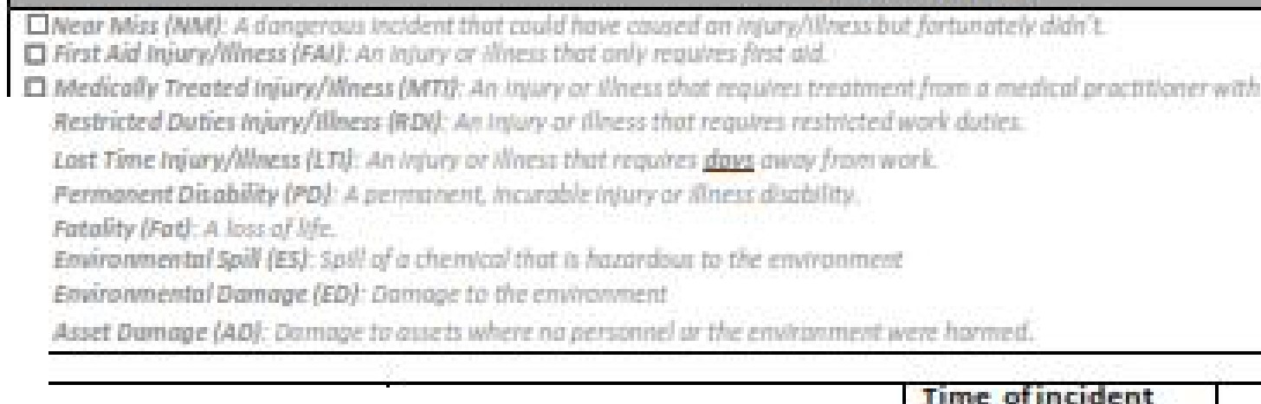

*'Whr,r* .de \'DUI think ·tl,is incidt:nt h211]pennn

'What ■c.tiiens;de ,rcu , oemrn5ld HJ•tbil, de :s not h11p:p,en **11.c:,11in]'**

SJTM 2179 Rev 1 70 | P a g e

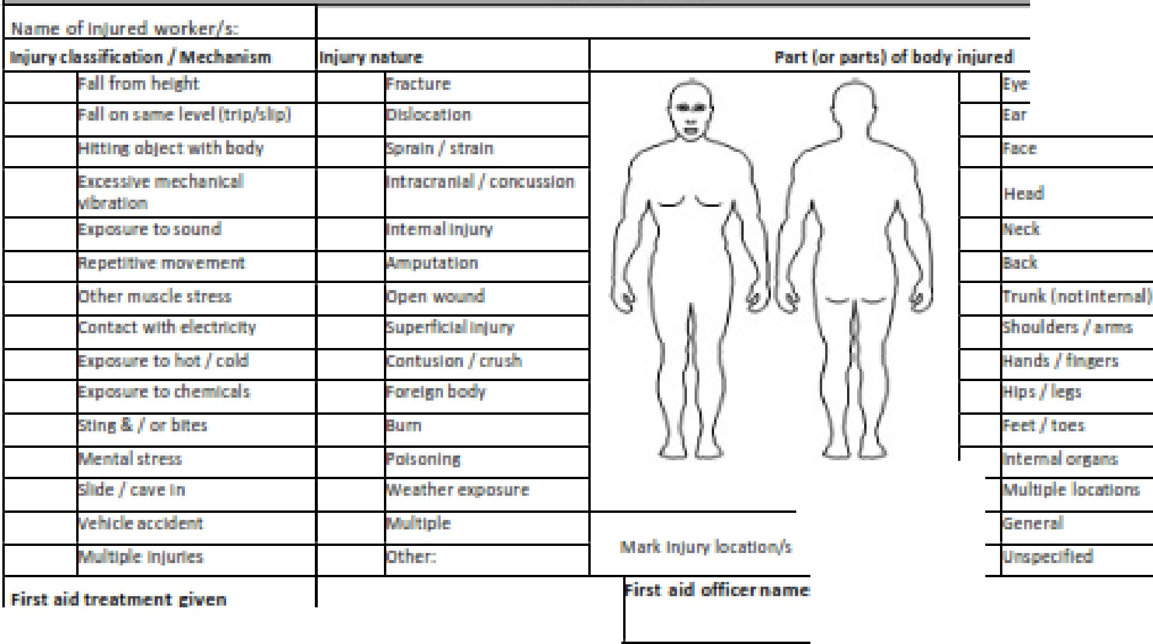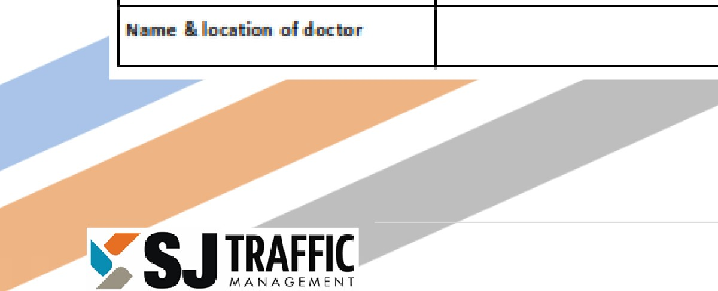

**INJURY DETAILS**

00 llllll'!lm

SJTM 2179

Rev 1

71 | P a g e

-t

I

Pl II.S omplete di;ac:1111m D [kpict in.c'idmt [as r q 'iml]_

**SECTION 2**

t

0

l

.

I oll"tlh

t

I



--..---,--1 --

--, -



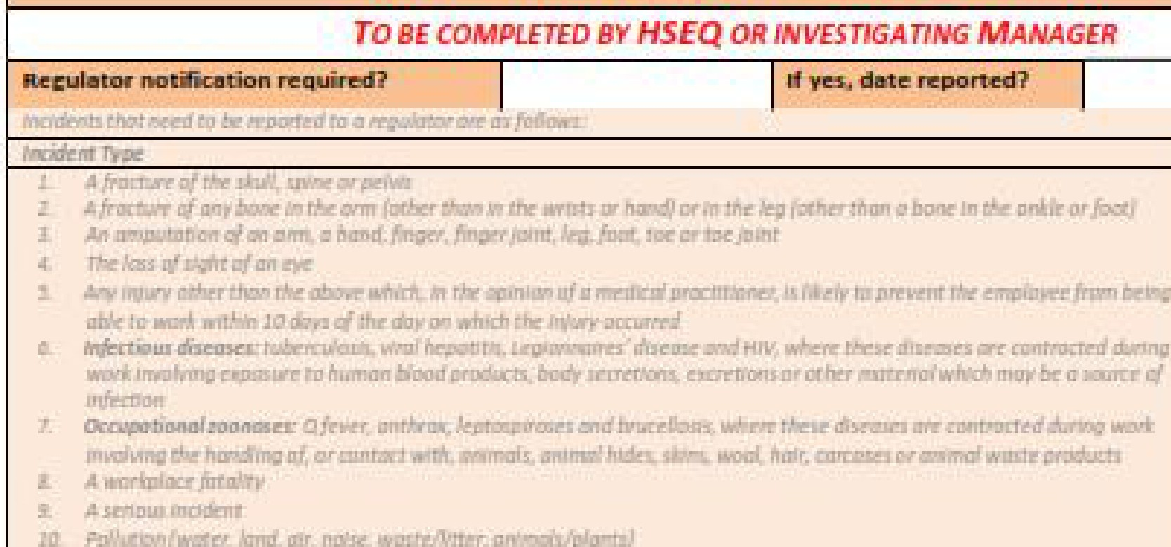

**SECTION 3**

**lnv-esti.11:il**111lon A.e,qu:lred1

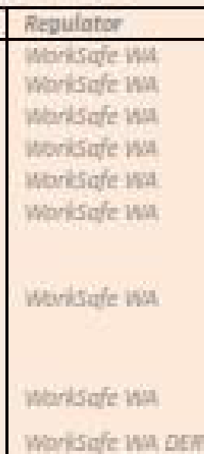lllck al 1:ir sufflclient

|  |  |  |
| --- | --- | --- |
|  | | |
| IZll'llC!ll  f.llCt[ll'!; |  |  |
|  |  |
| l!l'SD1111r.l  lfllctClf':S |  |
|  |  |

C!l□Billi CAUs.£ FACliO !5 TOBIE C:DN!SIDERElD

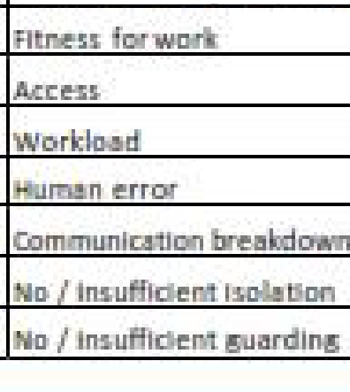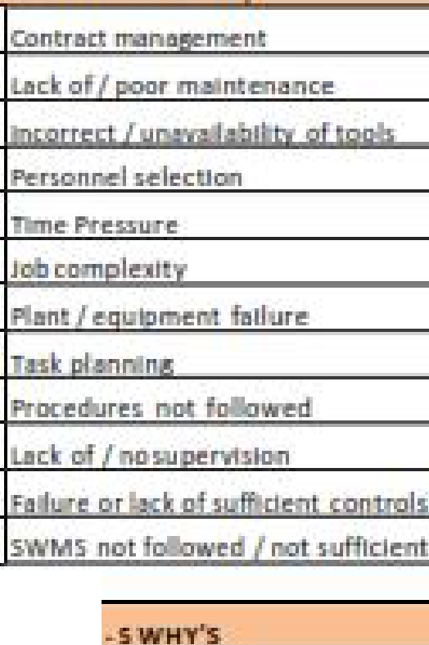

5Ue cDOOltlllffli lb11d 1Re11lh!!r

ROOT LJiUSE ANMJl'SIS CAU!SE OF FAIW

Why 1 .. Wh'l' did lh I! lm:ldoBJ!

P511

pt,if.;111 c■used II la h:.sJl'pell:;'

Why 3 -Wh'l' did I I! 11b::w1! h11 *1*

'Uh11t EIILSl!d 11 la Ml l!f'l7

Why-4 - Wh did t

Wb.111 c111al!d . ta h

Why - Why drd *t oll!* 11001,11!h111',!11!r.? Wh.11t 11!.r.d 'III IIP !!II?

SJTM 2179 Rev 1 72 | P a g e

|  |  |  |  |  |  |  |  |  |  |  |  |  |  |  |
| --- | --- | --- | --- | --- | --- | --- | --- | --- | --- | --- | --- | --- | --- | --- |
| SECT1I10N **4** | | | | | | | | | | | | | | |
|  | INCIDENTINVEs:llrl'i'ATtON RECORD | | | | | | | | | | | | | |
|  | ore-: | *MIT)'* | inrJ.urk | ti.ml!.linl! | *aJ l!lll?'ntl"., dl!t11m ol* di'Kurnons witfl pl!mms "1 | | | 111 In!! | m,ack-nt | **rl!llrt!I** | | klirddilMnal'flJ,ps *o,* | "11111 |  |
|  |  | | | | | | | | | | | | | |
| Dtll | | | | | |  | **Tm!!!** | | | |  | | | |
| !!•& Die | | | | | |  |  | | | |  | | | |

COR.llEClllliE ADilONS IMmTi!illllilLB11001CA=•

m DI.

*RV. l.* IISOf!I

,_

CD llt,MlllCl!!I

Du!,lll!T?,

,o:r.rru,_,ious

**IWIKl'nM!Nli** ![!(SIDI!,

. I

/

I

|  |  |  |  |  |  |  |
| --- | --- | --- | --- | --- | --- | --- |
| COJUIIJEDilliE **ACIIDN** CLD51E OUT | | | | | | |
| ls,the t11dio · t11h11 i:ft1 | |  | l'ES  Cbmpl!!tl! I!' !!ICiW&.  rl!tur ta H58QCoor natc;r. |  | NO  iida- ilI:! HSEQ ClJa- mr forasslst11n.c.e **111**  «llf=lna:root DIUlil!.. | |
| Rl!11sm1 /,mmm nts-: |  | | | | | |
| do!lil! Oll'I: cDffll]r4!!tl!/  lllCCo!!p'tedl | 1N11me: | |  | | I'(]silm.n,: |  |
| %Ii: | |  | | □llltl!: |  |

SJTM 2179 Rev 1 73 | P a g e

### FORM 2: ROAD SPECIFIC RISK ASSESSMENT - (DAY OF BURN)



###### This assessment is to be applied, where required, as part of the Daily Operational Risk Management process.

|  |  |  |  |  |  |  |  |
| --- | --- | --- | --- | --- | --- | --- | --- |
| ***HAZARD*** | **Pre-Treatment Risk Rating** | | | ***RISK RESPONSE*** | ***Residual Risk Rating*** | | |
| **C** | **L** | **Rating** | **C** | **L** | **Rating** |
| *E.g. Mornington Road – not enough signs to comply with TGS.* | *L* | *U* | *Low 24* | *Extend Speed Control Signs repeaters out to 1 Km on the north side of the road. Given the low hourly traffic volume and road width (note that the selected speed is 70 Km/h)* | *L* | *P* | *Medium 40 (tolerable)* |
|  |  |  |  |  |  |  |  |
|  |  |  |  |  |  |  |  |
|  |  |  |  |  |  |  |  |
|  |  |  |  |  |  |  |  |
|  |  |  |  |  |  |  |  |
|  |  |  |  |  |  |  |  |

SJTM 2179 Rev 1 74 | P a g e

### FORM 3: RISK ASSESSMENT AND TREATMENT SCHEDULE



This schedule is developed in the burn planning stage of the burn in consultation with an appropriate Road Authority representative see Section 7.2.

|  |  |  |  |  |  |  |  |  |  |  |  |  |  |  |  |  |
| --- | --- | --- | --- | --- | --- | --- | --- | --- | --- | --- | --- | --- | --- | --- | --- | --- |
| **District Proposed Burn Program Risk Assessment and Treatment Schedule** | | | | | | | |  |  |  |  |  |  |  |  |  |
| **DPaW Admin** | | **Location** | | | | | | **Risk Assessment** | | | | | | | | |
| **DPaW**  **Burn ID** | **DPaW Burn Name** | **Road Authority** | **Road Weighting** | **Rd No** | **Rd Name** | **Approx SLK Start** | **Approx SLK**  **Finish** | **Hazard** | | **Untreated Risk** | | | **Treatment Measures** | **Residual Risk after Treatment** | | |
| **Consequence** | **Likelihood** | **Risk Score** | **Consequence** | **Likelihood** | **Risk Score** |
|  |  |  |  |  |  |  |  | Risk Category | Road Network |  |  |  |  |  |  |  |
| Road User |  |  |  |  |  |  |  |
| DPaW Employee |  |  |  |  |  |  |  |
|  |  |  |  |  |  |  |  | Risk Category | Road Network |  |  |  |  |  |  |  |
| Road User |  |  |  |  |  |  |  |
| DPaW Employee |  |  |  |  |  |  |  |
|  |  |  |  |  |  |  |  | Risk Category | Road Network |  |  |  |  |  |  |  |
| Road User |  |  |  |  |  |  |  |
| DPaW Employee |  |  |  |  |  |  |  |
|  |  |  |  |  |  |  |  | Risk Category | Road Network |  |  |  |  |  |  |  |
| Road User |  |  |  |  |  |  |  |
| DPaW Employee |  |  |  |  |  |  |  |
|  |  |  |  |  |  |  |  | Risk Category | Road Network |  |  |  |  |  |  |  |
| Road User |  |  |  |  |  |  |  |
| DPaW Employee |  |  |  |  |  |  |  |
|  |  |  |  |  |  |  |  | Risk Category | Road Network |  |  |  |  |  |  |  |
| Road User |  |  |  |  |  |  |  |
| DPaW Employee |  |  |  |  |  |  |  |
|  |  |  |  |  |  |  |  | Risk Category | Road Network |  |  |  |  |  |  |  |
| Road User |  |  |  |  |  |  |  |
| DPaW Employee |  |  |  |  |  |  |  |
|  |  |  |  |  |  |  |  | Risk Category | Road Network |  |  |  |  |  |  |  |
| Road User |  |  |  |  |  |  |  |
| DPaW Employee |  |  |  |  |  |  |  |
|  |  |  |  |  |  |  |  |  |  |  |  |  |  |  |  |  |
| We confirm that all DPaW prescribed burns adjacent to or within 1km of MRWA/LGA managed roads and proposed for theXXX burning season are included in the above schedule, and these sites have been inspected and assessed with regard to traffic management and worksite safety. | | | | | |  | | | | | | | | | | |
| NAME | | **SIGNATURE** | | AGENCY | DATE |
|  | |  | | DPaW XX  Region |  |
|  | |  | | MRWA |  |
|  | |  | | LGA |  |
|  | |  | | LGA |  |

SJTM 2179 Rev 1 75 | P a g e

# APPENDIX D



SJTM 2179

Rev 1

76 | P a g e

# TRAFFIC ANALYSIS AND VOLUME COUNTS

This assessment is to be applied as part of the burn planning stage of the burn refer section 3.4.

# APPENDIX E



SJTM 2179

Rev 1

77 | P a g e

# EXAMPLES OF TRAFFIC MANAGEMENT DEVICES

###### SIGNS

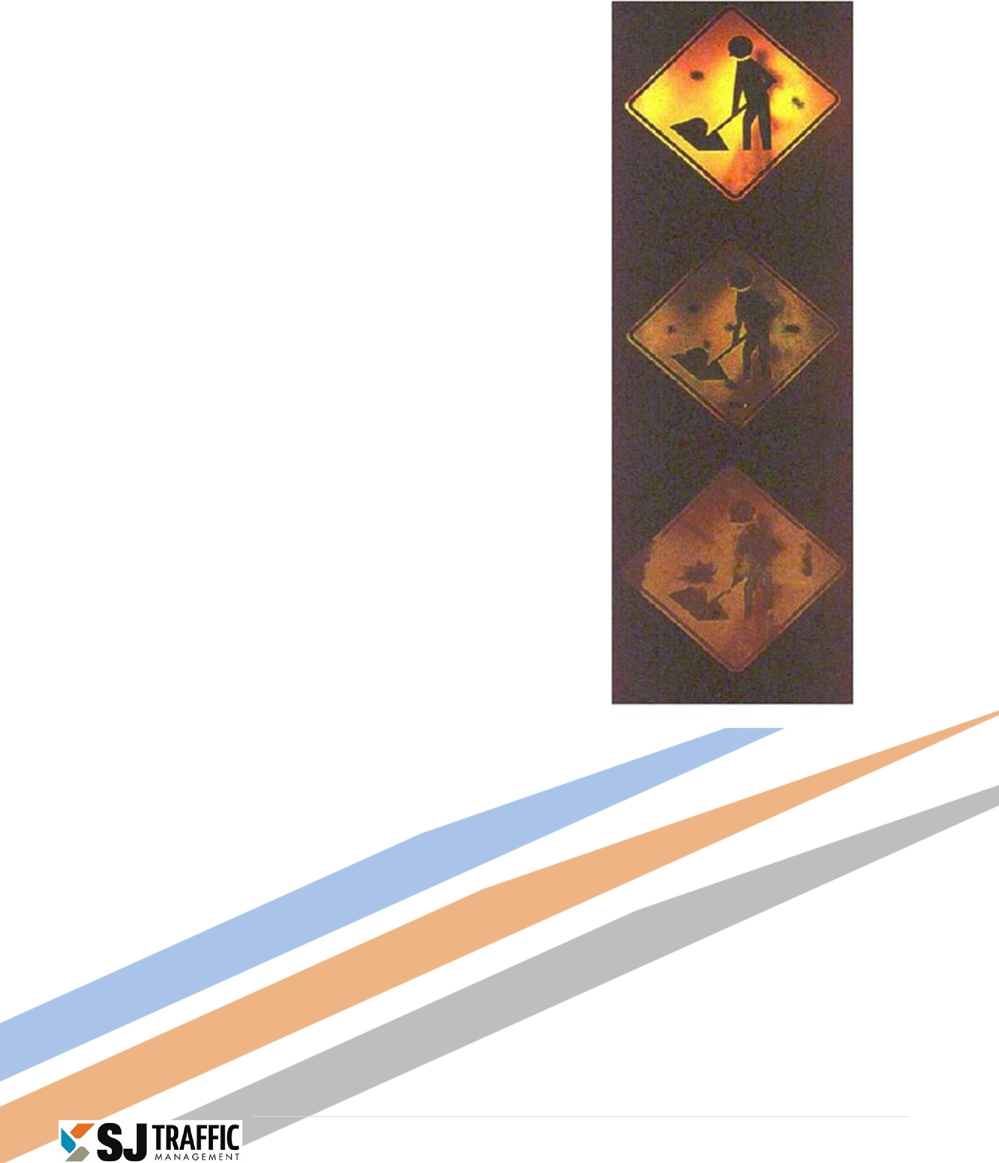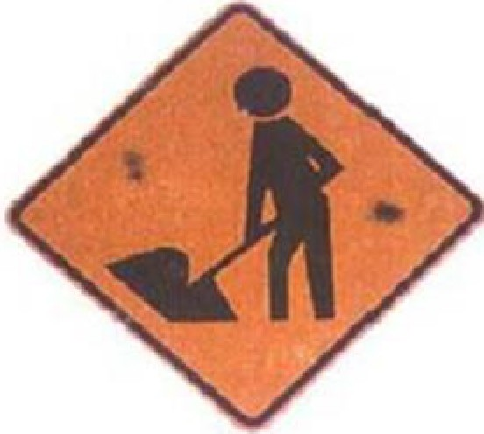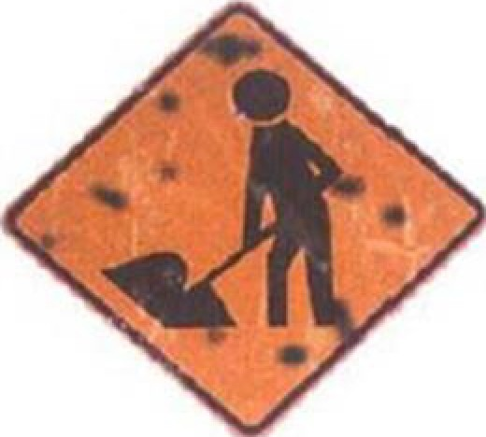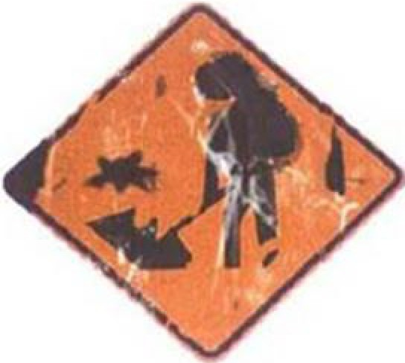

**Daytime Night-time**

Acceptable

arginal

Unacceptable

SJTM 2179 Rev 1 78 | P a g e

###### DEVICES

**Daytime light-tim,e**

#### Acceptable

Marginal

#### Unacceptable

SJTM 2179 Rev 1 79 | P a g e

##### PERSONAL PROTECTIVE CLOTHING

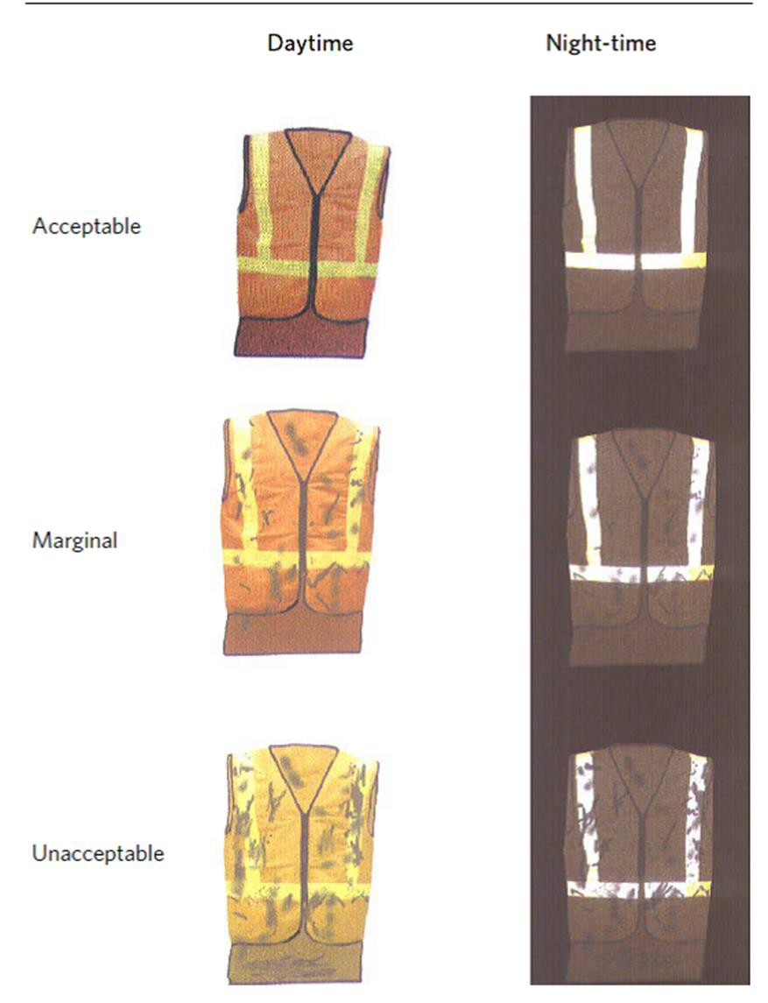

SJTM 2179 Rev 1 80 | P a g e

# APPENDIX F



SJTM 2179

Rev 1

81 | P a g e

# TRAFFIC GUIDANCE SCHEMES

##### Traffic Guidance Schemes



SJTM 2179

Rev 1

82 | P a g e

|  |  |
| --- | --- |
| **TGS No** | **Diagram** |
| DBCA - 22 - 01 | Burning Off - All posted speeds Working Greater than 6 m from Traffic |
| DBCA - 22 – 02a | Burning Off - 90 / 110 km/h posted speed Working 3 m - 6 m from Traffic |
| DBCA - 22 – 02b | Burning Off – Up to 80 km/h posted speed Working 3 m - 6 m from Traffic |
| DBCA - 22 - 03 | Burning Off - 90 / 110 km/h posted speed Working 1.2 m - 3.0 m from Traffic |
| DBCA - 22 - 04 | Burning Off - 90 / 110 km/h posted speed Working Within 1.2 m from Traffic |
| DBCA - 22 - 05 | Burning Off - 70 / 80 km/h posted speed Working 1.2 m - 3.0 m from Traffic |
| DBCA - 22 - 06 | Burning Off - 70 / 80 km/h posted speed Working Within 1.2 m from Traffic |
| DBCA - 22 - 07 | Burning Off - 50 / 60 km/h posted speed Working Within 1.2 m from Traffic |
| DBCA - 22 - 08 | Burning Off - 70 / 80 km/h posted speed Working 1.2 m - 3.0 m from Traffic with Traffic Controllers |
| DBCA - 22 - 09 | Burning Off - 90 / 110 km/h posted speed Working 1.2 m - 3.0 m from Traffic with Traffic Controllers |
| DBCA - 22 - 10 | Burning Off - 90 / 110 km/h posted speed Working Within 1.2 m from Traffic with Traffic Controllers |
| DBCA - 22 - 11 | Burning Off - Derestricted Working 1.2 m - 3.0 m from Traffic with Traffic Controllers |
| DBCA - 22 - 12 | Burning Off - 70 / 80 km/h posted speed Working Within 1.2 m from Traffic with Traffic Controllers |
| DBCA - 22 - 13 | Burning Off - 50 / 60 km/h posted speed Working Within 1.2 m from Traffic with Traffic Controllers |
| DBCA - 22 - 14 | Burning Off - 90 / 110 km/h posted speed Working 1.2 m - 3.0 m from Traffic with Traffic Controllers and Escort Vehicle |
| DBCA - 22 - 15 | Burning Off - 70 / 80 km/h posted speed Working 1.2 m - 3.0 m from Traffic with Traffic Controllers and Escort Vehicle |
| DBCA - 22 - 16 | Burning Off - Mobile Works Operations 90 / 110 km/h posted speed Working 1.2 m - 3.0 m from Traffic |
| DBCA - 22 - 17 | Burning Off - Mobile Works Operations 70 / 80 km/h posted speed Working 1.2 m - 3.0 m from Traffic |
| DBCA - 22 - 18 | Typical Detour – Local Government Roads only |
| DBCA - 22 - 19 | Burning Off - Full Track / Road Closure Less 10 VPD (Signs or Tape) |
| DBCA - 22 - 20 | Truck Movements |
| DBCA - 22 - 21 | Burning Off - Pedestrian Control (Signs or Tape) |
| DBCA - 22 - 22 | Unattended Worksite - 90 / 110 km/h posted speed Smoke Hazard Waring 80 km/h Speed restriction |
| DBCA - 22 - 23 | Fuel Modification |
| DBCA – 22 - 24 | Traffic Controller interchanged with PTCD. |

**TGS Selection Table**



SJTM 2179

Rev 1

83 | P a g e

|  |  |  |  |  |
| --- | --- | --- | --- | --- |
| **Working Distance**  **/Speed Zone** | **0.0 – 1.2 m** | **1.2 – 3.0 m** | **3.0 – 6.0 m** | **< 6.0 m** |
| **Works on Edge of Road** | | | | |
| 110 km/h | TGS 04 | TGS 03 | TGS 02a | TGS 01 |
| 100 km/h | TGS 04 | TGS 03 | TGS 02a | TGS 01 |
| 90 km/h | TGS 04 | TGS 03 | TGS 02a | TGS 01 |
| 80 km/h | TGS 06 | TGS 05 | TGS 02b | TGS 01 |
| 70 km/h | TGS 06 | TGS 05 | TGS 02b | TGS 01 |
| 60 km/h | TGS 07 | TGS 02b | TGS 02b | TGS 01 |
| 50 km/h | TGS 07 | TGS 02b | TGS 02b | TGS 01 |
| 40 km/h | TGS 07 | TGS 02b | TGS 02b | TGS 01 |
|  | | | | |
| **Works with Traffic Controller interchanged with PTCD TGS 24** | | | | |
| Derestricted (+60 km/h) |  | TGS 11 |  |  |
| 110 km/h | TGS 10 | TGS 09 |  |  |
| 100 km/h | TGS 10 | TGS 09 |  |  |
| 90 km/h | TGS 10 | TGS 09 |  |  |
| 80 km/h | TGS 12 | TGS 08 |  |  |
| 70 km/h | TGS 12 | TGS 08 |  |  |
| 60 km/h | TGS 13 |  |  |  |
| 50 km/h | TGS 13 |  |  |  |
| 40 km/h | TGS 13 |  |  |  |
|  | | | | |
| **Works with Traffic Controller & Escort Vehicle** | | | | |
| 110 km/h |  | TGS 14 |  |  |
| 100 km/h |  | TGS 14 |  |  |
| 90 km/h |  | TGS 14 |  |  |
| 80 km/h |  | TGS 15 |  |  |
| 70 km/h |  | TGS 15 |  |  |
|  |  |  |  |  |
|  |  |  |  |  |



SJTM 2179

Rev 1

84 | P a g e

|  |  |  |  |  |
| --- | --- | --- | --- | --- |
| **Mobile Works** | | | | |
| 110 km/h |  | TGS 16 |  |  |
| 100 km/h |  | TGS 16 |  |  |
| 90 km/h |  | TGS 16 |  |  |
| 80 km/h |  | TGS 17 |  |  |
| 70 km/h |  | TGS 17 |  |  |
|  | | | | |
| **Miscellaneous** | | | | |
| Road Closure | TGS 18 |  |  |  |
| Track Closure | TGS 19 |  |  |  |
| Truck Access | TGS 20 |  |  |  |
| Pedestrian Control | TGS 21 |  |  |  |
|  | | | | |
| **Unattended Works - Aftercare** | | | | |
| 90 – 110 km/h | TGS 22 |  |  |  |
| All Speeds | TGS 01 |  |  |  |
|  | | | | |
| **Fuel Modification** | | | | |
| All Speeds | TGS 23 |  |  |  |

**Legend**

Work Area Safety Buffer

**Road Authority shall approve usage of this TGS.**

**DRIVE SAFELY**

**END OF BURN**

2 x Sign

Signage can be multi changeable

Spacing

20m SAFETY BUFFER

Greater than 6.0m

**SMOKE BURNING**

**BURNING OFF**

**60**

|  |  |
| --- | --- |
| **SMOKE HAZARD** | **BURNING OFF** |
| **DRIVE SLOWLY** | |

Side roads may be sealed or unsealed and may be posted or derestricted.

**HAZARD OFF**

**END OF BURN**

**DRIVE SAFELY**

**ROADWORKS**

**END OF BURN**

**DRIVE SAFELY**

REPEATER SIGNAGE TO BE PLACED EVERY 500m, CREST AND AT INTERSECTIONS.

**GENERAL NOTES:**

1. This TGS is only to be used as part of the DBCA Generic Traffic Management Plan.
2. All sign locations are to be checked prior to setout and positions adjusted to allow for specific site constraints such as vegetation, other signs, roadside furniture and sufficient space on shoulders/emergency lanes.
3. The positioning of signs, lengths of tapers or markings shall be:
   1. Minimum 10% less than the distances or lengths given.
   2. Maximum 25% more than the distances or lengths given.
4. When using MMS two 5mm thick core flute signs back to back in the MM frame to help prevent the sign from blowing out.
5. Drive slowly can be swapped with Smoke

**DRIVE SLOWLY**

WORK AREA

**DRIVE SLOWLY**

20m SAFETY BUFFER

2D

2 x Sign

***OFF***

***BURNING***

***YSLOWL DRIVE***

**BURNING OFF**

**DRIVE SLOWLY**

**SMOKE BURNING HAZARD OFF**

**SMOKE BURNING HAZARD OFF**

OR

**NEXT**

**km**

**DRIVE SLOWLY**

Hazard, or Burning Off.

1. Use of Fold up signs and Swing signs and signs on one side of the road may be acceptable in narrow, very low volume tracks

<50 VPD

DISCLAIMER:

**DISCLAIMER:**

It is the responsibility of the user of this traffic guidance scheme to confirm the appropriateness or otherwise for the intended work site based on rigorous risk assessment, review of the requirements of AS1742.3 and Main Roads WA Traffic Management for Works on Roads CoP and AGGTM. All responsibility will remain with the user to ensure compliance with relevant standards and the provision of the necessary level of protection for work personnel and work site.

Drawn: Cheryl Johnson

AWTM Cert. No: KTS­AWTM­19­47786­01

Signed:

Spacing

OR

**BURNING OFF**

**DRIVE SLOWLY**

***BURN***

***OF END***

***YSAFEL DRIVE***

|  |  |
| --- | --- |
| **SMOKE HAZARD** | **BURNING OFF** |
| **NEXT km** | |

|  |  |
| --- | --- |
| **SMOKE HAZARD** | **BURNING OFF** |
| **DRIVE SLOWLY** | |

Signage can be multi changeable

SIGN SPACING

Reviewed by: Brad Brooksby

AWTM Cert. No: AUS­AWTM­19­1183­07

Speed of Traffic km/h

55 or less

56 to 65

Distance (m)

15m 45m

**BURNING OFF**

**ALL POSTED SPEED ROADS GREATER THAN 6m FROM TRAFFIC**

Signed:



Greater than 65

Speed of traffic in km/h

DATE: 24/02/2022

REV No: 14

DBCA ­ 22 ­ 01

**Legend**

Work Area Safety Buffer Cone

VMS MESSAGES

DRIVE CAREFULLY

BURNING OFF AHEAD

**Road Authority shall approve usage of this TGS.**

**VMS are optional and messages may change to suit works.**

**To be installed minimum 2 x sign spacing from first temporary work signage**

Reset Speed to original Speed Zone

**80**



|  |  |
| --- | --- |
| **END OF BURN** | **?** |
| **DRIVE SAFELY** | |

2 x Sign Spacing

2 x Sign

Spacing

Side roads may be sealed or unsealed and may be posted or derestricted.

20m SAFETY BUFFER

Reset Speed to original Speed Zone

|  |  |
| --- | --- |
| **BURNING OFF** | **80** |
| **DRIVE SLOWLY** | |

REPEATER SIGNAGE TO BE PLACED EVERY 500m, AT INTERSECTIONS,

CURVES AND CRESTS.

**GENERAL NOTES:**

## 80

or

REPEATER SIGNAGE MAY BE A STAND ALONE 600x600

**BURNING OFF**

**DRIVE SLOWLY**

**80**

WORK AREA

3.0m ­ 6.0m

2 x Sign

**80**

**END OF BURN**

**?**

**DRIVE SAFELY**

1. This TGS is only to be used as part of the

DBCA Generic Traffic Management Plan.

1. All sign locations are to be checked prior to setout and positions adjusted to allow for specific site constraints such as vegetation, other signs, roadside furniture and sufficient space on shoulders/emergency lanes.
2. The positioning of signs, lengths of tapers or markings shall be:
   1. Minimum 10% less than the distances or lengths given.
   2. Maximum 25% more than the distances or lengths given.
3. Supervisor shall undertake risk assessment to determine appropriate temporary speed restriction.
4. When using MMS two 5mm thick core flute signs back to back in the MM frame to help prevent the sign from blowing out.
5. Drive slowly can be swapped with Smoke Hazard, or Burning Off.

|  |  |
| --- | --- |
|  | **80** |
| **REDUCE SPEED** | |

1. Use of Fold up signs and Swing signs acceptable in narrow, very low volume tracks

<50 VPD

DISCLAIMER:

**DISCLAIMER:DISCLAIMER:**

It is the responsibility of the user of this traffic guidance scheme to confirm the appropriateness or otherwise for the intended work site based on rigorous risk assessment, review of the requirements of AS1742.3 and Main Roads WA Traffic Management for Works on Roads CoP and AGGTM. All responsibility will remain with the user to ensure compliance with relevant standards and the provision of the necessary level of protection for work personnel and work site.

Drawn: Cheryl Johnson

AWTM Cert. No: KTS­AWTM­19­47786­01

Signed:

20m SAFETY BUFFER

OR

|  |  |  |
| --- | --- | --- |
| **BURNING OFF** | **80** |  |
| **REDUCE SPEED** | |  |
|  | | |

SIGN SPACING

2 x Sign Spacing

2 x Sign Spacing

Spacing

Reset Speed to original Speed Zone

***80***

**80**

**REDUCE SPEED**

**BURNING OFF**

**80**

OR

**REDUCE SPEED**

Reviewed by: Brad Brooksby

AWTM Cert. No: AUS­AWTM­19­1183­07

Signed:

Speed of Traffic km/h

55 or less

56 to 65

Distance (m)

15m 45m

**BURNING OFF**

**90km/h­110km/h POSTED SPEED WORKING 3m­6m from TRAFFIC.**

Greater than 65



Speed of traffic in km/h

DATE: 24/02/2022

REV No: 14

DBCA ­ 22 ­ 02a

**Legend**

Work Area Safety Buffer Cone

VMS MESSAGES

DRIVE CAREFULLY

BURNING OFF AHEAD

**Road Authority shall approve usage of this TGS.**

**VMS are optional and messages may change to suit works.**

Reset Speed to original Speed Zone

2 x Sign Spacing

**To be installed minimum 2 x sign spacing from first temporary work signage**

**END E OF O BURNBU**

**E N O**

**BU**

**DD**

**FF80? RRNN**

**DRIVEDRIVEDRIVE SAFELSAFELSAFELYYY**

**80**



|  |  |
| --- | --- |
| **END N**  **OF BURN** | **?** |
| **DRIVE SAFELY** | |

2 x Sign Spacing

Side roads may be sealed or unsealed and may be posted or derestricted.

20m SAFETY BUFFER

Reset Speed to original Speed Zone

3.0m ­ 6.0m

**BURNING OFF**

**80**

**END END**

**OF OF80?**

**BURNBURN**

**DRIVEDRIVE SAFELSAFELYY**

**END OF BURN**

**DRIVE SAFELY**

|  |  |
| --- | --- |
| **BURNING OFF** |  |
| **DRIVE SLOWLY** | |

REPEATER SIGNAGE TO BE PLACED EVERY 500m, AT INTERSECTIONS,

**DRIVE SLOWLY**

CURVES AND CRESTS.

**GENERAL NOTES:**

1. This TGS is only to be used as part of the DBCA Generic Traffic Management Plan.
2. All sign locations are to be checked prior to setout and positions adjusted to allow for specific site constraints such as vegetation, other signs, roadside furniture and sufficient space on shoulders/emergency lanes.
3. The positioning of signs, lengths of tapers or markings shall be:
   1. Minimum 10% less than the distances or lengths given.
   2. Maximum 25% more than the distances or lengths given.
4. Supervisor shall undertake risk assessment to determine appropriate temporary speed restriction.
5. When using MMS two 5mm thick core flute

**BURNING OFF**

**DRIVE SLOWLY**

WORK AREA

20m SAFETY BUFFER

2 x Sign

***YSAFEL DRIVE***

**DRIVE SLOWLY**

2 x Sign Spacing

**BURNING OFF**

signs back to back in the MM frame to help

prevent the sign from blowing out.

1. Drive slowly can be swapped with Smoke Hazard, or Burning Off.
2. Use of Fold up signs and Swing signs acceptable in narrow, very low volume tracks

<50 VPD

DISCLAIMER:

**DISCLAIMER:DISCLAIMER:**

It is the responsibility of the user of this traffic guidance scheme to confirm the appropriateness or otherwise for the intended work site based on rigorous risk assessment, review of the requirements of AS1742.3 and Main Roads WA Traffic Management for Works on Roads CoP and AGGTM. All responsibility will remain with the user to ensure compliance with relevant standards and the provision of the necessary level of protection for work personnel and work site.

Drawn: Cheryl Johnson

AWTM Cert. No: KTS­AWTM­19­47786­01

Signed:

Reviewed by: Brad Brooksby

AWTM Cert. No: AUS­AWTM­19­1183­07

Signed:

SIGN SPACING

Speed of Traffic km/h

55 or less

56 to 65

Distance (m)

15m 45m

Spacing

2 x Sign Spacing

|  |  |
| --- | --- |
| **BURNING OFF** |  |
| **DRIVE SLOWLY** | |

Reset Speed to original Speed Zone

***BURN***

***OF END***

**BURNING OFF**

**UP TO 80km/h POSTED SPEED WORKING 3m­6m from TRAFFIC.**

Greater than 65



Speed of traffic in km/h

DATE: 24/02/2022

REV No: 14

DBCA ­ 22 ­ 02b

**Legend**

Work Area Safety Buffer Cone

**Road Authority shall approve usage of this TGS.**

2D

***km NEXT***

VMS MESSAGES

DRIVE CAREFULLY

BURNING OFF AHEAD

**VMS are optional and messages may change to suit works.**

**To be installed minimum 2 x sign spacing from first temporary work signage**

Reset Speed to original Speed Zone or use End 80 if no speed zone

**80**

***OFF***

***BURNING***

***80***



|  |  |
| --- | --- |
| **END OF BURN** | **?** |
| **DRIVE SAFELY** | |

300m

160m

Side roads may be sealed or unsealed and may be posted or derestricted.

|  |  |
| --- | --- |
|  | **60** |
| **DRIVE SLOWLY** | |

REPEATER SIGNAGE TO BE PLACED EVERY 500m, AT INTERSECTIONS, CURVES AND CREST.

**GENERAL NOTES:**

## 60

REPEATER SIGNAGE MAY BE A STAND ALONE 600x600

20m SAFETY BUFFER

## 60

**DRIVE SLOWLY**

1.2m ­ 3.0m

**80**

**?**

Reset Speed to original Speed Zone or use End 80 if no speed zone

**END OF BURN**

**DRIVE SAFELY**

1. This TGS is only to be used as part of the DBCA Generic Traffic Management Plan.
2. All sign locations are to be checked prior to setout and positions adjusted to allow for specific site constraints such as vegetation, other signs, roadside furniture and sufficient space on shoulders/emergency lanes.
3. The positioning of signs, lengths of tapers or markings shall be:
   1. Minimum 10% less than the distances or lengths given.
   2. Maximum 25% more than the distances or lengths given.
4. Supervisor shall undertake risk assessment to determine appropriate temporary speed restriction.
5. The symbolic worker signs shall be installed only when on­foot personnel will be visible to passing traffic.
6. When using MMS two 5mm thick core flute signs back to back in the MM frame to help prevent the sign from blowing out.
7. Drive slowly can be swapped with Smoke Hazard, or Burning Off.

WORK AREA

20m SAFETY BUFFER

160m

**BURNING OFF**

**80**

OR

**SMOKE HAZARD**

|  |  |
| --- | --- |
|  | **60** |
| **REDUCE SPEED** | |

160m

300m

**BURNING OFF**

**80**

**NEXT km**

**60**

**REDUCE SPEED**

**BURNING OFF**

**60**

**AHEAD**

**km**

**NEXT**

1. Use of Fold up signs and Swing signs acceptable in narrow, very low volume tracks

<50 VPD.

DISCLAIMER:

**DISCLAIMER:DISCLAIMER:**

It is the responsibility of the user of this traffic guidance scheme to confirm the appropriateness or otherwise for the intended work site based on rigorous risk assessment, review of the requirements of AS1742.3 and Main Roads WA Traffic Management for Works on Roads CoP and AGGTM. All responsibility will remain with the user to ensure compliance with relevant standards and the provision of the necessary level of protection for work personnel and work site.

Drawn: Cheryl Johnson

AWTM Cert. No: KTS­AWTM­19­47786­01

Signed:

Reviewed by: Brad Brooksby

AWTM Cert. No: AUS­AWTM­19­1183­07

Signed:

OR

SIGN SPACING

|  |  |
| --- | --- |
| **BURNING OFF** | **80** |
| **SMOKE HAZARD** | |

Speed of Traffic km/h

1. or less
2. to 65

Distance (m)

15m 45m

300m

***80***



2D

|  |  |
| --- | --- |
| **BURNING OFF** | **60**  **AHEAD** |
| **NEXT km** | |

Reset Speed to original Speed Zone or use End 80 if no speed zone

**BURNING OFF**

**90km/h­110km/h POSTED SPEED WORKING 1.2m­3m FROM TRAFFIC**

REV No: 13

DATE: 24/03/2021

DBCA ­ 21 ­ 03

Greater than 65



Speed of traffic in km/h

DATE: 24/02/2022

REV No: 14

DBCA ­ 22 ­ 03

**Road Authority shall approve usage of this TGS.**

Work Area Safety Buffer Cone

**Legend**

VMS MESSAGES

Works near road side barrier.

LOOKOUT PERSON

BURNING OFF AHEAD

2D

DRIVE CAREFULLY

**VMS are optional and messages may change to suit works.**

**To be installed minimum 2 x sign spacing from first temporary work signage**

Reset Speed to original Speed Zone

|  |  |
| --- | --- |
|  | **40** |
| **DRIVE SLOWLY** | |

**END**

**OF ?**

**80**

**BURN**

300m

200m

REPEATER SIGNAGE TO BE PLACED EVERY 500m, AT INTERSECTIONS, CURVES AND CRESTS.

**GENERAL NOTES:**

**80**

**40**

REPEATER SIGNAGE MAY BE A STAND ALONE 600x600

**DRIVE SAFELY**

20m SAFETY BUFFER

90m

>1.2m

**END OF BURN**

**?**

**DRIVE SAFELY**

Side roads may be sealed or unsealed and may be posted or derestricted.

1. This TGS is only to be used as part of the DBCA Generic Traffic Management Plan.
2. All sign locations are to be checked prior to setout and positions adjusted to allow for specific site constraints such as vegetation, other signs, roadside furniture and sufficient space on shoulders/emergency lanes.
3. All existing speed zone signage within the temporary speed zone shall be covered with

Reset Speed to original Speed Zone

suitable opaque material for the duration of the stage and covers to be removed on completion of works each day. Unless otherwise noted.

**DRIVE SLOWLY**

**40**

1. Minimum traffic lane width of 3.2m is to be maintained past the worksite at all times.
2. The positioning of signs, lengths of tapers or markings shall be:
   1. Minimum 10% less than the distances or lengths given.
   2. Maximum 25% more than the distances or lengths given.
3. Supervisor shall undertake risk assessment to determine appropriate temporary speed restriction.
4. The symbolic worker signs shall be installed only when on­foot personnel will be visible to passing traffic.
5. When using MMS two 5mm thick core flute signs back to back in the MM frame to help prevent the sign from blowing out.
6. Drive slowly can be swapped with Smoke

WORK AREA

20m SAFETY BUFFER

90m

**60**

OR

**60**

**AHEAD**

OR

|  |  |
| --- | --- |
|  | **40** |
| **REDUCE SPEED** | |

200m

|  |  |
| --- | --- |
| **BURNING OFF** | **60** |
| **SMOKE HAZARD** | |

90m

**40**

**REDUCE SPEED**

200m

**60**

300m

**BURNING OFF**

**80**

**NEXT km**

**BURNING OFF**

**SMOKE HAZARD**

**BURNING OFF**

**40**

**AHEAD**

**BURNING OFF**

**SMOKE HAZARD**

**SMOKE HAZARD**

Hazard, or Burning Off.

1. Use of Fold up signs and Swing signs acceptable in narrow, very low volume tracks

<50 VPD.

DISCLAIMER:

**DISCLAIMER:DISCLAIMER:**DISCLAIMER:

It is the responsibility of the user of this traffic

guidance scheme to confirm the appropriateness or otherwise for the intended work site based on rigorous risk assessment, review of the requirements of AS1742.3 and Main Roads WA Traffic Management for Works on Roads CoP and AGGTM. All responsibility will remain with the user to ensure compliance with relevant standards and the provision of the necessary level of protection for work personnel and work site.

It is the responsibility of the user of this traffic guidance scheme to confirm the appropriateness or otherwise for the intended work site based on rigorous risk assessment, review of the requirements of AS1742.3 and Main Roads WA Traffic Management for Works on Roads CoP and AGGTM. All responsibility will remain with the user to ensure compliance with relevant standards and the provision of the necessary level of protection for work personnel and work site.

Drawn: Cheryl Johnson

AWTM Cert. No: KTS­AWTM­19­47786­01

Signed:

OR

SIGN SPACING

DATE: 24/03/2021

|  |  |
| --- | --- |
| **HEADLIGHTS ON** | **60** |
| **BURNING OFF** | |

300m

***80***

**HEADLIGHTS ON**

**HEADLIGHTS ON**

2D

|  |  |
| --- | --- |
| **BURNING OFF** | **80** |
| **SMOKE HAZARD** | |

Reset Speed to original Speed Zone

**BURNING OFF**

Reviewed by: Brad Brooksby

AWTM Cert. No: AUS­AWTM­19­1183­07

Signed:

Speed of Traffic km/h

1. or less
2. to 65

Distance (m)

15m 45m

**90km/h ­ 110km/h POSTED SPEED WORKING WITHIN 1.2m OF TRAFFIC**

Greater than 65

REV No: 13



Speed of traffic in km/h

DATE: 24/02/2022

REV No: 14

DBCA ­ 22 ­ 04

**Legend**

Cone Work Area

Safety Buffer

**Road Authority shall approve usage of this TGS.**

2 x Sign Spacing

VMS MESSAGES

DRIVE CAREFULLY

BURNING OFF AHEAD

**VMS are optional and messages may change to suit works.**

Reset Speed to original Speed Zone

1D

**To be installed minimum 2 x sign spacing from first temporary work signage**

**80**



|  |  |
| --- | --- |
| **END OF BURN** | **?** |
| **DRIVE SAFELY** | |

|  |  |
| --- | --- |
|  | **60** |
| **DRIVE SLOWLY** | |

REPEATER SIGNAGE TO BE PLACED EVERY 500m, AT INTERSECTIONS, CURVES AND CRESTS.

**GENERAL NOTES:**

## 60

REPEATER SIGNAGE MAY BE A STAND ALONE 600x600

20m SAFETY BUFFER

160m

1.2m ­ 3.0m

Side roads may be sealed or unsealed and may be posted or derestricted.

Reset Speed to original Speed Zone

**END OF BURN**

**DRIVE SAFELY**

1. This TGS is only to be used as part of the DBCA Generic Traffic Management Plan.

**DRIVE SLOWLY**

**60**

1. All sign locations are to be checked prior to setout and positions adjusted to allow for specific site constraints such as vegetation, other signs, roadside furniture and sufficient space on shoulders/emergency lanes.
2. All existing speed zone signage within the temporary speed zone shall be covered with suitable opaque material for the duration of the stage and covers to be removed on completion of works each day. Unless otherwise noted.
3. Minimum traffic lane width of 3.2m is to be maintained past the worksite at all times.
4. The positioning of signs, lengths of tapers or markings shall be:
   1. Minimum 10% less than the distances or lengths given.
   2. Maximum 25% more than the distances or lengths given.
5. Supervisor shall undertake risk assessment to determine appropriate temporary speed restriction.
6. The symbolic worker signs shall be installed only when on­foot personnel will be visible to passing traffic.
7. When using MMS two 5mm thick core flute signs back to back in the MM frame to help prevent the sign from blowing out.
8. Drive slowly can be swapped with Smoke Hazard, or Burning Off.
9. Use of Fold up signs and Swing signs acceptable in narrow, very low volume roads

<50 VPD

WORK AREA

**80**

**?**

20m SAFETY BUFFER

160m

***80***

|  |  |
| --- | --- |
|  | **60** |
| **REDUCE SPEED** | |

160m 1D

**60**

**REDUCE SPEED**

**BURNING OFF**

**DRIVE SLOWLY**

DISCLAIMER:

**DISCLAIMER:**

It is the responsibility of the user of this traffic guidance scheme to confirm the appropriateness or otherwise for the intended work site based on rigorous risk assessment, review of the requirements of AS1742.3 and Main Roads WA Traffic Management for Works on Roads CoP and AGGTM. All responsibility will remain with the user to ensure compliance with relevant standards and the provision of the necessary level of protection for work personnel and work site.

Drawn: Cheryl Johnson

AWTM Cert. No: KTS­AWTM­19­47786­01

Signed:

Reviewed by: Brad Brooksby

AWTM Cert. No: AUS­AWTM­19­1183­07

Signed:

SIGN SPACING

Speed of Traffic km/h

55 or less

56 to 65

Distance (m)

15m 45m

1D

2 x Sign Spacing

**DRIVE SLOWLY**

**BURNING OFF**

Reset Speed to original Speed Zone

**BURNING OFF**

**70km/h­80km/h POSTED SPEED WORKS 1.2m­3m FROM TRAFFIC**

Greater than 65



Speed of traffic in km/h

DATE: 24/02/2022

REV No: 14

DBCA ­ 22 ­ 05

**Road Authority shall approve usage of this TGS.**

Work Area Safety Buffer Cone

**Legend**

Works near road side barrier.

VMS MESSAGES

BURNING OFF AHEAD

DRIVE CAREFULLY

**VMS are optional and messages may change to suit works.**

**To be installed minimum 2 x sign spacing from first temporary work signage**

Reset Speed to

|  |  |
| --- | --- |
|  | **40** |
| **DRIVE SLOWLY** | |

LOOKOUT PERSON

**END**

**80**

**OF ?**

2 x Sign Spacing

200m

REPEATER SIGNAGE TO BE PLACED EVERY 500m, AT INTERSECTIONS, CURVES AND CRESTS.

**40**

REPEATER SIGNAGE MAY BE A STAND ALONE 600x600

original Speed Zone

**BURN**

**DRIVE SAFELY**

20m

90m

>1.2m

**DRIVE SAFELY**

Side roads may be sealed or unsealed and may be posted or derestricted.

**GENERAL NOTES:**

1. This TGS is only to be used as part of the DBCA Generic Traffic Management Plan.
2. All sign locations are to be checked prior to setout and positions adjusted to allow for specific site constraints such as vegetation, other signs, roadside furniture and sufficient space on shoulders/emergency lanes.
3. All existing speed zone signage within the temporary speed zone shall be covered with suitable opaque material for the duration of the stage and covers to be removed on completion of works each day. Unless otherwise noted.
4. Minimum traffic lane width of 3.2m is to be maintained past the worksite at all times.
5. The positioning of signs, lengths of tapers or markings shall be:
   1. Minimum 10% less than the distances or lengths given.
   2. Maximum 25% more than the distances or lengths given.
6. Supervisor shall undertake risk assessment to determine appropriate temporary speed restriction.
7. The symbolic worker signs shall be installed only when on­foot personnel will be visible to passing traffic.
8. When using MMS two 5mm thick core flute signs back to back in the MM frame to help prevent the sign from blowing out.
9. Drive slowly can be swapped with Smoke

SAFETY BUFFER

WORK AREA

**DRIVE SLOWLY**

**40**

20m SAFETY BUFFER

90m

***80***

**60**

OR

|  |  |
| --- | --- |
|  | **40** |
| **REDUCE SPEED** | |

90m

**40**

**REDUCE SPEED**

**BURNING OFF**

**BURNING OFF**

Reset Speed to original Speed Zone

200m

**80**

**END OF BURN**

**?**

**60**

**SMOKE HAZARD**

Hazard, or Burning Off.

1. Use of Fold up signs and Swing signs acceptable in narrow, very low volume roads

<50 VPD

DISCLAIMER:

**DISCLAIMER:DISCLAIMER:**DISCLAIMER:

It is the responsibility of the user of this traffic

guidance scheme to confirm the appropriateness or otherwise for the intended work site based on rigorous risk assessment, review of the requirements of AS1742.3 and Main Roads WA Traffic Management for Works on Roads CoP and AGGTM. All responsibility will remain with the user to ensure compliance with relevant standards and the provision of the necessary level of protection for work personnel and work site.

It is the responsibility of the user of this traffic guidance scheme to confirm the appropriateness or otherwise for the intended work site based on rigorous risk assessment, review of the requirements of AS1742.3 and Main Roads WA Traffic Management for Works on Roads CoP and AGGTM. All responsibility will remain with the user to ensure compliance with relevant standards and the provision of the necessary level of protection for work personnel and work site.

Drawn: Cheryl Johnson

AWTM Cert. No: KTS­AWTM­19­47786­01

Signed:

OR

SIGN SPACING

REV No: 13

DATE: 24/03/2021

|  |  |
| --- | --- |
| **HEADLIGHTS ON** | **60** |
| **BURNING OFF** | |

200m

2 x Sign Spacing

**HEADLIGHTS ON**

|  |  |
| --- | --- |
| **BURNING OFF** | **60** |
| **SMOKE HAZARD** | |

Reset Speed to original Speed Zone

**BURNING OFF**

Reviewed by: Brad Brooksby

AWTM Cert. No: AUS­AWTM­19­1183­07

Signed:

Speed of Traffic km/h

55 or less

56 to 65

Distance (m)

15m 45m

**70km/h ­ 80km/h POSTED SPEED WORKING WITHIN 1.2m OF TRAFFIC**

Greater than 65



Speed of traffic in km/h

DATE: 24/02/2022

REV No: 14

DBCA ­ 22 ­ 06

**Legend**

Cone

Safety Buffer Work Area

**Road Authority shall approve usage of this TGS.**

VMS MESSAGES

DRIVE CAREFULLY

BURNING OFF AHEAD

180m

***YSLOWL DRIVE***

**VMS are optional and messages may change to suit works.**

**To be installed minimum 2 x sign spacing from first temporary work signage**

Reset Speed to original Speed Zone

30m

***AHEAD***

***WORK ROAD***

**END OF**

**50**

**?**

|  |  |
| --- | --- |
|  | **40** |
| **DRIVE SLOWLY** | |

REPEATER SIGNAGE TO BE PLACED EVERY 500m, AT INTERSECTIONS, CURVES AND CRESTS.

**GENERAL NOTES:**

**40**

REPEATER SIGNAGE MAY BE A STAND ALONE 600x600

**BURN**

**DRIVE SAFELY**

20m SAFETY BUFFER

15m

>1.2m

Side roads may be sealed or unsealed and may be posted or derestricted.

Reset Speed to original Speed Zone

**END**

**40**

**END OF BURN**

**?**

**DRIVE SAFELY**

1. This TGS is only to be used as part of the DBCA Generic Traffic Management Plan.
2. All sign locations are to be checked prior to setout and positions adjusted to allow for specific site constraints such as vegetation, other signs, roadside furniture and sufficient space on shoulders/emergency lanes.
3. All existing speed zone signage within the temporary speed zone shall be covered with suitable opaque material for the duration of the stage and covers to be removed on completion of works each day. Unless otherwise noted.
4. Minimum traffic lane width of 3.2m is to be maintained past the worksite at all times.
5. The positioning of signs, lengths of tapers or markings shall be:
   1. Minimum 10% less than the distances or lengths given.
   2. Maximum 25% more than the distances or lengths given.
6. Supervisor shall undertake risk assessment to determine appropriate temporary speed restriction.
7. The symbolic worker signs shall be installed only when on­foot personnel will be visible to passing traffic.
8. When using MMS two 5mm thick core flute signs back to back in the MM frame to help prevent the sign from blowing out.
9. Drive slowly can be swapped with Smoke

**DRIVE SLOWLY**

**40**

WORK AREA

20m SAFETY BUFFER

15m

|  |  |
| --- | --- |
|  | **40** |
| **REDUCE SPEED** | |

15m

30m

**40**

**REDUCE SPEED**

**BURNING OFF**

**DRIVE SLOWLY**

Hazard, or Burning Off.

1. Use of Fold up signs and Swing signs acceptable in narrow, very low volume tracks

<50 VPD

DISCLAIMER:

**DISCLAIMER:**

It is the responsibility of the user of this traffic guidance scheme to confirm the appropriateness or otherwise for the intended work site based on rigorous risk assessment, review of the requirements of AS1742.3 and Main Roads WA Traffic Management for Works on Roads CoP and AGGTM. All responsibility will remain with the user to ensure compliance with relevant standards and the provision of the necessary level of protection for work personnel and work site.

Drawn: Cheryl Johnson

AWTM Cert. No: KTS­AWTM­19­47786­01

Signed:

Reviewed by: Brad Brooksby

AWTM Cert. No: AUS­AWTM­19­1183­07

Signed:

SIGN SPACING

Speed of Traffic km/h

55 or less

56 to 65

Distance (m)

15m 45m

30m

180m

**ROAD WORK AHEAD**

**DRIVE SLOWLY**

|  |  |
| --- | --- |
| **BURNING OFF** |  |
| **DRIVE SLOWLY** | |

Reset Speed to original Speed Zone

**BURNING OFF**

***50***

**50km/h­60km/h POSTED SPEED WORKING WITHIN 1.2m OF TRAFFIC**

Greater than 65



Speed of traffic in km/h

DATE: 24/02/2022

REV No: 14

DBCA ­ 22 ­ 07

**Legend**

Safety Buffer Work Area Cone

**Road Authority shall approve usage of this TGS.**

## 60

|  |  |
| --- | --- |
| **BURNING OFF** | **60** |
| **SMOKE HAZARD** | |

REPEATER SIGNAGE TO BE PLACED EVERY 500m, AT INTERSECTIONS,

CURVES AND CRESTS.

REPEATER SIGNAGE MAY BE A STAND ALONE 600x600

Reset Speed to original Speed Zone

**END**

**80**

**OF ?**

**BURN**

80m

80m

**STOP HERE WHEN DIRECTED**

**BURNING OFF**

Cones may be placed alone edge to reduce lane width to max 4m.

12m

6 Cones 4m spacing

**DRIVE SAFELY**

PTS may be removed when

low traffic volume and/or low speed

Prepare to Stop spacing based on anticipated

end of queue plus 2 X Sign Spacing, Traffic Controllers

160m

45m

**THRESHOLD**

**GENERAL NOTES:**

:

shall monitor end of queue.

**BURNING OFF**

**80**

**END OF BURN**

**?**

**DRIVE SAFELY**

**60**

Side roads may be sealed or unsealed

1. This TGS is only to be used as part of the DBCA Generic Traffic Management Plan.
2. All sign locations are to be checked prior to setout and positions adjusted to allow for specific site constraints such as vegetation, other signs, roadside furniture and sufficient space on shoulders/emergency lanes.
3. All existing speed zone signage within the temporary speed zone shall be covered with suitable opaque material for the duration of the stage and covers to be removed on completion of works each day. Unless otherwise noted.

**PREPARE TO STOP**

**DO NOT OVERTAKE**

**SMOKE HAZARD**

20m SAFETY BUFFER

and may be posted or derestricted. Reset Speed to original Speed Zone

1. Minimum traffic lane width of 3.2m is to be maintained past the worksite at all times.
2. The positioning of signs, lengths of tapers or markings shall be:
   1. Minimum 10% less than the distances or lengths given.
   2. Maximum 25% more than the distances or lengths given.
3. Supervisor shall undertake risk assessment to determine appropriate temporary speed restriction.
4. The symbolic worker signs shall be installed only when on­foot personnel will be visible to passing traffic.
5. When using MMS two 5mm thick core flute signs back to back in the MM frame to help

20km MAX

WORK AREA

20m SAFETY BUFFER

45m

160m

110m

80m

prevent the sign from blowing out.

1. Drive slowly can be swapped with Smoke Hazard, or Burning Off.
2. Use of Fold up signs and Swing signs acceptable in narrow, very low volume tracks

<50 VPD.

DISCLAIMER:

**DISCLAIMER:**

It is the responsibility of the user of this traffic guidance scheme to confirm the appropriateness or otherwise for the intended work site based on rigorous risk assessment, review of the requirements of AS1742.3 and Main Roads WA Traffic Management for Works on Roads CoP and AGGTM. All responsibility will remain with the user to ensure compliance with relevant standards and the provision of the necessary level of protection for work personnel and work site.

**BURNING OFF**

**60**

OR 

**BURNING**

**DO NOT OVERTAKE**

**PREPARE TO**

**STOP**

OR **OFF**

45m

**PREPARE TO STOP**

**DO NOT OVERTAKE**

**PREPARE TO**

**STOP**

**DO NOT OVERTAKE**

OR

**60**

**REDUCE SPEED**

**60**

**BURNING OFF**

OR

**DRIVE SLOWLY**

160m

|  |  |
| --- | --- |
|  | **PREPARE TO STOP** |
| **DO NOT OVERTAKE** | |

|  |  |
| --- | --- |
|  | **PREPARE TO STOP** |
| **DO NOT OVERTAKE** | |

80m

|  |  |
| --- | --- |
|  | **60** |
| **REDUCE SPEED** | |

80m

**60**

Cone spacing shall be 12m.

PTS may be removed when

**BURNING OFF**

**SMOKE HAZARD**

low traffic volume and/or low speed

Reset Speed to original Speed Zone

***80***

Drawn: Cheryl Johnson

AWTM Cert. No: KTS­AWTM­19­47786­01

**SMOKE HAZARD**

**DRIVE SLOWLY**

Signed:

Reviewed by: Brad Brooksby

AWTM Cert. No: AUS­AWTM­16­1183­07

Signed:

SIGN SPACING

Speed of Traffic km/h

55 or less

56 to 65

Distance (m)

15m 45m

**BURNING OFF WITH TRAFFIC CONTROL**

**70km/h­80km/h POSTED SPEED WORKING 1.2m­3m FROM TRAFFIC**

Greater than 65

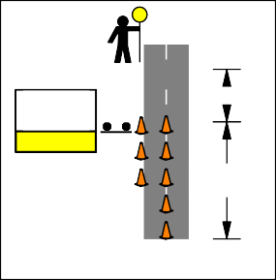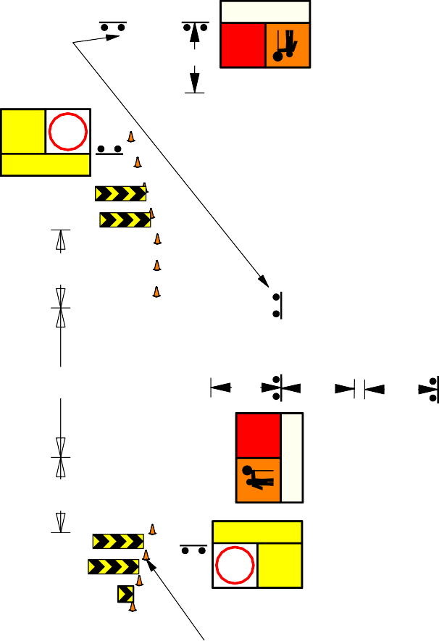

**60**

Speed of traffic in km/h

DATE: 24/02/2022

REV No: 14

DBCA ­ 22 ­ 08

**Legend**

Safety Buffer Work Area Cone

**Road Authority shall approve usage of this TGS.**

**BURNING**

**60**

**OFF** **60**

**SMOKE HAZARD**

REPEATER SIGNAGE TO BE PLACED EVERY 500m, AT INTERSECTIONS,

CURVES AND CRESTS.

REPEATER SIGNAGE MAY BE A STAND ALONE 600x600

Reset Speed to original Speed Zone



|  |  |
| --- | --- |
| **END OF BURN** | **?** |
| **DRIVE SAFELY** | |

300m

80m

**80**

**STOP HERE WHEN DIRECTED**

**BURNING OFF**

Cones may be placed alone edge to reduce lane width to max 4m.

12m

6 Cones 4m spacing

PTS may be removed when

low traffic volume and/or low speed

Prepare to Stop spacing based on anticipated

end of queue plus 2 X Sign Spacing, Traffic Controllers

160m

45m

**THRESHOLD**

**GENERAL NOTES:**

shall monitor end of queue.

**BURNING OFF**

**60**

Side roads may be sealed or unsealed

1. This TGS is only to be used as part of the DBCA Generic Traffic Management Plan.
2. All sign locations are to be checked prior to setout and positions adjusted to allow for specific site constraints such as vegetation, other signs, roadside furniture and sufficient space on shoulders/emergency lanes.
3. All existing speed zone signage within the temporary speed zone shall be covered with suitable opaque material for the duration of the stage and covers to be removed on completion of works each day. Unless otherwise noted.
4. Minimum traffic lane width of 3.2m is to be maintained past the worksite at all times.
5. The positioning of signs, lengths of tapers or markings shall be:
   1. Minimum 10% less than the distances or lengths given.
   2. Maximum 25% more than the distances or lengths given.
6. Supervisor shall undertake risk assessment to determine appropriate temporary speed restriction.
7. The symbolic worker signs shall be installed only when on­foot personnel will be visible to passing traffic.
8. When using MMS two 5mm thick core flute signs back to back in the MM frame to help prevent the sign from blowing out
9. Drive slowly can be swapped with Smoke

**SMOKE HAZARD**

20m SAFETY BUFFER

20km MAX WORK AREA

20m SAFETY BUFFER

and may be posted or derestricted. Reset Speed to original Speed Zone

110m 300m

**80**

**END OF BURN**

**?**

**DRIVE SAFELY**

45m

**PREPARE TO STOP**

**DO NOT OVERTAKE**

160m

**PREPARE TO STOP**

OR

**DO NOT OVERTAKE DO NOT OVERTAKE**

**60**

**REDUCE SPEED**

**80**

**BURNING OFF**

OR

**DRIVE SLOWLY**

Cone spacing shall be 12m.

**PREPARE TO**

**STOP**

**80**

**BURNING OFF**

**SMOKE HAZARD**

Hazard, or Burning Off.

1. Use of Fold up signs and Swing signs acceptable in narrow, very low volume tracks

<50 VPD.

DISCLAIMER:

**DISCLAIMER:**

It is the responsibility of the user of this traffic guidance scheme to confirm the appropriateness or otherwise for the intended work site based on rigorous risk assessment, review of the requirements of AS1742.3 and Main Roads WA Traffic Management for Works on Roads CoP and AGGTM. All responsibility will remain with the user to ensure compliance with relevant standards and the provision of the necessary level of protection for work personnel and work site.

**BURNING OFF**

OR

**BURNING**

**DO NOT OVERTAKE**

**PREPARE TO**

**STOP**

**80**

**80**

OR **OFF**

45m

160m

|  |  |
| --- | --- |
|  | **PREPARE TO STOP** |
| **DO NOT OVERTAKE** | |

|  |  |
| --- | --- |
|  | **PREPARE TO STOP** |
| **DO NOT OVERTAKE** | |

80m

|  |  |
| --- | --- |
|  | **60** |
| **REDUCE SPEED** | |

300m

PTS may be removed when

low traffic volume and/or low speed

Reset Speed to original Speed Zone

***80***

Drawn: Cheryl Johnson

AWTM Cert. No: KTS­AWTM­19­47786­01

**SMOKE HAZARD**

**DRIVE SLOWLY**

Signed:

Reviewed by: Brad Brooksby

AWTM Cert. No: AUS­AWTM­19­1183­07

Signed:

SIGN SPACING

Speed of Traffic km/h

55 or less

56 to 65

Distance (m)

15m 45m

**BURNING OFF WITH TRAFFIC CONTROL**

**90km/h­110km/h POSTED SPEED WORKING 1.2m­3m FROM TRAFFIC**

Greater than 65

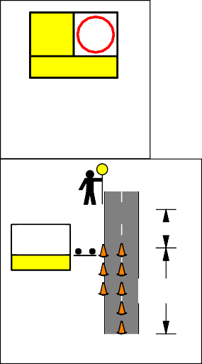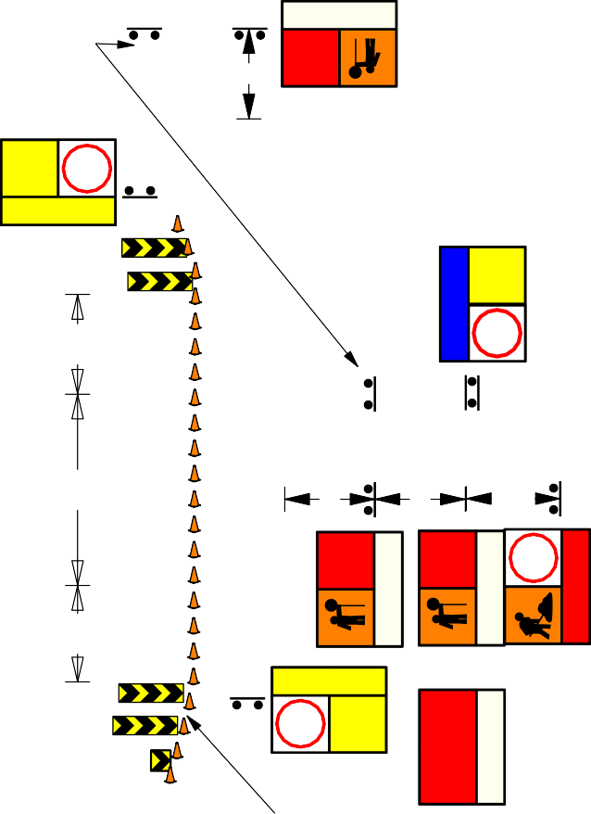

Speed of traffic in km/h

DATE: 24/02/2022

REV No: 14

DBCA ­ 22 ­ 09

**Legend**

Cone Work Area

Safety Buffer

**Road Authority shall approve usage of this TGS.**

300m

|  |  |
| --- | --- |
| **BURNING OFF** | **40** |
| **SMOKE HAZARD** | |

REPEATER SIGNAGE TO BE PLACED EVERY 500m, AT INTERSECTIONS,

CURVES AND CRESTS.

**40**

REPEATER SIGNAGE MAY BE A STAND ALONE 600x600

Reset Speed to original Speed Zone

**80**



|  |  |
| --- | --- |
| **END OF BURN** | **?** |
| **DRIVE SAFELY** | |

80m

160m

**STOP HERE WHEN DIRECTED**

**BURNING OFF**

Cones may be placed alone edge to reduce lane width to max 4m.

12m

6 Cones 4m spacing

PTS may be removed when

low traffic volume and/or low speed

**60**

45m

**THRESHOLD**

**GENERAL NOTES:**

1. This TGS is only to be used as part of the

30m TAPER

20m

**80**

45m

160m

1.2 ­ 3m

**END OF BURN**

Side roads may be sealed or unsealed and may be posted or derestricted.

Reset Speed to original Speed Zone

**DRIVE SAFELY**

DBCA Generic Traffic Management Plan.

1. All sign locations are to be checked prior to setout and positions adjusted to allow for specific site constraints such as vegetation, other signs, roadside furniture and sufficient space on shoulders/emergency lanes.
2. All existing speed zone signage within the temporary speed zone shall be covered with suitable opaque material for the duration of the stage and covers to be removed on completion of works each day. Unless otherwise noted.
3. Minimum traffic lane width of 3.2m is to be maintained past the worksite at all times.
4. The positioning of signs, lengths of tapers or markings shall be:
   1. Minimum 10% less than the distances or lengths given.
   2. Maximum 25% more than the distances or lengths given.
5. Supervisor shall undertake risk assessment to determine appropriate temporary speed restriction.
6. The symbolic worker signs shall be installed only when on­foot personnel will be visible to passing traffic.

SAFETY BUFFER

A

5KM MAX WORK AREA

20m SAFETY BUFFER

30m TAPER

**REDUCE SPEED**

**40**

A

**?**

90m

**PREPARE TO**

**STOP**

**DO NOT OVERTAKE**

80m

**PREPARE TO STOP**

**DO NOT OVERTAKE**

**PREPARE TO STOP**

**DO NOT OVERTAKE**

OR

**60**

**REDUCE SPEED**

**BURNING OFF**

80m

**60**

**AHEAD**

**DRIVE SLOWLY**

1. When using MMS two 5mm thick core flute signs back to back in the MM frame to help prevent the sign from blowing out.
2. Drive slowly can be swapped with Smoke Hazard, or Burning Off.
3. Use of Fold up signs and Swing signs acceptable in narrow, very low volume tracks

<50 VPD.

DISCLAIMER:

**DISCLAIMER:**

It is the responsibility of the user of this traffic guidance scheme to confirm the appropriateness or otherwise for the intended work site based on rigorous risk assessment, review of the requirements of AS1742.3 and Main Roads WA Traffic Management for Works on Roads CoP and AGGTM. All responsibility will remain with the user to ensure compliance with relevant standards and the provision of the necessary level of protection for work personnel and work site.

Drawn: Cheryl Johnson

AWTM Cert. No: KTS­AWTM­19­47786­01

Signed:

Reviewed by: Brad Brooksby

AWTM Cert. No: AUS­AWTM­16­1183­07

Signed:

OR

SIGN SPACING

**DO NOT OVERTAKE**

**PREPARE TO**

**STOP**

Speed of Traffic km/h

55 or less

56 to 65

Distance (m)

15m 45m

45m

160m

|  |  |
| --- | --- |
|  | **PREPARE TO STOP** |
| **DO NOT OVERTAKE** | |

|  |  |
| --- | --- |
|  | **PREPARE TO STOP** |
| **DO NOT OVERTAKE** | |
|  |  |
|  | **60** |
| **DRIVE SLOWLY** | |

80m

300m

|  |  |
| --- | --- |
| **BURNING OFF** | **80** |
| **DRIVE SLOWLY** | |

Prepare to Stop spacing based on anticipated end of queue plus 1.5D, Traffic Controllers shall monitor end of queue.

PTS may be removed when

low traffic volume and/or low speed

Reset Speed to original Speed Zone

**BURNING OFF WITH TRAFFIC CONTROL**

**90km/h­110km/h POSTED SPEED WORKING WITHIN 1.2m FROM TRAFFIC**

Greater than 65

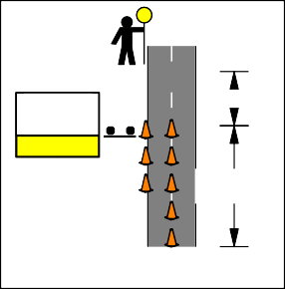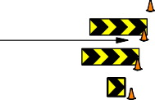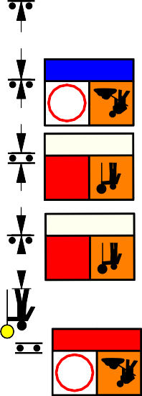

Speed of traffic in km/h

DATE: 24/02/2022

REV No: 14

DBCA ­ 22 ­ 10

**Legend**

Cone Work Area

Safety Buffer

**Road Authority shall approve usage of this TGS.**

## 60

300m

REPEATER SIGNAGE TO BE PLACED EVERY 500m, AT INTERSECTIONS,

|  |  |
| --- | --- |
| **BURNING OFF** | **60** |
| **SMOKE HAZARD** | |

CURVES AND CRESTS.

REPEATER SIGNAGE MAY BE A STAND ALONE 600x600

**END OF BURN**

Reset Speed to original Speed Zone

**END OF BURM**

**END**

**80?**

60

110m

**STOP HERE WHEN DIRECTED**

**BURNING OFF**

Cones may be placed alone edge to reduce lane width to max 4m.

12m

6 Cones 4m spacing

**DRIVE SAFELY**

PTS may be removed when

**DRIVE SAFELY**

low traffic volume and/or low speed

Prepare to Stop spacing based on anticipated

end of queue plus 2 x Sign Spacing, Traffic Controllers

160m

45m

**THRESHOLD**

shall monitor end of queue.

**GENERAL NOTES:**

1. This TGS is only to be used as part of the DBCA Generic Traffic Management Plan.
2. All sign locations are to be checked prior to setout and positions adjusted to allow for

30m TAPER

20m

**80**

**END**

**60**

1.2 ­ 3m

Side roads may be sealed or unsealed and may be posted or derestricted.

Reset Speed to original Speed Zone

**END OF BURN**

**DRIVE SAFELY**

**END OF BURM**

**DRIVE SAFELY**

specific site constraints such as vegetation, other signs, roadside furniture and sufficient space on shoulders/emergency lanes.

1. All existing speed zone signage within the temporary speed zone shall be covered with suitable opaque material for the duration of the stage and covers to be removed on completion of works each day. Unless otherwise noted.
2. Minimum traffic lane width of 3.2m is to be maintained past the worksite at all times.
3. The positioning of signs, lengths of tapers or markings shall be:
   1. Minimum 10% less than the distances or lengths given.
   2. Maximum 25% more than the distances or lengths given.
4. Supervisor shall undertake risk assessment to determine appropriate temporary speed restriction.
5. The symbolic worker signs shall be installed only when on­foot personnel will be visible to passing traffic.
6. When using MMS two 5mm thick core flute signs back to back in the MM frame to help prevent the sign from blowing out.

|  |  |
| --- | --- |
|  | **PREPARE TO STOP** |
| **DO NOT OVERTAKE** | |

SAFETY BUFFER

A

20KM MAX WORK AREA

20m SAFETY BUFFER

30m TAPER

A

**?**

45m

**PREPARE TO STOP**

**DO NOT OVERTAKE**

160m

**PREPARE TO STOP**

**DO NOT OVERTAKE**

110m

**60**

**REDUCE SPEED**

300m

**60**

**AHEAD**

**BURNING OFF**

**DRIVE SLOWLY**

1. Drive slowly can be swapped with Smoke Hazard, or Burning Off.
2. Use of Fold up signs and Swing signs acceptable in narrow, very low volume tracks

<50 VPD.

DISCLAIMER:

**DISCLAIMER:DISCLAIMER:**

It is the responsibility of the user of this traffic guidance scheme to confirm the appropriateness or otherwise for the intended work site based on rigorous risk assessment, review of the requirements of AS1742.3 and Main Roads WA Traffic Management for Works on Roads CoP and AGGTM. All responsibility will remain with the user to ensure compliance with relevant standards and the provision of the necessary level of protection for work personnel and work site.

OR

**DO NOT OVERTAKE**

**PREPARE TO**

**STOP**

|  |  |
| --- | --- |
|  | **PREPARE TO STOP** |
| **DO NOT OVERTAKE** | |

|  |  |
| --- | --- |
|  | **60** |
| **REDUCE SPEED** | |

**BURNING OFF**

**60**

**AHEAD**

45m

160m

110m

300m

PTS may be removed when

low traffic volume and/or low speed

**PREPARE TO**

**STOP** OR

**DO NOT OVERTAKE**

Reset Speed to original Speed Zone

Drawn: Cheryl Johnson

AWTM Cert. No: KTS­AWTM­19­47786­01

Signed:

Reviewed by: Brad Brooksby

AWTM Cert. No: AUS­AWTM­16­1183­07

Signed:

SIGN SPACING

Speed of Traffic km/h

55 or less

56 to 65

**DRIVE SLOWLY**

Distance (m)

15m 45m

**BURNING OFF WITH TRAFFIC CONTROL DERESTRICTED ZONE**

**WORKING 1.2m­3m FROM TRAFFIC**

Greater than 65

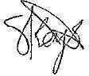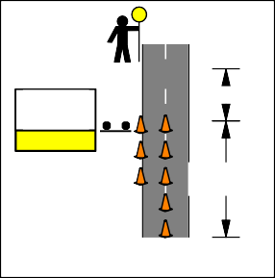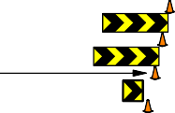

Speed of traffic in km/h

DATE: 24/02/2022

REV No: 14

DBCA ­ 22 ­ 11

**Legend**

Cone Work Area

Safety Buffer

**Road Authority shall approve usage of this TGS.**

80m

|  |  |
| --- | --- |
| **BURNING OFF** | **40** |
| **SMOKE HAZARD** | |

REPEATER SIGNAGE TO BE PLACED EVERY 500m, AT INTERSECTIONS,

CURVES AND CRESTS.

**40**

REPEATER SIGNAGE MAY BE A STAND ALONE 600x600

Reset Speed to original Speed Zone

**80**



|  |  |
| --- | --- |
| **END OF BURN** | **?** |
| **DRIVE SAFELY** | |

80m

160m

**STOP HERE WHEN DIRECTED**

**BURNING OFF**

Cones may be placed alone edge to reduce lane width to max 4m.

12m

6 Cones 4m spacing

PTS may be removed when

low traffic volume and/or low speed

**60**

45m

**THRESHOLD**

**GENERAL NOTES:**

1. This TGS is only to be used as part of the

30m TAPER

20m

**80**

**?**

45m

1.2 ­ 3m

**END OF BURN**

Side roads may be sealed or unsealed and may be posted or derestricted.

Reset Speed to original Speed Zone

**DRIVE SAFELY**

DBCA Generic Traffic Management Plan.

1. All sign locations are to be checked prior to setout and positions adjusted to allow for specific site constraints such as vegetation, other signs, roadside furniture and sufficient space on shoulders/emergency lanes.
2. All existing speed zone signage within the temporary speed zone shall be covered with suitable opaque material for the duration of the stage and covers to be removed on completion of works each day. Unless otherwise noted.
3. Minimum traffic lane width of 3.2m is to be maintained past the worksite at all times.
4. The positioning of signs, lengths of tapers or markings shall be:
   1. Minimum 10% less than the distances or lengths given.
   2. Maximum 25% more than the distances or lengths given.
5. Supervisor shall undertake risk assessment to determine appropriate temporary speed restriction.
6. The symbolic worker signs shall be installed only when on­foot personnel will be visible to passing traffic.
7. When using MMS two 5mm thick core flute signs back to back in the MM frame to help

SAFETY BUFFER

A

5KM MAX WORK AREA

20m SAFETY BUFFER

30m TAPER

**REDUCE SPEED**

**40**

A

90m

**PREPARE TO**

**STOP**

**DO NOT OVERTAKE**

160m

**PREPARE TO STOP**

**DO NOT OVERTAKE**

**PREPARE TO STOP**

**DO NOT OVERTAKE**

80m

OR

**60**

**REDUCE SPEED**

80m

**60**

**AHEAD**

**BURNING OFF**

**DRIVE SLOWLY**

prevent the sign from blowing out.

1. Drive slowly can be swapped with Smoke Hazard, or Burning Off.
2. Use of Fold up signs and Swing signs acceptable in narrow, very low volume tracks

<50 VPD.

DISCLAIMER:

**DISCLAIMER:**

It is the responsibility of the user of this traffic guidance scheme to confirm the appropriateness or otherwise for the intended work site based on rigorous risk assessment, review of the requirements of AS1742.3 and Main Roads WA Traffic Management for Works on Roads CoP and AGGTM. All responsibility will remain with the user to ensure compliance with relevant standards and the provision of the necessary level of protection for work personnel and work site.

Drawn: Cheryl Johnson

AWTM Cert. No: KTS­AWTM­19­47786­01

Signed:

Reviewed by: Brad Brooksby

AWTM Cert. No: AUS­AWTM­16­1183­07

Signed:

OR

SIGN SPACING

**DO NOT OVERTAKE**

**PREPARE TO**

**STOP**

Speed of Traffic km/h

55 or less

56 to 65



Distance (m)

15m 45m

45m

160m

|  |  |
| --- | --- |
|  | **PREPARE TO STOP** |
| **DO NOT OVERTAKE** | |

|  |  |
| --- | --- |
|  | **PREPARE TO STOP** |
| **DO NOT OVERTAKE** | |
|  |  |
|  | **60** |
| **DRIVE SLOWLY** | |

80m

80m

|  |  |
| --- | --- |
| **BURNING OFF** | **60**  **AHEAD** |
| **DRIVE SLOWLY** | |

Prepare to Stop spacing based on anticipated

end of queue plus 2 x Sign Spacing, Traffic Controllers shall monitor end of queue.

PTS may be removed when

low traffic volume and/or low speed

Reset Speed to original Speed Zone

**BURNING OFF WITH TRAFFIC CONTROL**

**70km/h­80km/h POSTED SPEED WORKING WITHIN 1.2m FROM TRAFFIC**

Greater than 65

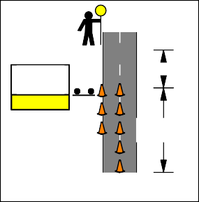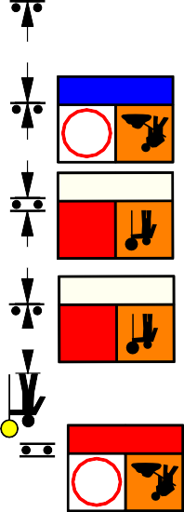

Speed of traffic in km/h

DATE: 24/02/2022

REV No: 14

DBCA ­ 22 ­ 12

**Legend**

Safety Buffer Work Area Cone

|  |  |
| --- | --- |
| **BURNING OFF** | **40** |
| **SMOKE HAZARD** | |

**Road Authority shall approve usage of this TGS.**

REPEATER SIGNAGE TO BE PLACED EVERY 500m, AT INTERSECTIONS,

CURVES AND CRESTS.

**STOP HERE WHEN DIRECTED**

**BURNING OFF**

12m

Reset Speed to original Speed Zone

|  |  |
| --- | --- |
| **END OF BURN** | **?** |
| **DRIVE SAFELY** | |

PTS may be removed when

**80**



**40**

REPEATER SIGNAGE MAY BE A STAND ALONE 600x600

low traffic volume and/or low speed

45m

90m

45m

Cones may be placed alone edge to reduce lane width to max 4m.

6 Cones 4m spacing

**?**

**THRESHOLD**

**GENERAL NOTES:**

1. This TGS is only to be used as part of the DBCA Generic Traffic Management Plan.
2. All sign locations are to be checked prior to setout and positions adjusted to allow for specific site constraints such as vegetation, other signs, roadside furniture and sufficient space on shoulders/emergency lanes.
3. All existing speed zone signage within the temporary speed zone shall be covered with suitable opaque material for the duration of the stage and covers to be removed on completion of works each day. Unless otherwise noted.
4. Minimum traffic lane width of 3.2m is to be maintained past the worksite at all times.
5. The positioning of signs, lengths of tapers or markings shall be:
   1. Minimum 10% less than the distances or lengths given.
   2. Maximum 25% more than the distances or lengths given.
6. Supervisor shall undertake risk assessment to determine appropriate temporary speed restriction.
7. The symbolic worker signs shall be installed only when on­foot personnel will be visible to passing traffic.
8. When using MMS two 5mm thick core flute signs back to back in the MM frame to help prevent the sign from blowing out.
9. Drive slowly can be swapped with Smoke Hazard, or Burning Off.
10. Use of Fold up signs and Swing signs acceptable in narrow, very low volume tracks

<50 VPD.

DISCLAIMER:

**DISCLAIMER:**

It is the responsibility of the user of this traffic guidance scheme to confirm the appropriateness or otherwise for the intended work site based on rigorous risk assessment, review of the requirements of AS1742.3 and Main Roads WA Traffic Management for Works on Roads CoP and AGGTM. All responsibility will remain with the user to ensure compliance with relevant standards and the provision of the necessary level of protection for work personnel and work site.

Drawn: Cheryl Johnson

AWTM Cert. No: KTS­AWTM­19­47786­01

30m TAPER

20m SAFETY BUFFER

5KM MAX WORK AREA

20m SAFETY BUFFER

30m TAPER

## 40

**REDUCE SPEED**

45m

|  |  |
| --- | --- |
|  | **PREPARE TO STOP** |
| **DO NOT OVERTAKE** | |

90m

**PRE**

**T STO**

**PARE O**

**P**

**PREPARE TO**

**STOP**

|  |  |
| --- | --- |
|  | **PREPARE TO STOP** |
| **DO NOT OVERTAKE** | |

OR 

**DO NOT OVERTAKE**

**DO NOT OVERTAKE**

45m

|  |  |
| --- | --- |
| **BURNING OFF** |  |
| **DRIVE SLOWLY** | |

90m

90m

Side roads may be sealed or unsealed and may be posted or derestricted.

Reset Speed to original Speed Zone

**80**

**END OF BURN**

**?**

**DRIVE SAFELY**

45m 45m

**PREPARE** 45m

**TO STOP**

**DO NOT OVERTAKE**

90m

**PREPARE TO**

**STOP**

**DO NOT OVERTAKE**

**PREPARE TO STOP**

**DO NOT OVERTAKE**

OR

**40**

**REDUCE SPEED**

**40**

**AHEAD** OR

**BURNING OFF**

**DRIVE SLOWLY**

**DRIVE SLOWLY**

Prepare to Stop spacing based on anticipated

**BURNING OFF**

end of queue plus 2 x Sign Spacing, Traffic Controllers shall monitor end of queue.

PTS may be removed when

low traffic volume and/or low speed

Reset Speed to original Speed Zone

***80***

Signed:

Reviewed by: Brad Brooksby

AWTM Cert. No: AUS­AWTM­16­1183­07

Signed:

|  |  |
| --- | --- |
| Speed of Traffic km/h | Distance (m) |
| 55 or less | 15m |
| 56 to 65 | 45m |
| Greater than 65 | Speed of traffic in km/h |

SIGN SPACING

**BURNING OFF WITH TRAFFIC CONTROL**

**50km/h­60km/h POSTED SPEED WORKING WITHIN 1.2m OF TRAFFIC**

DATE: 24/02/2022

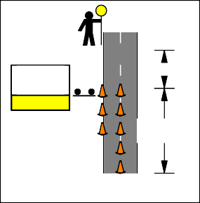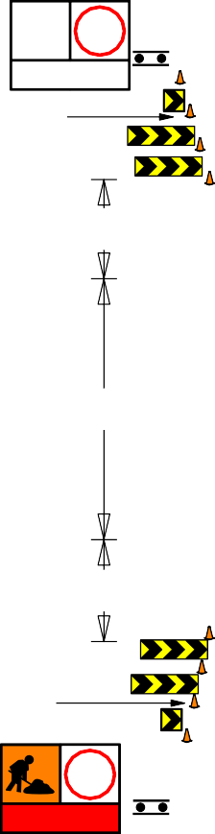

REV No: 14

DBCA ­ 22­ 13

**Road Authority shall approve usage of this TGS.**

**Legend**

**BURNING OFF**

**60**

**60**

**SMOKE HAZARD**

REPEATER SIGNAGE TO BE PLACED EVERY 500m, AT INTERSECTIONS,

CURVES AND CRESTS.

**STOP HERE WHEN DIRECTED**

**BURNING OFF**

REPEATER SIGNAGE MAY BE A STAND ALONE 600x600

12m

Reset Speed to original Speed Zone

300m

110m

100m

Cones may be placed alone edge to reduce lane width to max 4m.

6 Cones 4m spacing

**80**

**DRIVE SAFELY**

**END OF BURN**

**?**

PTS may be removed when

low traffic volume and/or low speed

45m

Side roads may be sealed or unsealed

**THRESHOLD**

**GENERAL NOTES:**

Prepare to Stop spacing based on anticipated

end of queue plus 2 x Sign Spacing, Traffic Controllers shall monitor end of queue.

**END OF BURN**

**DRIVE SAFELY**

and may be posted or derestricted. Reset Speed to original Speed Zone

1. This TGS is only to be used as part of the DBCA Generic Traffic Management Plan.

**80**

**?**

**60**

1. All sign locations are to be checked prior to

45m

**BURNING OFF**

setout and positions adjusted to allow for specific site constraints such as vegetation, other signs, roadside furniture and sufficient space on shoulders/emergency lanes.

1. All existing speed zone signage within the temporary speed zone shall be covered with suitable opaque material for the duration of the stage and covers to be removed on completion of works each day. Unless otherwise noted.
2. Minimum traffic lane width of 3.2m is to be maintained past the worksite at all times.
3. The positioning of signs, lengths of tapers or markings shall be:
   1. Minimum 10% less than the distances or lengths given.
   2. Maximum 25% more than the distances or lengths given.
4. Supervisor shall undertake risk assessment to determine appropriate temporary speed restriction.
5. The symbolic worker signs shall be installed only when on­foot personnel will be visible to passing traffic.
6. When using MMS two 5mm thick core flute signs back to back in the MM frame to help prevent the sign from blowing out.
7. Drive slowly can be swapped with Smoke Hazard, or Burning Off.
8. Use of Fold up signs and Swing signs

**SMOKE HAZARD**

Escort Vehicle

**DO NOT OVERTAKE**

**FOLLOW ME**

To be displayed on the back of the rear of the Escort Vehicle.

Optional Tail Vehicle

Escort and Tail vehicle to be driven by Department personnel with radio communication.

45m

|  |  |
| --- | --- |
|  | **PREPARE TO STOP** |
| **DO NOT OVERTAKE** | |

100m

**PREPARE TO**

**STOP**

**DO NOT OVERTAKE**

**PREPARE TO STOP**

**DO NOT OVERTAKE**

OR

**80**

**BURNING OFF**

**80**

OR

110m

**60**

**REDUCE SPEED**

300m

**DRIVE SLOWLY**

acceptable in narrow, very low volume tracks

<50 VPD.

1. 20KM MAX WORK AREA.

DISCLAIMER:

**DISCLAIMER:DISCLAIMER:**

It is the responsibility of the user of this traffic guidance scheme to confirm the appropriateness or otherwise for the intended work site based on rigorous risk assessment, review of the requirements of AS1742.3 and Main Roads WA Traffic Management for Works on Roads CoP and AGGTM. All responsibility will remain with the user to ensure compliance with relevant standards and the provision of the necessary level of protection for work personnel and work site.

**BURNING OFF**

OR

**BURNING**

**DO NOT OVERTAKE**

**PREPARE TO**

**STOP**

**80**

**80**

OR **OFF**

100m

110m

|  |  |
| --- | --- |
|  | **PREPARE TO STOP** |
| **DO NOT OVERTAKE** | |

|  |  |
| --- | --- |
|  | **60** |
| **REDUCE SPEED** | |

300m

PTS may be removed when

low traffic volume and/or low speed

**BURNING OFF**

**SMOKE HAZARD**

Reset Speed to original Speed Zone

***80***

Drawn: Cheryl Johnson

AWTM Cert. No: KTS­AWTM­19­47786­01

**SMOKE HAZARD**

**DRIVE SLOWLY**

Signed:

Reviewed by: Brad Brooksby

AWTM Cert. No: AUS­AWTM­16­1183­07

Signed:

SIGN SPACING

Speed of Traffic km/h

55 or less

56 to 65

Distance (m)

15m 45m

**BURNING OFF**

**90km/h­110km/h POSTED SPEED WITH TC AND ESCORT VEHICLE**

Greater than 65

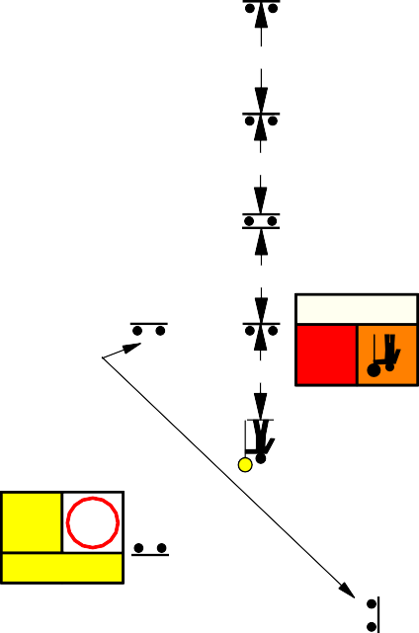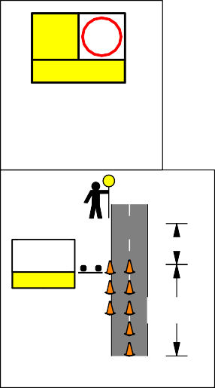

Speed of traffic in km/h

DATE: 24/02/2022

REV No: 14

DBCA ­ 22 ­ 14

**Road Authority shall approve usage of this TGS.**

**Legend**

**BURNING**

**60**

**OFF** **60**

**SMOKE HAZARD**

REPEATER SIGNAGE TO BE PLACED EVERY 500m, AT INTERSECTIONS,

CURVES AND CRESTS.

REPEATER SIGNAGE MAY BE A STAND ALONE 600x600

Reset Speed to original Speed Zone

**DRIVE SAFELY**

**END OF BURN**

**?**

180m

90m

**80**

**STOP HERE WHEN DIRECTED**

**BURNING OFF**

Cones may be placed alone edge to reduce lane width to max 4m.

12m

6 Cones 4m spacing

PTS may be removed when

low traffic volume and/or low speed

100m

45m

Side roads may be sealed or unsealed

**THRESHOLD**

**GENERAL NOTES:**

Prepare to Stop spacing based on anticipated

end of queue plus 2 x Sign Spacing, Traffic Controllers shall monitor end of queue.

**END OF BURN**

**DRIVE SAFELY**

and may be posted or derestricted. Reset Speed to original Speed Zone

1. This TGS is only to be used as part of the DBCA Generic Traffic Management Plan.

**80**

**?**

**60**

1. All sign locations are to be checked prior to

**PREPARE** 45m

**TO STOP**

**DO NOT OVERTAKE**

100m

**BURNING OFF**

setout and positions adjusted to allow for specific site constraints such as vegetation, other signs, roadside furniture and sufficient space on shoulders/emergency lanes.

1. All existing speed zone signage within the temporary speed zone shall be covered with suitable opaque material for the duration of the stage and covers to be removed on completion of works each day. Unless otherwise noted.
2. Minimum traffic lane width of 3.2m is to be maintained past the worksite at all times.
3. The positioning of signs, lengths of tapers or markings shall be:
   1. Minimum 10% less than the distances or lengths given.
   2. Maximum 25% more than the distances or lengths given.
4. Supervisor shall undertake risk assessment to determine appropriate temporary speed restriction.
5. The symbolic worker signs shall be installed only when on­foot personnel will be visible to passing traffic.
6. When using MMS two 5mm thick core flute signs back to back in the MM frame to help prevent the sign from blowing out.
7. Drive slowly can be swapped with Smoke Hazard, or Burning Off.
8. Use of Fold up signs and Swing signs

**SMOKE HAZARD**

Escort Vehicle

**DO NOT OVERTAKE**

**FOLLOW ME**

To be displayed on the back of the rear of the Escort Vehicle.

Optional Tail Vehicle

Escort and Tail vehicle to be driven by Department personnel with radio communication.

45m

|  |  |
| --- | --- |
|  | **PREPARE TO STOP** |
| **DO NOT OVERTAKE** | |

90m

**PREPARE TO STOP**

**DO NOT OVERTAKE**

**60**

**REDUCE SPEED**

180m

**PREPARE TO**

**STOP**

**DO NOT OVERTAKE**

OR

**BURNING OFF**

OR

**SMOKE HAZARD**

**DRIVE SLOWLY**

acceptable in narrow, very low volume tracks

<50 VPD.

1. 20KM MAX WORK AREA.

DISCLAIMER:

**DISCLAIMER:DISCLAIMER:**

It is the responsibility of the user of this traffic guidance scheme to confirm the appropriateness or otherwise for the intended work site based on rigorous risk assessment, review of the requirements of AS1742.3 and Main Roads WA Traffic Management for Works on Roads CoP and AGGTM. All responsibility will remain with the user to ensure compliance with relevant standards and the provision of the necessary level of protection for work personnel and work site.

Drawn: Cheryl Johnson

AWTM Cert. No: KTS­AWTM­19­47786­01

**BURNING OFF**

**SMOKE HAZARD**

OR

**BURNING**

**DO NOT OVERTAKE**

**PREPARE TO**

**STOP**

|  |  |
| --- | --- |
|  | **PREPARE TO STOP** |
| **DO NOT OVERTAKE** | |

OR **OFF**

**DRIVE SLOWLY**

100m

90m

|  |  |
| --- | --- |
|  | **60** |
| **REDUCE SPEED** | |

180m

PTS may be removed when

low traffic volume and/or low speed

**BURNING OFF**

Reset Speed to original Speed Zone

***80***

Signed:

Reviewed by: Brad Brooksby

AWTM Cert. No: AUS­AWTM­16­1183­07

Signed:

SIGN SPACING

Speed of Traffic km/h

1. or less
2. to 65

Distance (m)

15m 45m

**BURNING OFF**

**70km/h­80km/h POSTED SPEED WITH TC AND ESCORT VEHICLE**

Greater than 65

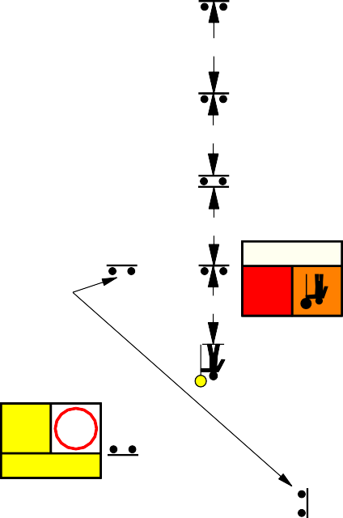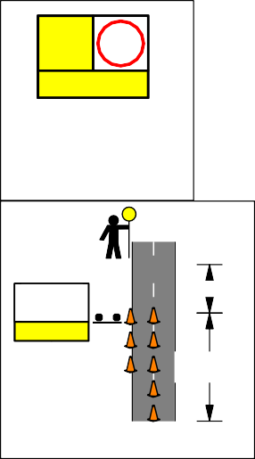

Speed of traffic in km/h

DATE: 24/02/2022

REV No: 14

DBCA ­ 22 ­ 15

**Legend**

Work Area Safety Buffer Cone



**Road Authority shall approve usage of this TGS.**

VMS MESSAGES

**80**

MOBILE PLANT AHEAD

BURNING OFF AHEAD

Reset Speed to original Speed Zone

|  |  |
| --- | --- |
| **END**  **OF BURN** | **?** |
| **DRIVE SAFELY** | |

**VMS are optional and messages may change to suit works.**

**To be installed minimum 2 x sign spacing from first temporary work signage**

MIN 2 x Sign Spacing

60 km/h temporary speed restriction shall be used when worker working between 1.2 – 3.0 m from traffic lane.

Lead Vehicle

|  |  |
| --- | --- |
| **ROAD PLANT AHEAD** |  |
| **BURNING OFF** | |

REPEATER SIGNAGE TO BE PLACE AT INTERSECTIONS.

**GENERAL NOTES:**

1. This TGS is only to be used as part of the DBCA Generic Traffic Management Plan.

**60** OR

**BURNING OFF**

**ROAD PLANT AHEAD**

180m ­ 220m

Open Road Area

**BURNING OFF**

1. All sign locations are to be checked prior to setout and positions adjusted to allow for specific site constraints such as vegetation, other signs, roadside furniture and sufficient space on shoulders/emergency lanes.
2. All existing speed zone signage within the temporary speed zone shall be covered with suitable opaque material for the duration of

Work Vehicle

**ROAD**

the stage and covers to be removed on completion of works each day. Unless otherwise noted.

**60** OR

**BURNING OFF**

**PLANT AHEAD**

**BURNING OFF**

1. Minimum traffic lane width of 3.2m is to be maintained past the worksite at all times.
2. The positioning of signs, lengths of tapers or markings shall be:
   1. Minimum 10% less than the distances or lengths given.
   2. Maximum 25% more than the distances or lengths given.

Shadow Vehicle

**ROAD**

180m ­ 220m

Open Road Area

1. Supervisor shall undertake risk assessment to determine appropriate temporary speed restriction.

**60** OR

**BURNING OFF**

**PLANT AHEAD**

**BURNING OFF**

1. The symbolic worker signs shall be installed only when on­foot personnel will be visible to passing traffic.
2. When using MMS two 5mm thick core flute signs back to back in the MM frame to help prevent the sign from blowing out.

DISCLAIMER:

**DISCLAIMER:**

It is the responsibility of the user of this traffic guidance scheme to confirm the appropriateness or otherwise for the intended work site based on rigorous risk assessment, review of the requirements of AS1742.3 and Main Roads WA Traffic Management for Works on Roads CoP and AGGTM. All responsibility will remain with the user to ensure compliance with relevant standards and the provision of the necessary level of protection for work personnel and work site.

Drawn: Cheryl Johnson

AWTM Cert. No: KTS­AWTM­19­47786­01

Signed:

Tail Vehicle

OR

|  |  |
| --- | --- |
| **ROAD PLANT AHEAD** | **60**  **AHEAD** |
| **NEXT km** | |

|  |  |  |
| --- | --- | --- |
|  | | |
| **ROAD PLANT AHEAD** | **60**  **AHEAD** |  |
|  |
| **BURNING OFF** | |  |

SIGN SPACING

MIN 2 x Sign Spacing



Reset Speed to original Speed Zone

***80***

**BURNING OFF**

Reviewed by: Brad Brooksby

AWTM Cert. No: AUS­AWTM­16­1183­07

Signed:

Speed of Traffic km/h

1. or less
2. to 65

Distance (m)

15m 45m

**90km/h­110km/h POSTED SPEED MOBILE WORKS OPERATIONS**

Greater than 65



Speed of traffic in km/h

DATE: 24/02/2022

REV No: 14

DBCA ­ 22 ­ 16

**Legend**

Work Area Safety Buffer Cone

**Road Authority shall approve usage of this TGS.**

Reset Speed to original Speed Zone

**80**



VMS MESSAGES

MOBILE PLANT AHEAD

BURNING OFF AHEAD

|  |  |
| --- | --- |
| **END OF BURN** | **?** |
| **DRIVE SAFELY** | |

**VMS are optional and messages may change to suit works.**

**To be installed minimum 2 x sign spacing from first temporary work signage**

MIN 2 x Sign Spacing

60 km/h temporary speed restriction shall be used when worker working between 1.2 – 3.0 m from traffic lane.

Lead Vehicle

|  |  |
| --- | --- |
| **ROAD PLANT AHEAD** |  |
| **BURNING OFF** | |

REPEATER SIGNAGE TO BE PLACED AT INTERSECTIONS.

**GENERAL NOTES:**

1. This TGS is only to be used as part of the DBCA Generic Traffic Management Plan.

**60** OR

**BURNING OFF**

180m ­ 220m

Open Road Area

**ROAD PLANT AHEAD**

**BURNING OFF**

1. All sign locations are to be checked prior to setout and positions adjusted to allow for specific site constraints such as vegetation, other signs, roadside furniture and sufficient space on shoulders/emergency lanes.
2. All existing speed zone signage within the temporary speed zone shall be covered with

Work Vehicle

suitable opaque material for the duration of the stage and covers to be removed on completion of works each day. Unless otherwise noted.

**60** OR

**BURNING OFF**

**ROAD**

**PLANT AHEAD**

**BURNING OFF**

1. Minimum traffic lane width of 3.2m is to be maintained past the worksite at all times.
2. The positioning of signs, lengths of tapers or markings shall be:
   1. Minimum 10% less than the distances or lengths given.
   2. Maximum 25% more than the distances

Shadow Vehicle

180m ­ 220m

Open Road Area

or lengths given.

1. Supervisor shall undertake risk assessment to determine appropriate temporary speed restriction.

**60** OR

**BURNING OFF**

**ROAD PLANT AHEAD**

**BURNING OFF**

1. The symbolic worker signs shall be installed only when on­foot personnel will be visible to passing traffic.
2. When using MMS two 5mm thick core flute signs back to back in the MM frame to help prevent the sign from blowing out.

DISCLAIMER:

**DISCLAIMER:**

It is the responsibility of the user of this traffic guidance scheme to confirm the appropriateness or otherwise for the intended work site based on rigorous risk assessment, review of the requirements of AS1742.3 and Main Roads WA Traffic Management for Works on Roads CoP and AGGTM. All responsibility will remain with the user to ensure compliance with relevant standards and the provision of the necessary level of protection for work personnel and work site.

Drawn: Cheryl Johnson

AWTM Cert. No: KTS­AWTM­19­47786­01

Signed:

Tail Vehicle

OR

|  |  |
| --- | --- |
| **ROAD PLANT AHEAD** | **60**  **AHEAD** |
| **NEXT km** | |

|  |  |  |
| --- | --- | --- |
|  | | |
| **ROAD PLANT AHEAD** | **60**  **AHEAD** |  |
|  |
| **BURNING OFF** | |  |

SIGN SPACING

MIN 2 x Sign Spacing



Reset Speed to original Speed Zone

***80***

**BURNING OFF**

Reviewed by: Brad Brooksby

AWTM Cert. No: AUS­AWTM­16­1183­07

Signed:

Speed of Traffic km/h

1. or less
2. to 65

Distance (m)

15m 45m

**70km/h­80km/h POSTED SPEED MOBILE WORKS OPERATIONS**

Greater than 65



Speed of traffic in km/h

DATE: 24/02/2022

REV No: 14

DBCA ­ 22 ­ 17

**Legend**

Work Area Cone

**Road Authority shall approve usage of this TGS.**

2 x Sign Spacing

VMS MESSAGES

MOBILE PLANT AHEAD

BURNING OFF AHEAD

**VMS are optional and messages may change to suit works.**

Reset Speed to original Speed Zone

|  |  |
| --- | --- |
| **END OF BURN** | **?** |
| **DRIVE SAFELY** | |

300m

80m

90m

15m

**DETOUR**

**SIDE ROAD CLOSED**

**SMOKE HAZARD**

**DETOUR**

90m

**DETOUR**

**GENERAL NOTES:**

Side roads may be sealed or unsealed and may be posted or derestricted

1. This TGS is only to be used as part of the DBCA Generic Traffic Management Plan.
2. All sign locations are to be checked prior to setout and positions adjusted to allow for specific site constraints such as vegetation, other signs, roadside furniture and sufficient space on shoulders/emergency lanes.
3. All existing speed zone signage within the temporary speed zone shall be covered with suitable opaque material for the duration of the stage and covers to be removed on completion of works each day. Unless otherwise noted.
4. The positioning of signs, lengths of tapers or markings shall be:
   1. Minimum 10% less than the distances or

90m

**SIDE ROAD CLOSED**

**SMOKE HAZARD**

15m

**DETOUR**

90m

**NO ENTRY**

**ROAD CLOSED**

Reset Speed to original Speed Zone

**END OF BURN**

**?**

**DRIVE SAFELY**

lengths given.

* 1. Maximum 25% more than the distances or lengths given.

1. Supervisor shall undertake risk assessment to determine appropriate temporary speed restriction.
2. The symbolic worker signs shall be installed only when on­foot personnel will be visible to passing traffic.
3. When using MMS two 5mm thick core flute signs back to back in the MM frame to help prevent the sign from blowing out.

DISCLAIMER:

**DISCLAIMER:**

It is the responsibility of the user of this traffic guidance scheme to confirm the appropriateness or otherwise for the intended work site based on rigorous risk assessment, review of the requirements of AS1742.3 and Main Roads WA Traffic Management for

|  |  |  |
| --- | --- | --- |
| **DETOUR AHEAD** | **40** |  |
|  |
| **REDUCE SPEED** | |  |

80m

**40**

**60**

**80**

OR

**BURNING OFF**

**60**

**ROAD CLOSED AHEAD**

|  |  |
| --- | --- |
| **ROAD CLOSED AHEAD** | **60** |
| **BURNING OFF** | |

300m

|  |  |
| --- | --- |
| **BURNING OFF** | **80** |
| **SMOKE HAZARD** | |

|  |  |
| --- | --- |
| **BURNING OFF** | **80** |
| **DO NOT OVERTAKE** | |

OR

2 x Sign Spacing

90m

80m

300m

Works on Roads CoP and AGGTM. All responsibility will remain with the user to ensure compliance with relevant standards and the provision of the necessary level of protection for work personnel and work site.

Drawn: Cheryl Johnson

AWTM Cert. No: KTS­AWTM­19­47786­01

Signed:

Reviewed by: Brad Brooksby

AWTM Cert. No: AUS­AWTM­16­1183­07

Signed:

SIGN SPACING

Speed of Traffic km/h

55 or less

56 to 65

Distance (m)

15m 45m

Reset Speed to original Speed Zone

**LOCAL GOVERNMENT ROADS <500 VPD BURNING OFF 90km/h ­ 110km/h POSTED SPEED FULL ROAD CLOSURE**

Greater than 65



**DETOUR AHEAD**

**REDUCE SPEED**

**SIDE ROAD CLOSED**

**SIDE ROAD**

**60**

OR **CLOSED**

**SMOKE HAZARD**

**BURNING OFF**

**80**

**BURNING OFF**

**BURNING OFF**

OR

**SMOKE HAZARD**

**DO NOT OVERTAKE**

Speed of traffic in km/h

DATE: 24/02/2022

REV No: 14

DBCA ­ 22 ­ 18

**Road Authority shall approve usage of this TGS.**

Work Area

**Legend**

Very low traffic road/track.

Less than 10 VPD

**ROAD CLOSED**

**GENERAL NOTES:**

1. This TGS is only to be used as part of the DBCA Generic Traffic Management Plan. To be implemented for emergency road closures. To be authorised by road authority prior to implementation.
2. All sign locations are to be checked prior to setout and positions adjusted to allow for specific site constraints such as vegetation, other signs, roadside furniture and sufficient space on shoulders/emergency lanes.
3. The positioning of signs, lengths of tapers or markings shall be:
   1. Minimum 10% less than the distances or lengths given.
   2. Maximum 25% more than the distances or lengths given.
4. When using MMS two 5mm thick core flute signs back to back in the MM frame to help prevent the sign from blowing out.
5. Double up closure tape if required.

DISCLAIMER:

**DISCLAIMER:**

It is the responsibility of the user of this traffic guidance scheme to confirm the appropriateness or otherwise for the intended work site based on rigorous risk assessment, review of the requirements of AS1742.3 and Main Roads WA Traffic Management for Works on Roads CoP and AGGTM. All responsibility will remain with the user to ensure compliance with relevant standards and the provision of the necessary level of protection for work personnel and work site.

Drawn: Cheryl Johnson

AWTM Cert. No: KTS­AWTM­19­47786­01

Signed:

Reviewed by: Brad Brooksby

AWTM Cert. No: AUS­AWTM­16­1183­07

Signed:

SIGN SPACING

**ROAD CLOSED PRESCRIBED BURN**

Speed of Traffic km/h

55 or less

56 to 65

Distance (m)

15m 45m

**BURNING OFF FULL TRACK CLOSURE**

Greater than 65



Speed of traffic in km/h

DATE: 24/02/2022

REV No: 14

DBCA ­ 22 ­ 19

**Road Authority shall approve usage of this TGS.**

**Legend**

SPEED RESTRICTION

**80**

|  |  |
| --- | --- |
| **END OF BURN** | **?** |
| **DRIVE SAFELY** | |

Reset Speed to original Speed Zone or use End 80 if no speed zone

2 x Sign Spacing

2 x Sign Spacing

**BURNING OFF**

**80**

Reset Speed to original Speed Zone or use End 80 if no speed zone

REPEATER SIGNAGE TO BE PLACED AT INTERSECTIONS.

***80***

To be used when pit is used frequently used.

2 x Sign Spacing

**GENERAL NOTES:**

1. This TGS is only to be used as part of the DBCA Generic Traffic Management Plan.
2. All sign locations are to be checked prior to setout and positions adjusted to allow for specific site constraints such as vegetation, other signs, roadside furniture and sufficient space on shoulders/emergency lanes.
3. All existing speed zone signage within the temporary speed zone shall be covered with suitable opaque material for the duration of the stage and covers to be removed on completion of works each day. Unless otherwise noted.
4. All plant used on site must be fitted with an audible reverse and flashing beacons.
5. When using MMS two 5mm thick core flute signs back to back in the MM frame to help prevent the sign from blowing out.
6. Use of Fold up signs and Swing signs acceptable in narrow, very low volume tracks

<50 VPD.

DISCLAIMER:

**DISCLAIMER:**

It is the responsibility of the user of this traffic guidance scheme to confirm the appropriateness or otherwise for the intended work site based on rigorous risk assessment, review of the requirements of AS1742.3 and Main Roads WA Traffic Management for Works on Roads CoP and AGGTM. All responsibility will remain with the user to ensure compliance with relevant standards and the provision of the necessary level of protection for work personnel and work site.

Drawn: Cheryl Johnson

AWTM Cert. No: KTS­AWTM­19­47786­01

Signed:

Reviewed by: Brad Brooksby

AWTM Cert. No: AUS­AWTM­16­1183­07

Signed:

SIGN SPACING

Speed of Traffic km/h

55 or less

56 to 65

Distance (m)

15m 45m

2 x Sign Spacing

**TRUCK MOVEMENTS**

Greater than 65



Speed of traffic in km/h

DATE: 24/02/2022

REV No: 14

DBCA ­ 22 ­ 20

**Road Authority shall approve usage of this TGS.**

Work Area Safety Buffer

**Legend**

**FOOTPATH CLOSED**

FOOTPATH CLOSED SIGN TO BE PLACED AT A POINT WHERE PEDESTRIANS CAN CROSS THE ROAD SAFELY

**GENERAL NOTES:**

1. This TGS is only to be used as part of the DBCA Generic Traffic Management Plan.
2. All sign locations are to be checked prior to setout and positions adjusted to allow for specific site constraints such as vegetation, other signs, roadside furniture and sufficient space on shoulders/emergency lanes.

DISCLAIMER:

**DISCLAIMER:DISCLAIMER:**

It is the responsibility of the user of this traffic guidance scheme to confirm the appropriateness or otherwise for the intended work site based on rigorous risk assessment, review of the requirements of AS1742.3 and Main Roads WA Traffic Management for Works on Roads CoP and AGGTM. All responsibility will remain with the user to ensure compliance with relevant standards and the provision of the necessary level of protection for work personnel and work site.

Drawn: Cheryl Johnson

AWTM Cert. No: KTS­AWTM­19­47786­01

**FOOTPATH CLOSED**

Burn Tape may be used to replace Footpath Closed.

**ROAD CLOSED PRESCRIBED BURN**

Signed:

Reviewed by: Brad Brooksby

AWTM Cert. No: AUS­AWTM­16­1183­07

Signed:

SIGN SPACING

Speed of Traffic km/h

55 or less

56 to 65

Distance (m)

15m 45m

**BURNING OFF PEDESTRIAN CONTROL**

Greater than 65



Speed of traffic in km/h

DATE: 24/02/2022

REV No: 14

DBCA ­ 22 ­ 21

**Road Authority shall approve usage of this TGS.**



**Legend**

Reset Speed to original Speed Zone

**E O**

**BU**

**EN O**

**B**

**DD F**

**RRNN**

**END BURN OFF**



|  |  |
| --- | --- |
| **END OF**  **BURNU** | **N**  ? |
| **DRIVE SAFELY** | |

Signage can be multi changeable

**DRIVEDRIVE SAFELSAFELYY**

2 x Sign Spacing

Side roads may be sealed or unsealed and may be posted or derestricted.

Reset Speed to original Speed Zone

**BURNING OFF**

**END OF BURN**

**DRIVEDRIVEDRIVE SAFELSAFELSAFELYYY**

**ENDEND OFOF BURNBURN**

**END BURN OFF**

**END OF BURN**

?

**DRIVE SAFELY**

|  |  |
| --- | --- |
| **SMOKE HAZARD** | **80** |
| **DRIVE SLOWLY** | |

REPEATER SIGNAGE TO BE PLACED EVERY 500m, CREST AND AT INTERSECTIONS.

|  |  |
| --- | --- |
| **SMOKE HAZARD** | **80** |
| **DRIVE SLOWLY** | |

**GENERAL NOTES:**

***YSLOWL DRIVE***

**80**

REPEATER SIGNAGE MAY BE A STAND ALONE 600x600

***OFF***

***BURNING***

**SMOKE HAZARD**

2 x Sign Spacing

**DRIVE SLOWLY**

**80**

**REDUCE SPEED**

1. This TGS is only to be used as part of the DBCA Generic Traffic Management Plan.

**80**

OR

**km**

1. All sign locations are to be checked prior to setout and positions adjusted to allow for specific site constraints such as vegetation, other signs, roadside furniture and sufficient space on shoulders/emergency lanes.
2. The positioning of signs, lengths of tapers or markings shall be:
   1. Minimum 10% less than the distances or lengths given.
   2. Maximum 25% more than the distances or lengths given.
3. When using MMS two 5mm thick core flute signs back to back in the MM frame to help

|  |  |
| --- | --- |
| **SMOKE HAZARD** | **80**  **AHEAD** |
| **NEXT km** | |

prevent the sign from blowing out. OR

DISCLAIMER:

**DISCLAIMER:**

2 x Sign Spacing

***YSAFEL DRIVE***

**SMOKE**

**HAZARD AHEAD**

**NEXT**

It is the responsibility of the user of this traffic guidance scheme to confirm the appropriateness or otherwise for the intended work site based on rigorous risk assessment, review of the requirements of AS1742.3 and Main Roads WA Traffic Management for Works on Roads CoP and AGGTM. All responsibility will remain with the user to ensure compliance with relevant standards and the provision of the necessary level of protection for work personnel and work site.

**BURNING OFF**

**DRIVE SLOWLY**

|  |  |
| --- | --- |
| **SMOKE HAZARD** | **80** |
| **REDUCE SPEED** | |

Drawn: Cheryl Johnson

AWTM Cert. No: KTS­AWTM­19­47786­01

Signed:

Signage can be multi changeable

SIGN SPACING

Reset Speed to original Speed Zone

***RN***

***F ND***

***OFF BURN B***

***ENDO E***

**UNATTENDED WORKSITE**

Reviewed by: Brad Brooksby

AWTM Cert. No: AUS­AWTM­16­1183­07

Speed of Traffic km/h

55 or less

Distance (m)

15m

**90km/h ­ 110km/h SPEED ZONE SMOKE HAZARD WARNING**

Signed:



56 to 65

Greater than 65

45m

Speed of traffic in km/h

DATE: 24/02/2022

REV No: 14

DBCA ­ 22 ­ 22

**Road Authority shall approve usage of this TGS.**

Work Area Safety Buffer

**Legend**

Signage to be dropped when machine is greater than 6m from trafficable lane.

Signage can be multi changeable

***YYSLOWLSLOWL DRIVEDRIVE***

***km NEXT***

Reset Speed to original Speed Zone

***AHEAD***

***WORKOFF***

***BURNINGROAD***

***80***

**NNDD**

**DUWR1ON10RK**

**F**

**ENDEE**

**roadO**

**ROWORKAB**

**E O**

**B**

**D**

**F ?**

**RN**

***AHEAD***

***WORK ROAD***

***AHEAD***

***60***

**N**

**END OF BURNU**

300m

**END BURN OFF**

?

**DRIVE SAFELY**

160m

**DRIVEDRIVEDRIVEDRIVEDRIVE SAFELSAFELSAFELSAFELSAFELYYYYY**

Side roads may be sealed or unsealed and may be posted or derestricted.

20m SAFETY BUFFER

Reset Speed to original Speed Zone

**VERGE WORKS**

**ENDEND OFOF110**

**BURNBURN**

**ENDEND**

**ROADWORKROAD**

**WORK**

**DRIVEDRIVEDRIVEDRIVEDRIVE SAFELSAFELSAFELSAFELSAFELYYYYY**

**END OF ?**

**BURN**

**END BURN OFF**

**END OF BURN**

?

**DRIVE SAFELY**

**60**

**DRIVE SLOWLY**

|  |  |
| --- | --- |
| **VERGE WORKS** | **60** |
| **DRIVE SLOWLY** | |

REPEATER SIGNAGE TO BE PLACED EVERY 500m, CREST AND AT INTERSECTIONS.

**GENERAL NOTES:**

**60**

REPEATER SIGNAGE MAY BE A STAND ALONE 600x600

WORK AREA

**BURNINGroad workOFF ahead**

**80**

**DRIVEDRIVE SLOWLSLOWLYY**

**VERGE WORKS**

**60**

**VERGE WORKS**

**80**

160m

300m

**REDUCE SPEED**

**DRIVE SLOWLY**

1. This TGS is only to be used as part of the DBCA Generic Traffic Management Plan.

**60**

OR

**km**

1. All sign locations are to be checked prior to setout and positions adjusted to allow for specific site constraints such as vegetation, other signs, roadside furniture and sufficient space on shoulders/emergency lanes.
2. The positioning of signs, lengths of tapers or markings shall be:
   1. Minimum 10% less than the distances or lengths given.
   2. Maximum 25% more than the distances or lengths given.
3. When using MMS two 5mm thick core flute signs back to back in the MM frame to help prevent the sign from blowing out.
4. Use of Fold up signs and Swing signs acceptable in narrow, very low volume tracks

<50 VPD.

DISCLAIMER:

**DISCLAIMER:**

It is the responsibility of the user of this traffic guidance scheme to confirm the appropriateness or otherwise for the intended

20m SAFETY BUFFER

OR

**BURNINGroad workOFF ahead**

**80**

**DRIVEDRIVE SLOWLSLOWLYY**

**60**

**AHEAD**

**NEXT km**



|  |  |
| --- | --- |
| **VERGE WORKS** | **60** |
| **REDUCE SPEED** | |

|  |  |
| --- | --- |
| **VERGE WORKS** | **60**  **AHEAD** |
| **NEXT km** | |

|  |  |
| --- | --- |
| **VERGE WORKS** | **80** |
| **DRIVE SLOWLY** | |

160m

300m

Signage can be multi changeable

**VERGE**

**WORKS AHEAD**

**NEXT**

Reset Speed to original Speed Zone

***BU***

***101 O***

***E***

***WORKRN***

***roadF NDend***

***RN***

***F ND***

***YYYSAFELSAFELSAFEL DRIVEDRIVEDRIVE***

***?***

***OFF BURN B***

***ENDO E***

**ROAD WORK AHEAD**

work site based on rigorous risk assessment, review of the requirements of AS1742.3 and Main Roads WA Traffic Management for Works on Roads CoP and AGGTM. All responsibility will remain with the user to ensure compliance with relevant standards and the provision of the necessary level of protection for work personnel and work site.

Drawn: Cheryl Johnson

AWTM Cert. No: KTS­AWTM­19­47786­01

Signed:

Reviewed by: Brad Brooksby

AWTM Cert. No: AUS­AWTM­16­1183­07

Signage can be multi changeable

VALUE OF DIMENSION 'D'

Speed of Traffic Dimension 'D'

km/h

m

1. or less
2. to 65

15

45

70 140

80 160

90 180

100 200

**FUEL MODIFICATION ALL POSTED SPEED ROADS**

**1.2 TO 3M FROM TRAFFIC**

Signed:

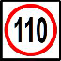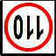

110 220

DATE: 24/02/2022

REV No: 14

DBCA ­ 22 ­ 23

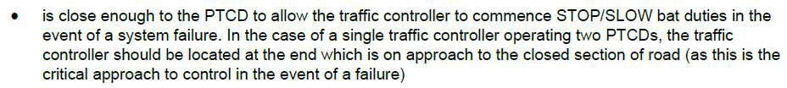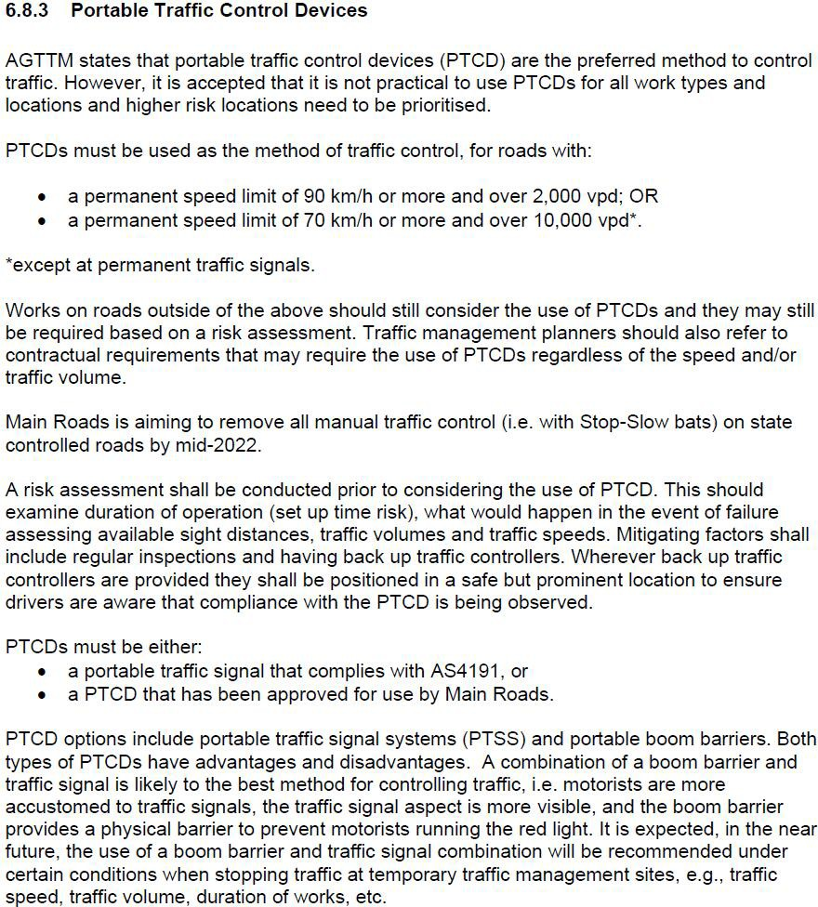

**STOP HERE WHEN DIRECTED**

OR

DATE: 24/03/2021

**DISCLAIMER:DISCLAIMER:**DISCLAIMER:

It is the responsibility of the user of this traffic

guidance scheme to confirm the appropriateness or otherwise for the intended work site based on rigorous risk assessment, review of the requirements of AS1742.3 and Main Roads WA Traffic Management for Works on Roads CoP and AGGTM. All responsibility will remain with the user to ensure compliance with relevant standards and the provision of the necessary level of protection for work personnel and work site.



Replaced with

Replaced with

WHEN PTCD IS EXCHANGED WITH TRAFFIC CONTROLLER,

PREPARE TO STOP TRAFFIC LIGHT TO BE INTERCHANGED

WITH PREPARE TO STOP / BATMAN.

**DO NOT OVERTAKE**

**PREPARE TO STOP**

|  |
| --- |
| **GENERAL NOTES:**   1. This TGS is only to be used as part of the DBCA Generic Traffic Management Plan. 2. All sign locations are to be checked prior to setout and positions adjusted to allow for specific site constraints such as vegetation, other signs, roadside furniture and sufficient space on shoulders/emergency lanes. 3. All existing speed zone signage within the temporary speed zone shall be covered with suitable opaque material for the duration of the stage and covers to be removed on completion of works each day. Unless otherwise noted. 4. Minimum traffic lane width of 3.2m is to be maintained past the worksite at all times. 5. The positioning of signs, lengths of tapers or markings shall be:    1. Minimum 10% less than the distances or lengths given.    2. Maximum 25% more than the distances or lengths given. 6. Supervisor shall undertake risk assessment to determine appropriate temporary speed restriction. 7. The symbolic worker signs shall be installed only when on­foot personnel will be visible to passing traffic. 8. When using MMS two 5mm thick core flute signs back to back in the MM frame to help prevent the sign from blowing out. 9. Drive slowly can be swapped with Smoke Hazard, or Burning Off. 10. Use of Fold up signs and Swing signs acceptable in narrow, very low volume tracks   <50 VPD. |
| DISCLAIMER:  It is the responsibility of the user of this traffic guidance scheme to confirm the appropriateness or otherwise for the intended work site based on rigorous risk assessment, review of the requirements of AS1742.3 and Main Roads WA Traffic Management for Works on Roads CoP and AGGTM. All responsibility will remain with the user to ensure compliance with relevant standards and the provision of the necessary level of protection for work personnel and work site. |
| Drawn: Cheryl Johnson  AWTM Cert. No: KTS­AWTM­19­47786­01  Signed: |
| Reviewed by: Brad Brooksby  AWTM Cert. No: AUS­AWTM­19­1183­07  Signed: |

|  |  |  |
| --- | --- | --- |
| **TC interchanged with PTCD** | | |
| DATE: 24/02/2022 | REV No: 14 | DBCA ­ 22 ­ 24 |

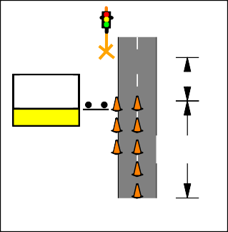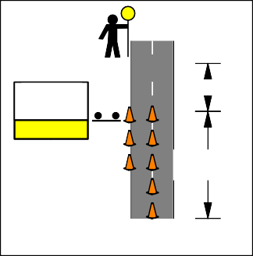

**STOP HERE WHEN DIRECTED**

**BURNING OFF**

Cones may be placed alone edge to reduce lane width to max 4m.

12m

6 Cones 4m spacing

**THRESHOLD**

**STOP HERE ON RED SIGNAL**

**BURNING OFF**

Cones may be placed alone edge to reduce lane width to max 4m.

12m

6 Cones 4m spacing

**THRESHOLD**

|  |  |
| --- | --- |
|  | **PREPARE TO STOP** |
| **DO NOT OVERTAKE** | |

# END OF DOCUMENT



SJTM 2179

Rev 1

85 | P a g e